Dysphagia Diets Abstract
Workshop or Poster

Ibrahim Abdullah Refaei
Manal Samarkandy, MS

Dysphagia can be defined as having difficulty or discomfort in swallowing. Patients present with choking and coughing on swallowing, with food sticking and causing pain or discomfort. Because of this, dysphagia sufferers often have a loss of appetite or weight loss. Aspiration and pneumonia is a serious consequence of food passing into the pharynx uncoordinated, entering the airways. Malnutrition and dehydration are very common, resulting from the reduced oral intake due to the increased effort it takes to eat and drink sufficient amounts. Poor nutritional status is associated with serious health risks such as impaired wound healing, higher risk of infection and impaired mental and physical function.

The outline for Work Shop will be as follows:

1-Education regarding different fluids consistencies (Thin, Nectar, Honey, Pudding)
2-The guidelines for preparing fluid with different kind of thickeners
3-The rule of dietitian in dysphagia management.
4-Recommended food for Different Dysphagia levels with Liquid consistencies.
5- Provide advice on which foods are easiest for the patient to eat, how they can be prepared to make them more palatable, and how to maintain a balanced diet.
6- How to fortify meals (with Modulars and Supplements) to make sure the patient achieves their Nutritional requirements.
7- Provide advice about which foods the patient should avoid and on which products can help to make food easier to swallow.
8- Dietitian may recommend Artificial nutritional support through a nasogastric or PEG tube (Formula Display).

Refaei, Ibrahim Abdullah Mobile: +966563212993

Email: ibrahimrefaei@hotmail.com

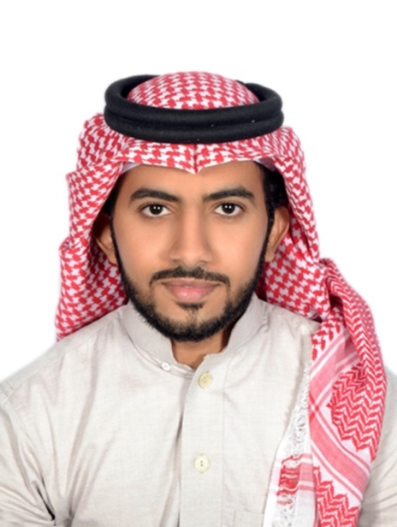

Professional Summary

Clinical Dietitian
Pediatric Dietitian in (Early Intervention program at SBAHC - Riyadh)
Member of National Newborn Screening Program of MOH (Saudi Metabolic Nutrition).

Nationality - Saudi

Education
Degree | University | Year of Passing
Bachelor of Clinical Nutrition | Jazan University | May - 2015

Speaking Experiences

- Speaker at ( Medical Affairs of ministry of Labor and Social Development Conference on 17th October 2019 in Riyadh
- Speaker at ( Spinal Cord Injuries Conference at sultan bin Abdelaziz humanitarian city 17 – 19 march 2019 )
- Speaker at ( Medical Affairs of ministry of Labor and Social Development Conference on 28th November 2018 in Riyadh
- Speaker at (Interdisciplinary Pediatric Nutritional Management) in SBAHC 12 December 2017
- Speaker at (Interdisciplinary Management of Dysphagia and Nutrition - ) in SBAHC 6th -7th February2017
- Speaker at (Latest Nutritional Therapeutic Interventions For diseases 2nd conference at KSMC 2016.
- Speaker at (3rd Symposium of Physical Activity) at KSMC 2016.
- Internal Auditor for Food Safety System (FSSC 22000 (Version 4.1) with the European Register of Certificated Auditors.

Experience

Organization | Designation | Duration
Sultan Bin Abdulaziz Humanitarian City – Riyadh - Kingdom of Saudi Arabia | Clinical Dietitian | September 2016  Until Now
King Saud Medical City – Riyadh – Kingdom of Saudi Arabia | Clinical Dietitian | oct 2015 To  Aug 2016
King Fahad Central Hospital - Jizan - Kingdom of Saudi Arabia | Clinical Dietitian | June 2015  To  October 2015

Achievements

- Leader of Jazan campaign (Your Heart Your Life) at Rashid Mall – jazan (27 – 28 October 2016)
- Star of the Month in SBAHC Nominated and Appreciated in Monthly Forum 6th April 2017
- Founder of Volunteer Clinical Dietitians Team (Dietitians) Jizan.
- Hosted in MBC 1 Channel in Good Morning Arab Program on 9th April 2018
- Hosted in Rotana Khalijia Channel on 7th March 2018 , and 11th December 2019
- Hosted in a Television in Medical Section in KSA cultural channel at 7thdec. 2015 and 18th Feb. 2016.
- Hosted in Riyadh Radio at 9th Jun and in UFM Radio 19th April 2016.
- Hosted in Selah TV channel at 4th Jun 2017.
- Member of Rowed al Ehsan volunteer medical team in Al Ehsan society in Jizan.

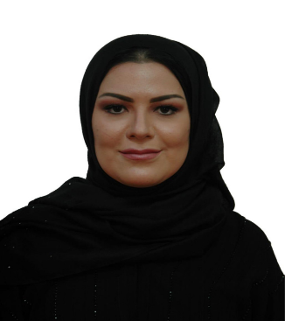

Professional Summary

I have skills and qualifications for Senior Management position with skills gained with Master’s Degree in Clinical Nutrition and three (3) years of my 15 years of as Dietitian Supervisor. Published three scientific paper published in Dietetics. I am a motivated, proactive and perfectionist in all aspects of Clinical and Managerial responsibilities with overwhelming innovative ideas with list of activities and projects to prove my achievements.

Nationality - Saudi

Education

Degree | University | Year of Graduation
MS Clinical Nutrition | King Saud University | September- 2007

Experience

Organization | Designation | Duration
Vision Realization Organization (VRO) of Ministry of Health | Project Manger | August 2018 to Present
Sultan Bin Abdulaziz Humanitarian City, Riyadh | Business Development Specialist | Feb 2018 To August 2018
Sultan Bin Abdulaziz Humanitarian City | Dietitian Supervisor  - Supervised 20 Dietitians and Techs  Patient care Supervision | November 2004-2015
National Diabetes Center | Dietitian and Diabetic Educator | 2004
Saudi German Hospital | Clinical Dietitian | 2003

Achievements

- Organized conference on Bariatric Surgery Impact on Diabetes 2018.
- Developed many Innovation ideas including one for new services such as One Stop Store for Therapeutic needs (Bariatric, Dysphagia, Diabetic, Formulas and Organic Food Products).
- Health Promotion Campaigns, just in 2016 -2017 did over 15 Campaigns two of which were outside Riyadh, and others in Malls, Schools and Medical Center.
- Invited as speaker in (4) International conferences at Greece, Turkey, France and UAE and in Saudi National conferences over (10) in last two years
- Supported the Bariatric Surgical Team to achieve Quality Standards for IFSO accreditation
- Employee of the month Recognition in 2008
- Took responsibility of Acting Manager of Dietetics for 10 years as assigned.
- Team Leader for the Telemedicine 2nd Opinion program with Cleveland Clinic of USA
- Developed and implemented Clinical Pathways and Practice Guidelines for disease specific therapies
- Achieved compliance to all Clinical Nutrition of Quality standards during JCI, CARF and CBAHI inspections.
- Organized successful Monthly forum in April 2017 under the theme of Earth day and coordinated display of recycled materials in Therapy Street
- Developed patient care programs and staff training modules
- Lead the team in developing Memorandum of Understanding (MoU) for referral of Diabetic Center patients to the Bariatric Surgical Center of Sultan Bin Abdulaziz Humanitarian City

Publications:
- www.semanticscholar.org/paper/Nutritional-assessment-and-obesity-in-Down-syndrome-Samarkandy-Mohamed/b21aef37d1d6fc9dd1a52d3812acd2af52f5da37
- http://globalscienceheritage.org/resources/volume-1-issue-1/dietary-practice-and-physical-activity-in-children-with-down-syndrome-and-their-siblings-in-saudi-arabia/
- http://www.acnut.com/v/images/stories/pdf/journals/arab-journal-of-food-and-nutrition-issue-20.pdf

