Advantages of use of an evidence-based guideline in nutritional intervention for cancer cases ESPEN/ESMO 2018

Dr. G. Saleh, Public Health PhD, 57375, Egypt

Abstract (300 word limit)

Malnutrition and loss of muscle mass are frequent in cancer patients and have a negative effect on clinical outcome.
Advantages: Prevention and control of malnutrition during and after the course of the disease. Overcome nutritional challenges and side effects of the treatment. Increase awareness of the patient and the care giver about the importance of nutrition. Regular monitoring of the nutritional status of the patient during the course of the treatment. Guarantee normal growth during the course of the disease for infants and children. Decrease the mean time span of the patient at the hospital.

This Guideline is intended to be used by: Clinical oncologists, nutritionists, health care providers involved in supportive care of cancer patients.
Plan of intervention: Psychosocial support and counselling. Screening and assessment. Route of feeding. Calculation of nutritional requirements. Immunonutrition.N3-fatty acids. Oral Nutrition Supplementation.
Nutritional counseling should be achieved by a health care professional, aiming to increase the awareness of the patient about the importance of nutritional intervention, Timing: At diagnosis, and throughout the journey of treatment.
Nutritional screening and assessment aim to identify patients at risk of malnutrition to start early & prompt nutritional plan .
- Requirements calculation: Energy: Total Energy Expenditure may be predicted to be 25-30 kcal/kg depending on the patient's performance status , and the exposure to stress factors .
, . Protein intake should be above 1 g/kg/day and, if possible, up to 1.5 g/kg/day, and may be higher in infants and children.
Carbohydrates/fat ratio There are additional advantages to replacing glucose with lipids in parenteral nutrition regimens. Supplementation with vitamins and minerals should be given with the RDA, and to avoid high doses, taking in consideration the drug interaction with the treatment protocol of cancer.

Image

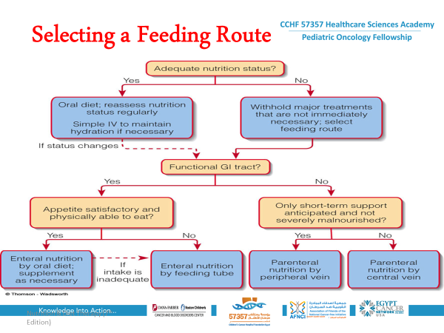

Recent Publications (minimum 5)

- Vitamin D deficiency and insufficiency in Africa and the Middle East, despite year-round sunny days. S Afr Med J. 2015 Jul;105(7):603-5.

- Factors associated with early growth in Egyptian infants: implications for addressing the dual burden of malnutrition, Maternal Child Nutr. 2016 Jan; 12(1): 139–151.

- Program considerations for integration of nutrition and family planning: Beliefs around maternal diet and breastfeeding within the context of the nutrition transition in Egypt. May 2017. http://onlinelibrary.wiley.com/doi/10.1111/mcn.12469/full

- Towards managing and controlling food safety based on contamination with fungi and its mycotoxins. Int J Gastroenterol Hepatol Transpl Nutr 2017;2(ii): 4 – 13

- Nutritional status of patients with acute lymphocytic leukemia (ALL), in Children Cancer Hospital Egypt (CCHE-57357) has been accepted for poster board viewing at the 51st Congress of the International Society of Pediatric Oncology (SIOP 2019), to be held in Lyon, France on October 23-26, 2019.

- Nutritional status of patients with acute myeloid leukemia (ALL), in Children Cancer Hospital Egypt (CCHE-57357), has been accepted for poster board viewing at the 51st Congress of the International Society of Pediatric Oncology (SIOP 2019), to be held in Lyon, France on October 23-26, 2019.

Photograph



Dr. has her expertise in the field of clinical nutrition since 1991, 2017 till now Head of clinical nutrition department at 57357 Cancer Children Hospital of Egypt (57357 CCHE).

- 2007- 2016
NATIONAL NUTRITION INSTITUTE (NNI), CAIRO- EGYPT:
Consultant of clinical nutrition and public health at "Field Studies & Researches Department", participating in different researches & scientific activities. Project Manager & general coordinator of IDD scientific secretariat of Egypt, NNI/UNICEF. General coordinator of the low salt/low fat initiative, NNI/WHO.General coordinator of NCDs committee, NNI/WHO.Head of media & conferences department (2009-2011)

- 2/2013 until 5/2014:
Nutritional consultant for Smart project, MCHIP/USAID/ Save the children/Path, for prevention and control of chronic infantile and young children malnutrition (stunting).

- 2001 until 2007 : Affected by the Ministry of FOREIGN AFFAIRS through the Egyptian- African Cooperation, as expert of Public Health to GABON (West of Africa) as consultant of Nutrition & Educational Programs - Center of Ambulatory Treatment for A.I.D.S. patients (CTA), which is under the supervision of French Red CREST & National Program for fight Against A.I.D.S.(PNLS).

1994 until 2001 : Specialist of Nutrition - NATIONAL NUTRITION INSTITUTE – CAIRO-EGYPT.

1991 until 1994 : Resident of Nutrition -t NATIONAL NUTRITION INSTITUTE – CAIRO-EGYPT.

Email: gulsen.saleh@57357.org

Notes/Comments:

