Microfluidic platform for controlled and tunable production of bioactive PLGA particles
Maria Camilla Operti¹, Yusuf Dölen^{1,2}, Jibbe Keulen¹, Eric A. W. van Dinther^{1,2}, Carl G. Figdor^{1,2} and Oya Tagit^{1,2}
¹ Department of Tumor Immunology, Radboud Institute for Molecular Life Sciences, Radboud University Medical Center, 6500 HB Nijmegen, The Netherlands
² Oncode Institute, 3553 Utrecht, The Netherlands

Abstract

Polymeric particles made up of biodegradable and biocompatible polymers such as poly(lactic-co-glycolic acid) (PLGA) containing active pharmaceutical ingredients (APIs) offer the advantages of improved stability, targeted delivery and controlled release of APIs in vivo. Particular emphasis is placed on the size and surface functionality of these systems as they are regarded as the main protagonists in dictating the particle behavior in vitro and in vivo. Conventional methods of manufacturing polymeric drug carriers offer a wide range of achievable particle sizes; however, they lack the precision and full control over the particle size and uniformity, particularly for larger scale processes. Microfluidics technology has emerged as an efficient tool to manufacture particles in a highly controllable manner.

In our study, we report on tuning the size of pegylated PLGA (PEG-PLGA) particles at diameters ranging from sub-micron (~100 nm and ~200 nm) to microns (>1000 nm) using a single microfluidics device through modification of flow and formulation parameters. A fluorescent dye was used as a model drug to assess the encapsulation efficacy, in situ release characteristics, particle uptake by mouse-derived immune cells and in vivo clearance. Efficiency of particle uptake by dendritic cells and myeloid-derived suppressor cells isolated from mice is strongly correlated with particle size and is most efficient for ~100 nm particles. Particles systemically administered to mice mainly accumulate in liver and ~100 nm particles are cleared slower.

Our research shows how PLGA particle size can be specifically tuned using a microfluidics system obtaining PEGylated PLGA particles in different sizes. The direct relation between particle size and the pharmacokinetics behavior of particles was confirmed, providing a further step towards the establishment of a customizable production process to generate tailor-made nanomedicines.

Image

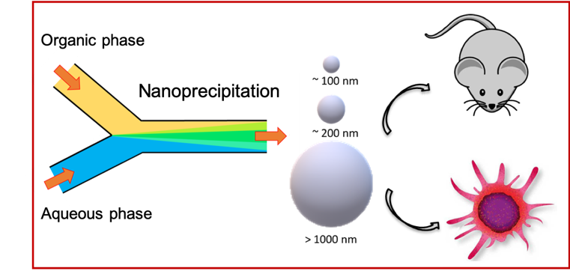
Figure 1: Schematic illustration of the PEG-PLGA particles generation process via microfluidic system and their biological evaluation.

Recent Publications
- Khalid, M.; El-Sawy, H.S. Polymeric nanoparticles: Promising platform for drug delivery. Int. J. Pharm. 2017, 528, 675–691.
- Toy, R.; Hayden, E.; Shoup, C.; Baskaran, H.; Karathanasis, E. The effects of particle size, density and shape on margination of nanoparticles in microcirculation. Nanotechnology 2011, 22, 115101.
- Suk, J.S.; Xu, Q.; Kim, N.; Hanes, J.; Ensign, L.M. PEGylation as a strategy for improving nanoparticle-based drug and gene delivery. Adv. Drug Deliv. Rev. 2016, 99, 28–51.
- Operti, M.C.; Fecher, D.; van Dinther, E.A.; Grimm, S.; Jaber, R.; Figdor, C.G.; Tagit, O. A comparative assessment of continuous production techniques to generate sub-micron size PLGA particles. Int. J. Pharm. 2018, 550, 140–148.
- Operti, M.C.; Dölen, Y.; Keulen, J.; van Dinther, E.A.W.; Figdor, C.G.; Tagit, O. Microfluidic-assisted size tuning and biological evaluation of PLGA particles. Pharmaceutics 2019, 11, 590.
Photograph

 Biography
M. Camilla Operti is currently is a PhD candidate at the Tumor Immunology department of the Radboudumc Institute of Molecular Life Sciences (The Netherlands), focusing on PLGA formulation development and the evaluation of new applications and technologies. She holds a master degree in Pharmaceutical Chemistry and Technologies from the University of Torino (Italy) and is a licensed pharmacist.
Email: mariacamilla.operti@radboudumc.nl

Notes/Comments:

