Abstract Template
Abstract Title: SKELETAL MUSCLE METASTASIS: AN UNUSUAL MANIFESTATION OF ADENOCARCINOMA OF LUNG
Sharan Badiger¹, Siddarthkumar Chawath².

¹Professor, Department of Medicine, Sri B M Patil Medical College, Vijayapur, India.
²Junior Resident, Department of Medicine, Sri B M Patil Medical College, Vijayapur, India.

Abstract (not more than 300 words)

Introduction: Lung carcinoma, the most common malignancy worldwide, presents as a metastatic disease in majority of the cases. The most frequent sites of distant metastases are liver, adrenal glands, bones, and brain. Skeletal muscle metastasis is an unusual presentation of lung adenocarcinoma. Case report: A 53 year old male patient, labourer by occupation, beedi smoker since twenty five years, admitted to tertiary care hospital with pain and swelling over left arm, cough and expectoration since 2 months, accompanied with weight loss of three kilograms. There was no evidence of chest pain or hemoptysis .On examination there was hard swelling over extensor compartment of left upper limb with mild tenderness, no loss of sensation and mild restriction of range of movements on flexion at elbow. Respiratory and other system examination was within normal results. CT Chest plain defined multilobulated lesion in right perihilar location in right middle lobe .USG study of left arm showed an irregular heterogenous soft tissue lesion noted within the triceps muscle with few areas of intra-lesional necrosis, MRI of left arm showed lobulated lesion in posteromedial aspect of mid and distal arm, involving triceps muscle, medial aspect of brachialis, encasing brachial artery, veins and median nerve. PET CT showed enhancing nodular soft tissue lesion noted in middle lobe of right lung, 2.9 x 2.4 cm. Biopsy revealed metastatic adenocarcinoma. For further studies Immunophenotyping was done which showed negative for EGFR and ALK. Patient was treated with palliative RT, Pem-Carbo f/b Pemtrexed maintenance and recently 3# of Gemcitabine. The patient died of metastasis to brain within eight weeks of diagnosis. Conclusion: Lung carcinoma with skeletal muscle metastasis should be considered as a potential differential diagnosis in patients presenting with intramuscular mass.
Keywords—Adenocarcinoma of Lung, Metastasis, Skeletal Muscle, Triceps Brachii

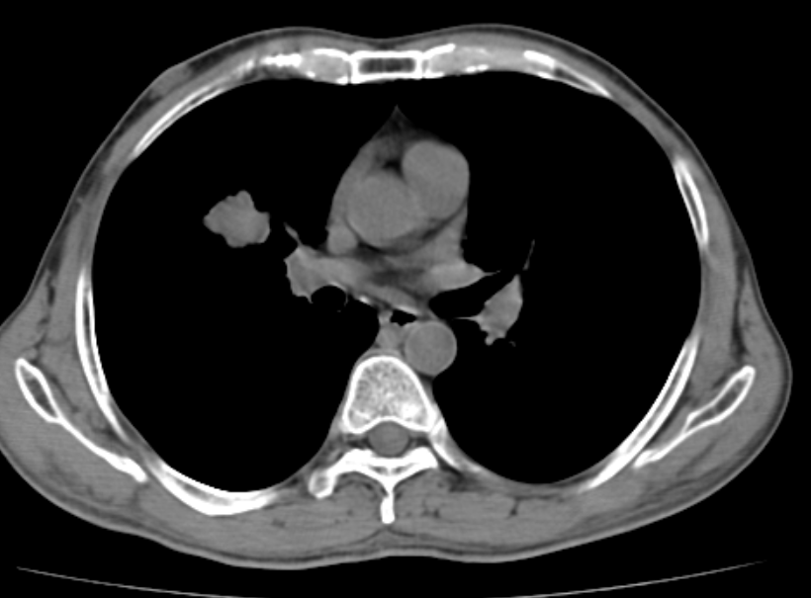
Figure 1. Computerized Tomography of Thorax: Well defined multi-lobulated lesion in right perihilar location in right middle lobe measuring 2.7 x 2.5 cm.
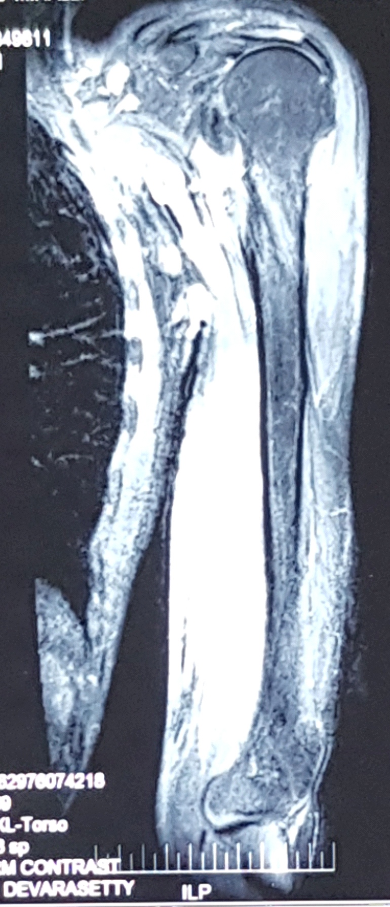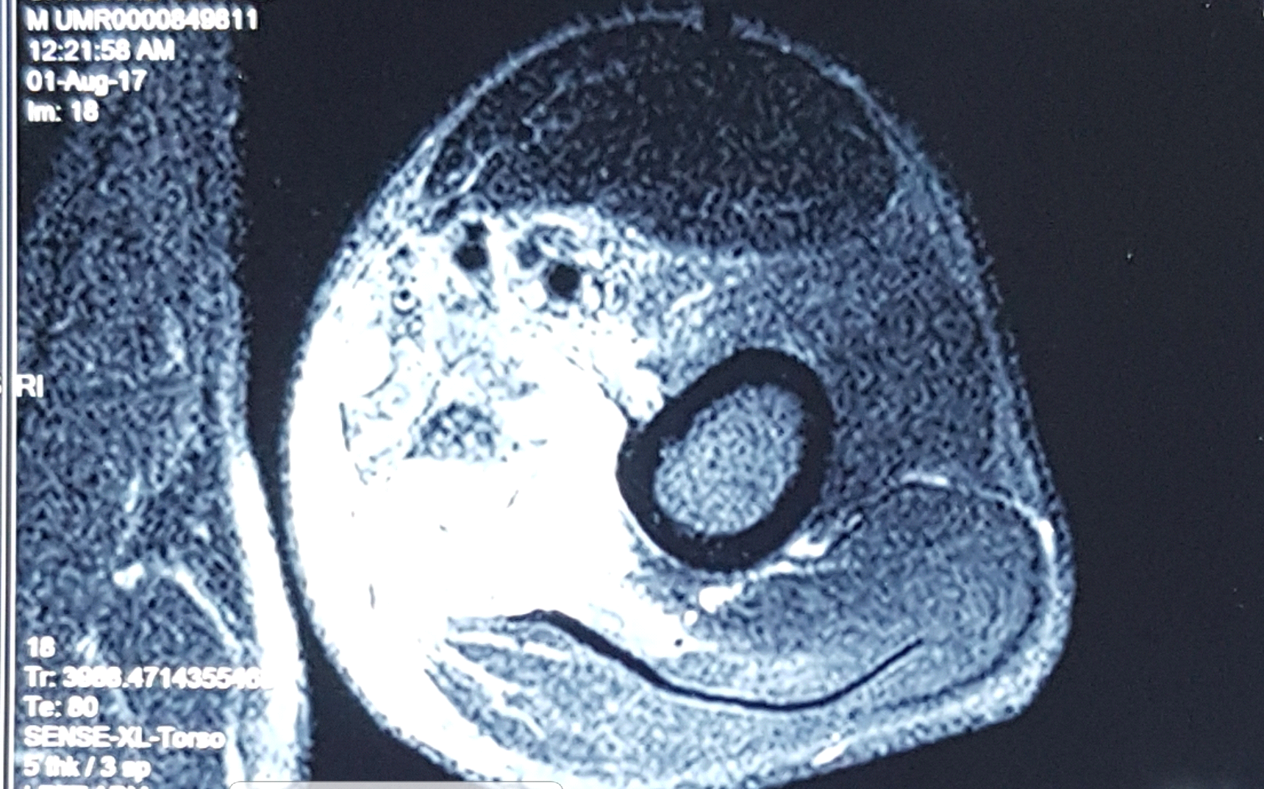
Figure 2. Magnetic Resonance Imaging of Left arm: Well defined irregular lobulated enhancing T1 hypo intense, T2 and T2 flair hyperintense lesion in the posteromedial aspect of mid and distal arm.

Professional Biography (100-150 words)

Dr. Sharan Badiger, born in 1968. He completed his MD in Internal Medicine, in 1994 and MBBS, in 1989 from Gulbarga University, Gulbarga, Karnataka, India. He is presently working as Professor of Medicine, Sri. B M Patil Medical College, Vijayapur, Karnataka, India. His main research interests are in Internal Medicine, Echocardiography and Imaging in Medicine. He has 60 publications in International / National reputed Journals and Proceedings of the conferences. He is a Life Member of Association of Physicians of India since 1996, Research Society for the Study of Diabetes in India since 2005, Indian Society of Cardiology since 2006, Indian Society of Electro-cardiology since 2010, Indian Academy of Geriatrics since 2010, International Association of Computer Science and Information Technology Singapore since 2010. He is an International Associate member of American College of Cardiology since 2014. He is serving as editor-in-chief, editorial board member, peer reviewer and advisory board member of various national, international journals and conferences of rupute.


Paste your Photograph here

Email Id: sharanrb@rediffmail.com

Any Comments: Happy to participate in the conference of international repute.
Is registration fees to be paid after acceptance?

