Abstract Title: A Case of Traumatic Abdominal Wall Hernia Secondary to Seatbelt Injury – Multidisciplinary Management by Delayed Surgical Mesh Repair, Complicated by Intervening Pregnancy
Stanislau Makaranka, Pennylouise Hever, Naveen Cavale

¹ Foundation Year 1 Doctor, King’s College Hospital, UK
²Core Surgical Trainee, Salisbury District Hospital, UK
³Consultant Plastic Surgeon, King’s College Hospital, UK

Abstract (not more than 300 words)

Background: Traumatic abdominal wall hernia (TAWH) is a rare type of hernia occurring secondary to blunt trauma, with a reported incidence of 0.2% on presentation CT scan. There is currently no consensus regarding the optimum time for repair, though conservative management with serial imaging +/- expectant elective repair has been favoured.
Methods: We present a case of a 20-year old female who was a seatbelt restrained rear-seat passenger in a road traffic collision and sustained two areas of Grade-5 TAWH along with bowel and colonic injuries. The patient was taken for an emergency laparotomy with initial conservative management of TAWH.
Results: Four years post-index admission the patient’s abdominal wall was closed using Strattice Mesh. Delay was due to the inability of the patient to reach the 100-110kg goal operative weight and a pregnancy. During her pregnancy, the patient was managed by active surveillance involving the obstetric, plastics and trauma team.
Key messages: This case illustrates successful delayed surgical repair of TAWH using biological mesh, without recurrence, demonstrating that elective repair provides a safe alternative to early repair in pregnancy. We reiterate the importance of a multidisciplinary approach to TAWH, involving input from the trauma, plastic surgery, and obstetric – in the case of pregnancy – teams.
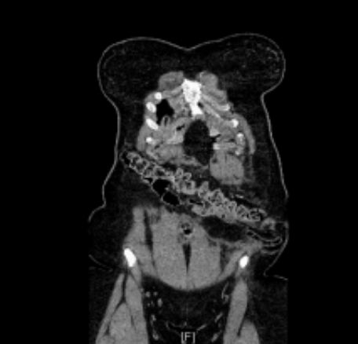
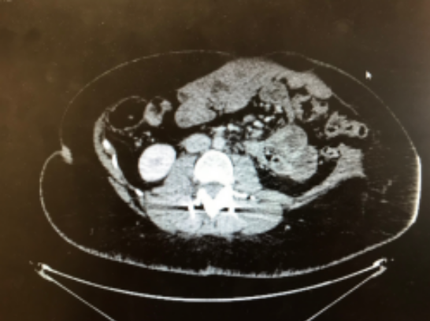

Figure 1b – Axial CT slice demonstrating a Grade 5 TAWH

Figure 1a – Coronal CT slice demonstrating TAWH in the seatbelt distribution

Keywords—complex management, hernia, pregnancy, seatbelt injury

Professional Biography (100-150 words)

Dr Stanislau Makaranka completed his medical degree at Southampton University. Since qualifying he started his medical training at King’s College Hospital where he has worked in general surgery, general medicine and orthoplastics, in 4 month blocks during Foundation Year 1. He has developed an interest in plastic surgery and published a case report on traumatic abdominal wall hernia in the British Medical Journal, whilst also teaching and attending conferences, which also relate to this topic. Since then he has continued his medical training at University College Hospital in London and is pursuing a career in plastic surgery.



Email Id: stanislau.makaranka@nhs.net

