Abstract Template
Abstract Title: Right-sided facial swelling with functional hemiparesis: A diagnosis dilemma
Claire Graham¹, Samantha Reid², Colette Balmer³, Kathryn Taylor⁴

¹ Dental Core Trainee (Liverpool University Dental Hospital, UK)
²Oral Surgery Registrar (Liverpool University Dental Hospital, UK)
³Consultant Oral Surgery (Liverpool University Dental Hospital, UK)
⁴Senior Lecturer/Hon Consultant Oral Surgery (Liverpool University Dental Hospital, UK)

Abstract (not more than 300 words)

Functional paresis is a psychogenic phenomenon resulting in patients complaining of weakness and disturbances in function without pathology. Often patients with function symptoms have a history of depression and anxiety.
Here we discuss a case of an 18 year old female who self-referred in to the local dental emergency clinic regarding an acute right-sided facial swelling and a right-sided facial paresis. Further investigation revealed the likely cause of her right parotid swelling was a mucous plug or sialolith that subsequently passed. It transpired the right facial paresis was not a new presentation and the patient had been under the care of a consultant neurologist for functional hemiparesis. Interestingly, the patient had worked in a stroke ward at the time of onset of the hemiparesis.
Due to the limited history expressed by the patient and clinical findings, upper motor neurone pathology was suspected initially. This case highlights the importance of liaising with other specialties in order to proceed with the correct management.

Keywords— functional neurological disorder, facial swelling, oral surgery, parotid gland

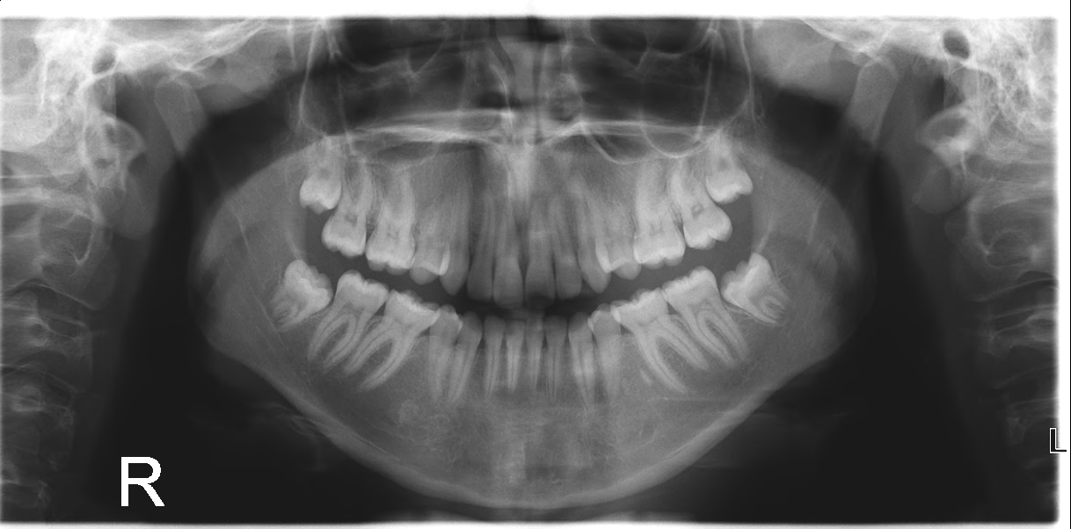

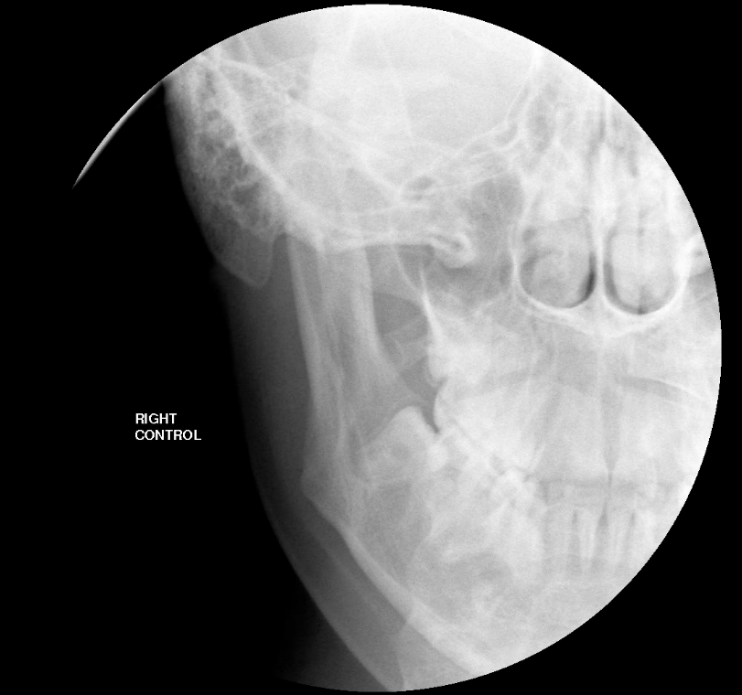

Professional Biography (100-150 words)

Claire Graham is a Dental Core Trainee in Oral Surgery at the Liverpool University Dental Hospital, UK. Claire completed her BSc (Honours) in Biomedical Sciences at Newcastle University, UK, where she undertook research in oral biofilms. This inspired Claire to go on and study Dentistry at the University of Aberdeen, UK. Since graduation Claire has trained in Oral and Maxillofacial Surgery posts in Manchester, Liverpool and the Wirral and continues her research as well as undergraduate teaching at Liverpool University Dental Hospital.
Claire is continuing her studies with a Postgraduate Certificate in Medical Education at Edge Hill University.

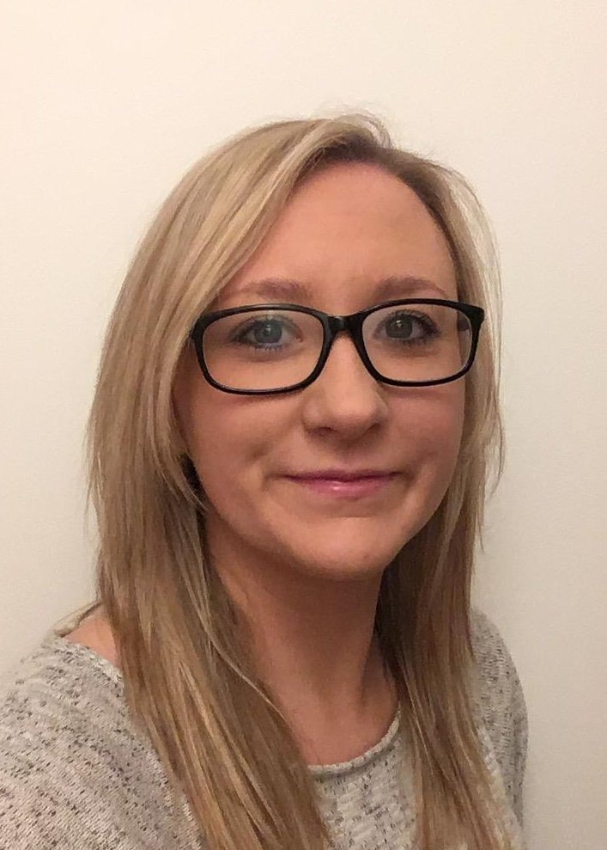

Email Id: Claire.graham6@nhs.net
Any Comments:
I would like to submit the above abstract for consideration as an oral presentation at the Clinical and Medical Case Reports conference, Paris 2018.

