﻿Beware of lethal Wernicke's encephalopathy after cytoreductive surgery with HIPEC for peritoneal pseudomyxoma: Case report of morbidity and mortality review
Oumayma Lahnaoui (1,2),*, Nezha EL Bahaoui (1), Raouf Mohsine (1,2), Amine Souadka (1,2)
1 Surgical Oncology Department, National Institute of Oncology, Ibn Sina University Hospital. Rabat, Morocco
2 Equipe de recherche en Oncologie Translationnelle (EROT), Faculty of Medicine and Pharmacy, Mohammed V University in Rabat, Morocco

Abstract

﻿Background: Pseudomyxoma peritonei (PMP) arising from the appendix is a rare entity. Complete cytoreductive

surgery (CRS) combined with hyperthermic intraperitoneal chemotherapy (HIPEC) is the only established

curative treatment, and is reputedly linked to high morbidity and mortality.

We report, to our knowledge, the first case of delayed lethal Wernicke encephalopathy (WE) complicating CRS

with HIPEC for an appendicular PMP. WE, caused by a thiamine deficiency, is characterized by ataxia, nystagmus

and changes in consciousness.

Methods: A patient underwent complete CRS with HIPEC for a low grade mucinous appendicular tumor at the

stage of PMP with a peritoneal index of 31, and was readmitted at POD 36 for persistent vomiting and vague

neurological symptoms of mental confusion. The classic triad of WE appeared tardily. Although thiamine substitution was promptly applied, the patient died at POD53.

Conclusion: WE is an uncommon and severe neurological disorder with a mortality rate up to 20 % and only 16 %

of treated patients can fully recover. This diagnosis should always be anticipated in patients undergoing major
surgery such as CRS- HIPEC. Efficient treatment should be quickly introduced in order to avoid a lethal outcome.
Figure 1 Cerebral MRI images showing hyperintense signal of the periaqueductal gray matter.

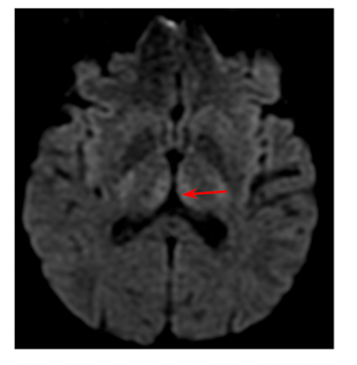
Recent Publications
T.C. Chua, B.J. Moran, P.H. Sugarbaker, E.A. Levine, O. Glehen, F.N. Gilly, et al.,
Early-and long-term outcome data of patients with pseudomyxoma peritonei from appendiceal origin treated by a strategy of cytoreductive surgery and hyperthermic
intraperitoneal chemotherapy, J. Clin. Oncol. 30 (20) (2012) 2449–2456.
A. Souadka, A. Benkabbou, M.A. Majbar, H. Essangri, L. Amrani, A. Ghannam, et al., CRS and HIPEC: the need for an adaptable learning curve model, J. Surg. Oncol. 122 (6) (2020 Nov) 1187–1188.
A. Souadka, H. Essangri, N. El Bahaoui, A. Ghannam, B. El Ahmadi, A. Benkabbou, et al., CRS and HIPEC: best model of antifragility in surgical oncology, J. Surg. Oncol. 126 (2) (2022 Aug) 396–397.
Saxena, T.D. Yan, T.C. Chua, D.L. Morris, Critical assessment of risk factors for complications after cytoreductive surgery and perioperative intraperitoneal chemotherapy for pseudomyxoma peritonei, Ann. Surg. Oncol. 17 (5) (2010 May)
1291–1301.

Biography
Dr O.Lahnaoui is a chief resident in general surgery . Through her work in the field of patient safety, she is a firm believer in analyzing systems of healthcare and cases of surgical complications in order to discover patterns of error and contributing factors to occurrence of complications.

Email:oumaima.lahnaoui@um5s.net.ma

