Elevated AFP in the absence of hepatic malignancy in a patient with acute hepatitis
Jacklyn M. So-Cabahug, MD, Manila Doctors Hospital, Philippines
Marc Lustre, MD, Manila Doctors Hospital, Philippines
Rafael Chan, MD, Manila Doctors Hospital, Philippines
Janus Ong, MD, Manila Doctors Hospital, Philippines

Abstract
Objective: This paper aims to describe a case of elevated AFP in a case of acute hepatitis and its pathophysiology
Materials and Methods: Case report
Results: The patient is a 26-year-old Asian male presenting with jaundice. He had no personal or family history of liver disease, occasional alcohol use, and drug or supplement use. The laboratory workup revealed hepatocellular type of liver injury (total bilirubin of 478 umol/L, direct bilirubin 401 umol/L, indirect bilirubin 77 umol/L, AST 1135 U/L, ALT 1592 U/L, LDH 53 U/L, ALP 139 u/L), elevated AFP (3337 IU/ml), elevated INR, positive autoimmune panel (ANA, Anti-Sm, Anti-TPO, Anti-TG). The serological examinations revealed a past infection with EBV and CMV, while imaging tests did not show ductal obstruction or the presence of mass lesions. A subsequent liver biopsy demonstrated interface hepatitis. The patient was then treated as a case of autoimmune hepatitis and was started on glucocorticoids with clinical and biochemical improvement including normalization of AFP levels.
Conclusion: This study demonstrated the low specificity of AFP as it relates to these unusually elevated levels even as compared to other studies on non-malignant cases of liver disease. In this patient with acute hepatitis, AFP elevation may represent hepatic regeneration.
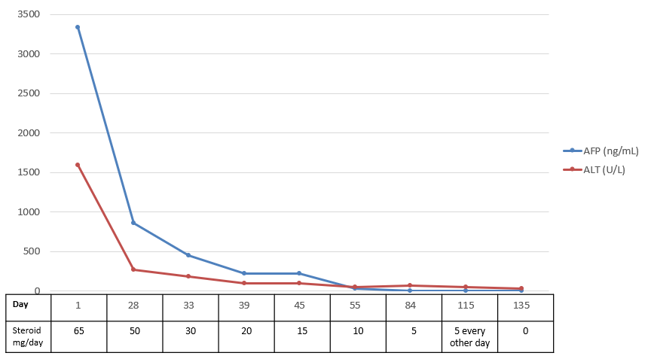
Figure 1. Trend of AFP and ALT levels in relation to steroid dosage

Figure 2. Timeline of intervention and outcome
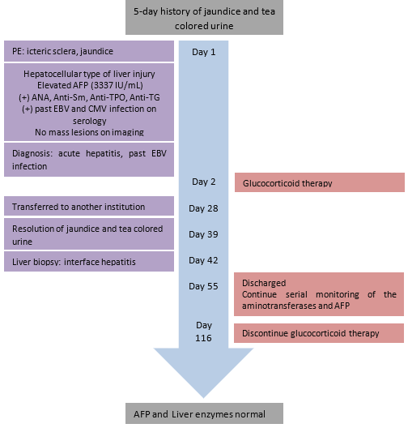
References

- Sebode, M., Hartl, J., Vergani, D., & Lohse, A. W. (2017). Autoimmune hepatitis: From current knowledge and clinical practice to future research agenda. Liver International, 38(1), 15–22. doi:10.1111/liv.13458
- Hinedi TB, Koff RS. Cholestatic hepatitis induced by Epstein-Barr virus infection in an adult. Dig Dis Sci. 2003 Mar;48(3):539-41. doi: 10.1023/a:1022592801060. PMID: 12757167.
- Modesto Dos Santos V, Da Costa Arruda Z Jr, De Farias Polcheira M, Da Silva De Souza DW, Rodrigues Oliveira Santos AM, Santos Corrêa Da Costa M. Hepatitis aguda por mononucleosis infecciosa en un varón de 21 años [Acute hepatitis due to infectious mononucleosis in a 21-year-old-man]. Rev Med Chil. 2013 Jul;141(7):917-21. Spanish. doi: 10.4067/S0034-98872013000700012. PMID: 24356741.
- Saadah, O. I., & Bokhary, R. Y. (2013). Anti-mitochondrial antibody positive autoimmune hepatitis triggered by EBV infection in a young girl. Arab Journal of Gastroenterology, 14(3), 130–132.
- Peng, H., Lim, T., Nam, J., & Lee, J. (2019). Autoimmune hepatitis following Epstein-Barr virus infection: a diagnostic dilemma. BMJ Case Reports, 12(7), e229615. doi:10.1136/bcr-2019-229615

Email: jacklynmso@gmail.com
Notes/Comments

