Case report: small bowel obstruction secondary to
Incarcerated femoral hernia
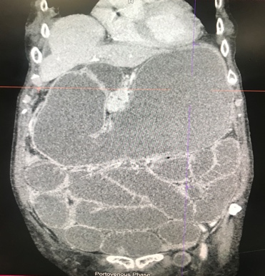
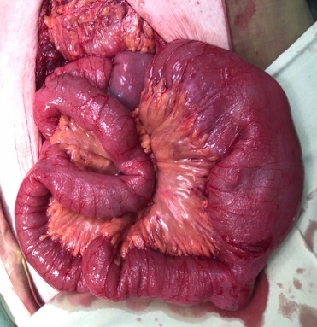
Johaniya Dimaporo, MD; Manila Doctors Hospital, Philippines
Ronalyn Bautista, M; Manila Doctors Hospital, Philippines
Virgilio Bañez, MD; Manila Doctors Hospital, Philippines
BA

Abstract

Significance: Femoral hernia is a rare cause of small bowel obstruction. This type of hernias is at high risk of incarceration and strangulation due to the narrow femoral canal and femoral ring. Therefore, can lead to symptoms of obstruction that may require emergency surgery and possible bowel resection.
A

Clinical presentation: This is a case of a 74-year-old woman, single, who sought consult at our institution due to increase in abdominal girth. Patient has no comorbidities and previous surgeries. She had pulmonary tuberculosis three years ago completely treated for 6 months with antikoch’s medications. Examination revealed one 3.0 cm x 3.0 cm, non-tender lump in the left inguinal area.
Management: Computerized tomography of the abdomen with contrast showed small bowel obstruction and left indirect inguinal hernia¹. Initial impression was small bowel obstruction probably secondary to ileocecal mass probably from tuberculosis versus malignancy. Patient was referred to surgery and on intra-operation findings showed incarceration of proximal segment of ileum (approximately 250cc from the Ligament of Trietz) at the left femoral canal without signs of gangrenous bowel². Explore laparotomy with proximal bowel decompression, reduction of femoral hernia and left femoral herniorrhaphy was done. She was stable after operation.
Recommendation: Hernias should always be considered as one of the possible causes of gastrointestinal obstruction.. Our case emphasizes the significance of meticulous history taking and clinical examination as any delay in diagnosis will increase the risk of mortality and morbidity for the patient.

Figure 1. CT scan of the abdomen which was performed on 3rd hospital day, (A) Coronal view showed distal small gut obstruction with fluid filled focus (2.1 cm) in the left parainguinal region likely an indirect inguinal hernia (pointed red arrow). Intra-operative finding (B) showing incarcerated of proximal segment of ileum (approximately 250cc from the ligament of trietz) at the left femoral canal without signs of gangrenous bowel (pointed by red arrow).

Sources:
- Sleisenger, Marvin H, Mark Feldman, Lawrence S. Friedman, and Lawrence J. Brandt. Sleisenger and Fordtran's Gastrointestinal and Liver Disease: Pathophysiology, Diagnosis, Management. 10th edition. Philadelphia: Saunders/Elsevier, 2016.
- Bendavid R. Femoral pseudo-hernias. Hernia 2002; 6:141.
- Fevang B, Fevang J, Stangeland L, et al. Complications and death after surgical treatment of small bowel obstruction. A 35-year institutional experience. Ann Surg 2000; 231:529-37.
- Ianora AA, Midiri M, Vinci R, et al. Abdominal wall hernias: imaging with spiral CT. Eur Radiol 2000; 10:914.
- Miller J, Cho J, Michael MJ, Saouaf R, Towfigh S. Role of Imaging in the Diagnosis of Occult Hernias. JAMA Surg. 2014;149(10):1077–1080. doi:10.1001/jamasurg.2014.48


Biography
Johaniya Dimaporo is a 29-year-old Filipino Muslim. She is currently on her first year gastroenterology fellowship in Manila Doctors Hospital, Manila, Philippines. She also had her internal medicine residency training on the same institution. She would like to pursue therapeutic or interventional endoscopy after her fellowship training.
Email: ningjohaniya31@gmail.com

Notes/Comments:

