COMMENTARY ENDOSCOPIC IMAGE
FILIFORM POLYPOSIS
M A. Benatta, M. Rahal, R. Chihoub, N. Torchi, K. Amalou, F. Senouci , S. Guelmami,
R. Smadhi, W. Menni , K. Saidani, A. Soualmia, S. Bouchemel, F Yahiaoui
Service de Gastroentérologie. Hôpital Central de l’Armée.algeria
Abstract
Appelman et al described a radiographic appearance of numerous
long slender worm-like projections in the colon with a
normal haustral pattern and used the term filiform polyposis
(FP) to describe this entity. The pathogenesis of FP is uncertain.
It is mostly asymptomatic and incidentally diagnosed on
colonoscopy, in the setting of IBD. At endoscopy filiform
polyps are multiple finger-like projections located in the
transverse and sigmoid colon, amongst endoscopically
normal mucosa. Sigmoid colon is the most common location
of FP. Filiform polyps are benign; however, in 2014 a first case
of adenomas and invasive adenocarcinoma developed on
filiform polyps was reported. Therefore, biopsies should be
recommended in such cases. We report here the case of a 48
years old patient with IBD, who presents a FP diagnosed
fortuitously.
Key words: Filiform polyposis - inflammatory bowel disease –
adenocarcinoma
benattaamine@yahoo.fr
encountered in the colon of patients with a history or
evidence of inflammatory bowel disease (IBD) [1]. Appelman
et al [2] first described in 1974 a syndrome involving the radiographic
appearance of numerous long slender worm-like or
filiform defects in the colon with a normal haustral pattern
and used the term filiform polyposis to describe this entity. [2]
Other terms, such as post-inflammatory polyps, giant pseudopolyposis,
and giant inflammatory polyposis, has been
used in the literature to describe that kind of polyposis. [3]
This picture illustrates the case of an asymptomatic and
incidentally diagnosed filiform polyposis in a 48 -year-old
female patient with a history of ulcerative colitis diagnosed 12
years earlier and referred to our center for endoscopic
follow-up. She was treated with long term oral aminosalicylates
(5 ASA) and never presented abdominal pain or bloody
stools. We had no recent endoscopic data of her IBD. Endoscopy
showed multiple thin straight shape polyps, resembling
headless polyps stalks, ranging between 1.5-3.0 cm in length
and 0.5 cm in diameter (fig A), with bridging between adjacent
polyps (fig B) in the transverse and sigmoid colon, amongst
endoscopically normal mucosa. There was no associated
diverticula and multiple biopsies were performed. Our patient
was in clinical and endoscopic remission from IBD.
FP is characterized by a large number of ‘‘wormlike’’ polyps
lined by normal colonic mucosa. It can occur anywhere in the
gastrointestinal tract, but the colon is the most involved site
where the sigmoid colon is the commonest location [4]. The
pathogenesis of FP is uncertain. The majority of cases occur in
the setting of IBD, it is generally believed that these benign
polyps are the results of an exuberant post-inflammatory
reaction [2]. 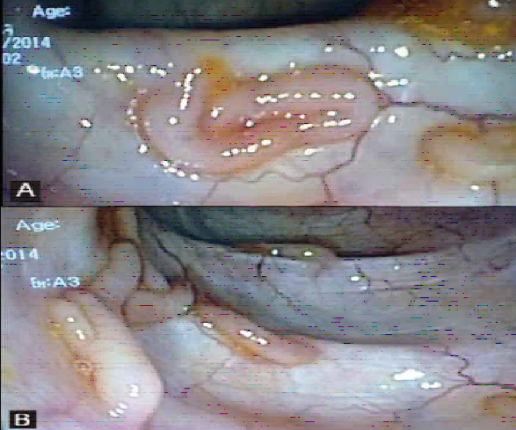

Figures : A straight shape resembling the stalks of headless polyps,
B bridging between adjacent polyps.
In patients with IBD, long-term inflammation of the colonic
mucosa with alternative periods of ulceration and healing are
incriminated in the development of these fingerlike polyps [5].
Although there is a strong association with IBD, there have
been reports on FP occurring in the absence of IBD [4]. There is
currently no physiopathological explanation for FP in patients
without IBD history [1, 5, and 6].
Filiform polyp has been encountered in other bowel inflammatory
conditions such as tuberculosis and even in “histiocytosis
X” [7] and in diverticular disease [8].
Some authors suggest that filiform polyps may be related to a
hamartomatous process including fibrovascular and neuromuscular
hyperplasia or disarray in their case series [1]. The
relationship between filiform polyps and neoplasia remains
unexplained.
Three cases of FP apart from any IBD, associated with adenomas
and intramucoal adénocarcinoma , which were distinct
from filiform polyps had been reported [6]. Despite these
unusual cases, FP can be considered as a benign condition,
without any risk of dysplasia or neoplasia [5].
adenomas and invasive adenocarcinoma developed on
filiform polyps in a patient without a past medical history of
IBD was reported [9]. Our patient showed no adenomatous
component. Given the large polyps intermittently proven to be
adenomas in reported series [5] and this association with
adenocarcinoma [9], periodic follow-up seems to be necessary
and biopsies should be recommended in all cases.
Despite the long clinical and endoscopic remission of ulcerative
colitis that lasted 12 years , our patient was scheduled for
a second look colonoscopy with biopsies of the largest
number of polyps and eventually endoscopic resection of the
adenomatous ones . This could be difficult to achieve given
the large number of polyps and malignancy could not be
excluded.
It was advocated that FP alone is not an indication for surgical
resection; however, complications, such as acute massive
bleeding or intestinal obstruction, may necessitate surgical
intervention [10]. After this reported association with adenocarcinoma
what are the therapeutic amendments to consider
in FP?
References
1. G. Oakley 3rd, W.H. Schraut, R. Peel, A. Krasinskas, Diffuse
filiform polyposes with unique histology mimicking familial
adenomatous polyposis in a patient without inflammatory
bowel disease, Arch. Pathol. Lab. Med. 2007;131:1821–1824.
[PMID:18081442].
2. H.D. Appelman, B.A. Threatt, C. Ernest, S.M. Lindernauer, W.
Blamey, Filiform polyposis of the colon: an unusual sequel of
ulcerative colitis, Am. J. Clin. Pathol. 1974; 21:145–146
[PMID:961678].
3. Bauknecht KJ, Grosse G, Kleinert J, Lachmann A, Niedobitek
F.Filiform polyposis of the colon in chronic inflammatory
bowel disease (so-called giant inflammatory polyps). Z
Gastroenterol 2000;38:845-854. [PMID:11089270].
4. G. Mavrogenis, P. Ngendahayo, P. Kisoka, M.L. Nicholas, E.
Kovács, Y. Hoebeke, P. Warzée, Intestinal obstruction caused
by giant filiform polyposis in a patient with normal colon,
Endoscopy 2013 ;45: E80-1. [PMID:23526530].
5. C.G. Lee, Y.J. Lim, J.S. Choi, J.H. Lee, Filiform polyposis in the
sigmoid colon: a case series, World J. Gastroenterol.
2010;16:2443–2447. [PMID:20480534].
6. F.A. Raila, M. Athar, M.A. Balaa, Colonic filiform polyposis
and a malignant adenomatous polyp, South Med. J.
1989;82:1448–1449. [PMID:2814635].
7. PehWC. Filiform polyposis in tuberculosis of the colon. Clin
Radiol 1988;39:534–6. [PMID:3180673].
8. Kim HS, Lee KY, Kim YW. Filiform polyposis associated with
sigmoid diverticulitis in a patient without inflammatory bowel
disease. J Crohns Colitis 2010;4:671-673 [PMID: 21122579 ].
9. C.Boulagnon , J.F Jazeron, A.Diaz-Cives, F.Ehrhard, O.Bouché,
M.D. Diebold. Filiform polyposis: A benign entity ? Case
report and literature review .Pathology – Research and Practice
2014 ; 210 : 189– 193. [PMID:24315830].
10. Park YB, Cheung DY, Kim JI, Park S-H, Cho S-H, Han J-Y: A
large inflammatory fibroid polyp in the sigmoid colon treated
by endoscopic resection. Inter Med 2007, 46(19):1647-1649.
[PMID:17917327].
email.larbiboutaleb@hotmail.fr

