Periodontal and inflammatory bowel diseases: is there evidence for complex pathogenic interactions?

Carlos Marcelo Figueredo*
Ronaldo Lira-Junior

* Associate Professor Periodontology and Dean of Research, Faculty of Dentistry, Rio de Janeiro State University, Brazil.

Abstract
Periodontal disease and inflammatory bowel disease (IBD) are both chronic inflammatory diseases and their pathogenesis is mediated by a complex interplay between a dysbiotic microbiota and the host immune-inflammatory response, influenced by genetic and environmental factors. This review aimed to provide an overview of the evidence dealing with a possible pathogenic interaction between periodontal disease and inflammatory bowel disease. The prevalence of periodontal disease seems to be increased in patients with IBD when compared to healthy controls, probably due to a changed oral microbiota and a higher inflammatory response. Moreover, the induction of periodontitis seems to result in gut dysbiosis and altered gut epithelial cell barrier function, which might contribute to the IBD pathogenesis. Considering the complexity of periodontal and inflammatory bowel diseases, and the coexistence of both, it is very challenging to comprehend the possible pathways involved in both diseases. In conclusion, this review points out to a complex pathogenic interaction between periodontal and inflammatory bowel diseases, in which one disease might alter the composition of the microbiota and increase the inflammatory response related to the other. However, we still need more data derived from human studies to confirm results from murine models. Thus, mechanistic studies are definitely warranted to clarify this possible bidirectional association.

Biography


My research focuses on the neutrophil activity and cytokines signalling in the pathogenesis of periodontal disease. I work with the autoimmune disease model to understand the influence of chronic disease profile, and consequently their medication, on the cytokine behavior in the periodontium. I have focused on patients with juvenile idiopathic arthritis, systemic lupus erythematosus and inflammatory bowel disease, and their relationship with periodontal disease.

Recent Publications (minimum 5)

Figueredo CM, Martins AP, Lira-Junior R, Menegat JB, Carvalho AT, Fischer RG, Gustafsson A. Activity of inflammatory bowel disease influences the expression of cytokines in gingival tissue. Cytokine. 2017 Feb 8;95:1-6. Epub ahead of print]
Oliveira LS, Lira-Junior R, Figueredo CM, Gomes MB, Fischer RG. Self-Reported Periodontitis and Complications in Type 1 Diabetes Patients: A Brazilian Nationwide Survey. Braz Dent J. 2016 Sep-Oct;27(5):599-603.
LIRA-JUNIOR, RONALDO ; Figueredo, CM . Periodontal and inflammatory bowel diseases: is there evidence for complex pathogenic interactions?. World Journal of Gastroenterology, 2016.
TEIXEIRA, M. K. ; LIRA, R. ; TELLES, D. M. ; LOURENCO, E. J. V. ; Figueredo, CM . Th17-related cytokines in mucositis: is there any difference between peri-implantitis and periodontitis patients?. Clinical Oral Implants Research, 2016.
MENEGAT, JULIANA SANTOS BITTENCOURT ; LIRA-JUNIOR, RONALDO ; SIQUEIRA, MARIANA ALVES ; BRITO, FERNANDA ; CARVALHO, ANA TERESA ; FISCHER, RICARDO GUIMARÃES ; Figueredo, carlos marcelo . Cytokine Expression in Gingival and Intestinal Tissues of Patients with Periodontitis and Inflammatory Bowel Disease: An Exploratory Study. Archives of Oral Biology, v. 66, p. 141-146, 2016.

Image

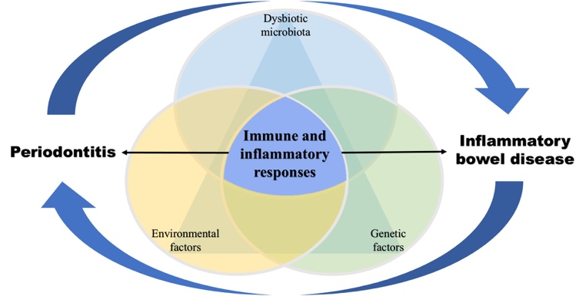

Notes/Comments: Model of pathogenesis of both periodontal disease and inflammatory bowel disease. It involves a complex interplay between the immune-inflammatory response and a dysbiotic microbiota under the influence of genetic and environmental factors, where the diseases might have a cyclic impact on each other

