
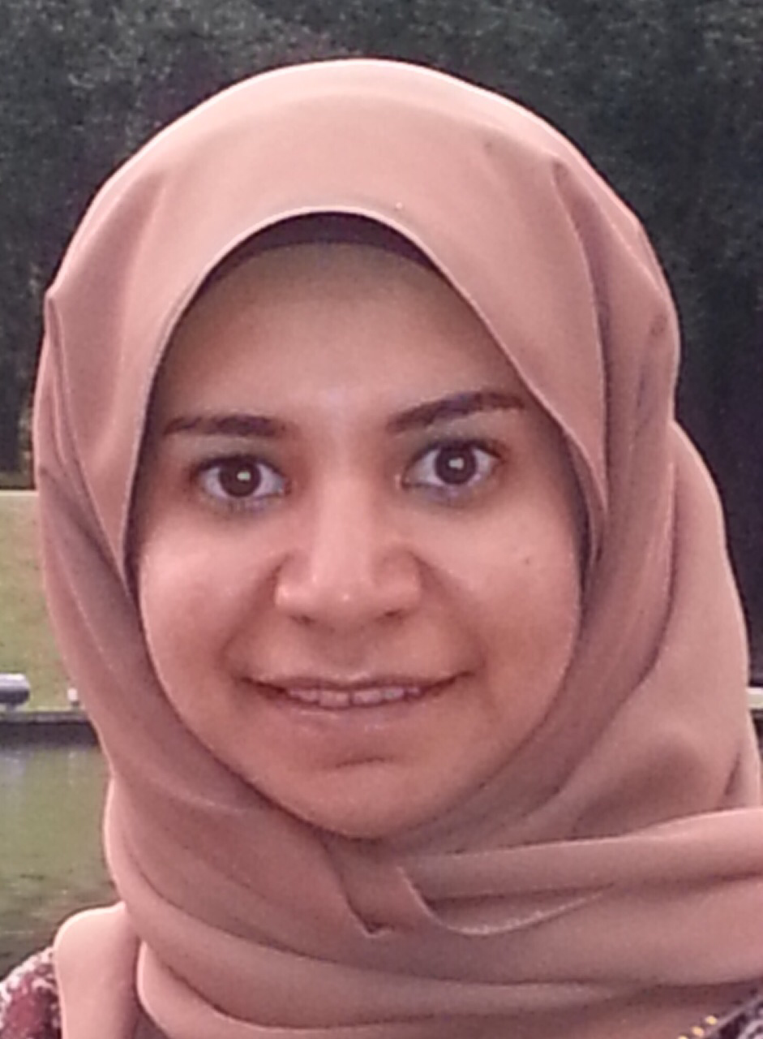

Inflammatory Fibroid Polyps:Intussusceptio Leading Point

Raja Eid,MBBCh,MRCS,CABS

Abstract:
Inflammatory fibroid polyp (historically known as Vanek's tumor) is a rare type of
mesenchymal gastrointestinal neoplasm, identified as localized almost solitary
submucosal polyp. IFPs present throughout the gastrointestinal tract, commonly in
gastric antrum followed by small bowel mainly ileum.
Symptoms depend on location and size of the lesion, usually found incidentally in
asymptomatic patient. However, patients can also present with abdominal pain,
weight loss, and bleeding. Whenever IFPs arise below ligament of Treitz, they might
present with acute abdomen secondary to Intussusception.
Herein, we are reviewing a case of a middle age male presented with sign and
symptoms of intestinal obstruction. Computed tomography scan revealed small bowel
obstruction secondary to ileoileal intussusception, however, the leading point was not
identified radiologically.
Patient underwent exploratory laparotomy in which ileal loop found invaginated into
adjoining intestinal lumen causing small bowel obstruction in addition to multiple
small bowel diverticuli. Reduction of ileoileal intussusception was done and
intraluminal polyp identified as the leading point. Therefore, involved segment was
excised and side-to-side anastomosis was performed. Histopathological examination
confirmed the diagnosis of IFP.
IFPs can be managed when discovered endoscopically (endoscopic submucosal
dissection) but whenever it presents with Intussusception, immediate surgical
exploration will be the best recommended option and should be performed as early as
possible in order to prevent possible complications of ischemia, necrosis, and
subsequent perforation.

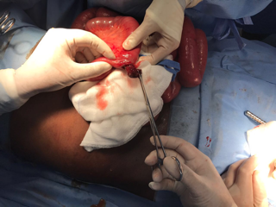
Biography
1.Dr.Raja Eid
MBBS, MRCS, CABS
chief Surgical Resident at Salmaniya Medical Complex(SMC),Kingdom of Bahrain
MBBS with honor -King Faisal university , Kingdom of Saudi Arabia
MRCS – Royal college of England 2012
Arab board of General Surgery 2015

Presenting author details
Full name: Dr.Raja Eid
Contact number: 0097333775529
Email id: dr.raja.eid@gmail.com
Category: (Oral presentation/ Poster presentation/E
Session name: EuroSSicon-Barcelona- May 2019
Research interest: Case Reports and clinical trials

