



Primary umbilical endometriosis: A case report
Author (s) Name: Dr.Tahera Ahmed Fateel, Dr.Hani Ali AlSaati
Salmanyia Medical Complex, Ministry of Health, Kingdom of Bahrain

Primary umbilical endometriosis is a very rare phenomenon accounting for 0,4-1,0% of extragenital endometriosis. Mostly presents as Typical cyclic umbilical discharge, pain and palpable mass is coincidental in very less numbers. The diagnosis is often delayed. In some conditions the nodules started to appear and cause symptoms after a laparoscopic surgery or any intra abdominal Surgery like our case.
We encountered a case which underwent Laparoscopic cholecystectomy for symptomatic gall stones complicated by trocher site hernia which was repaired.
one month after the 2nd surgery patient started to complain of cyclic abdominal pain and umbilical nodules with discharge from her umbilicus.
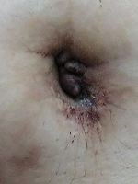
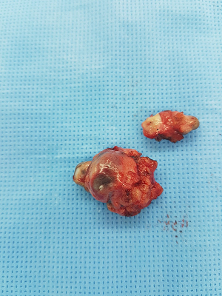
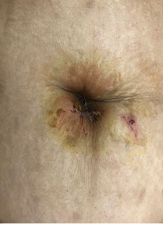
Pre-operative Specimen Post Operative
Biography
1.Dr.Tahera Ahmed Fateel
MD.MBBCH
Senior Surgical Resident at Salmaniya Medical Complex(SMC),Kingdom of Bahrain
University of Cairo –faculty of medicine M.B, B.CH in Dec 2010
Bahrain medical licensure exam November 2012
Arab board of Surgery Part 1 November 2014
2.Dr.Hani Ali AlSaati
MD,MRCS,CABS,AFRCIS,IMGSS-HPB,SurgOnc.
Consultant Surgical Oncology and laparoscopic HPB surgery at Salmaniya Medical Complex(SMC),Kingdom of Bahrain
Consultant Laparoscopic Upper GI and HBP surgery at KIng Hamad University Hospital(KHUH),Kingdom of Bahrain.
Medical degree from Jessenius Faculty of Medicine-Comenius University in Bratislava on June 23rd,1999.
Surgical Oncology Fellowship program at University of Toronto February 2011.
Laparoscopic HPB Fellowship from Southhampton University Hospitals,NHS trust in November 2013.
Published many papers in reputed Journals.

Presenting author details
Full name: Dr.Tahera Ahmed Taher Fateel
Contact number: 0097339924163
Email id: dr.tahera86@gmail.com
Category: (Oral presentation/ Poster presentation)
Session name: EuroSSicon-Barcelona- May 2019
Research interest: Case Reports and clinical trials - Primary Umbilical Endometriosis

