It is a bile!
By Ahmed Fayed¹ and Mona Hassan²
¹ Pulmonary specialist at Mansoura chest hospital, Dakahlia governorate, Egypt.
²Assistant lecturer in oral biology, faculty of density, Mansoura university, Egypt.
Abstract
Bilothorax is a rare reported complication of hepatobiliary tree manipulation and can cause a great threat for life. We reported in this case a benign course of this problem without detection of obvious communication between peritoneal and pleural spaces and without peritonitis.
Keywords
Bilothorax, Percutaneous transhepatic biliary drainage, conservative managment.
Abbreviations
ALT Alanine transaminase ARDS Acute respiratory distress syndrome
AST Aspartate transaminase ºC Celsius CT Computerized tomography
CXR Chest x ray HCO3 Bicarbonate ICT Intercostal tube
INR International normalized ratio K Potassium L Litre mmhg Millimetre mercury
Na Sodium PaCO2 Partial pressure of carbon dioxide in blood
PH Potential hysrogen PTBD Percutaneous transhepatic biliary drainage
SPO2 Partial pressure of oxygen in blood
Introduction
Known also as cholethorax, bilothorax is a rare described or seen cause of pleural effusion (1) in which pleural fluid consists of a bile and is usually occurs after hepatic tumor or abscess rupture or traumatic hepatobiliary laceration (2,3). It can be a very serious cause of morbidity and mortality (4) as bile have a strong corrosive effect and also a good soil for infection that can lead to ARDS with fatal course (2) .
Case description
A 59 y old female with history of metastatic cholangiocarcinoma to liver and lung on 2nd line oral chemotherapy capecitabine (after failure of the 1st line therapy) and non functioning common bile duct stent presented with epigastric pain, vomiting, diarrhoea and shortness of breath with lower back pain. In emergency room patient was in pain and jaundiced with Blood pressure 150/80 mmhg, heart rate 86 beat/minute, SPO2 98% on room air, temperature 37.4 ºC, abdominal examination showed epigastric tenderness and ecchymosis, chest examination was unremarkable, AST 44, ALT 37, Bilirubin 13.5, alkaline phosphatase 560, albumin 2.5, Na. 129, K 3.2, creatinine 0.6, INR 1.2, PH 7.57, PCO2 24, HCO3 22.
After 2 days a percutaneous transhepatic biliary drainage (PTBD) was inserted by interventional radiologist but suspected to be leaked by internal medicine team after that and also patient started to be desaturated at night with SPO2 89% on room air with a right basal heterogeneous opacity and obliteration of costophrenic angle on chest x ray (CXR) figure 1 for which pulmonologist on call consulted and he advised for chest physiotherapy and hypertonic saline nebulization (he may thought of lung collapse) and patient kept on oxygen 5 L by face mask keeping SPO2 at 95%.
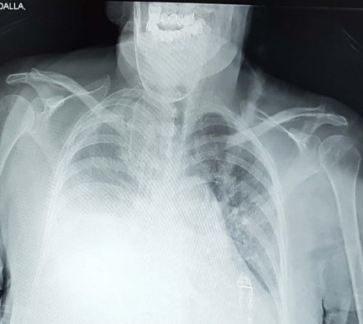

Figure 1: Showing right pleural effusion.

3 days later pulmonologist was consulted for more desaturation of the patient. Later on CXR, requested urgently by pulmonologist, showed massive right pleural effusion figure 2 for which a diagnostic thoracothentesis done which revealed yellow to brownish coloured fluid mostly bilious in nature figure 3 and a representative sample was sent for analysis and later on pleural fluid investigations results as following: brownish turbid sample, WBCs 4500 mm³ with 95% neutrophils, no bacteria with few inflammatory cells in gram stain with no growth on culture and sensitivity, glucose 67 mg/dl , LDH 350 U/L (335 U/L in blood), albumin 1.8 G/dl (2.5 G/dl in blood), protein 3.0 G/dl (4.7 G/dl in blood) and amylase 29 U/L.
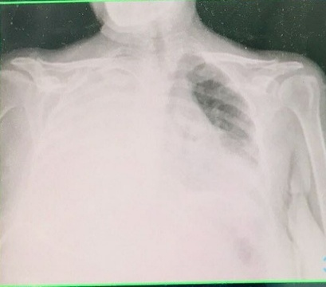
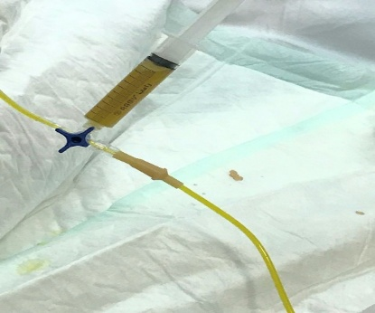

Figure 2: CXR with massive pleural effusion. Figure 3: Fluid colour during thoracocentesis.

Urgent thoracic surgery consultation was done for intercostal tube (ICT) insertion but strangely thoracic surgeon postponed the procedure for the next day waiting for computerized tomography (CT) of the abdomen and chest with contrast requested by oncologist to ensure about leakage from PTBD and commented on low thoracocentesis done by pulmonologist in eight space (he may thought about iatrogenic biliary injury by pulmonologist!). CT chest and abdomen came later and reported by radiologistagainst any leakage figure 4.
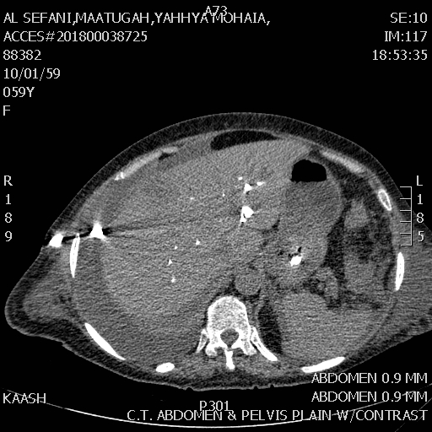
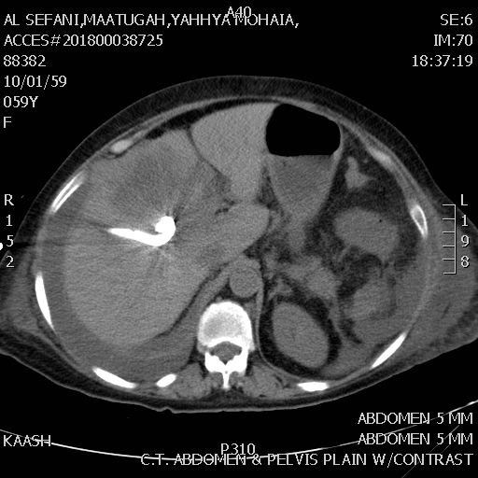
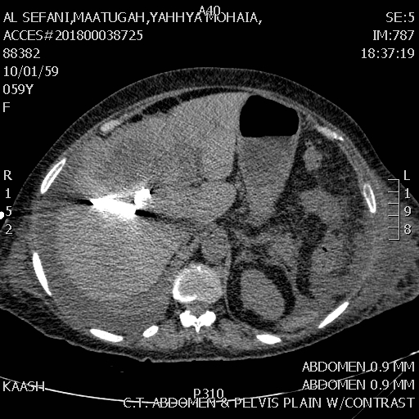
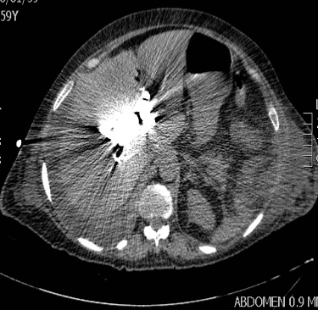
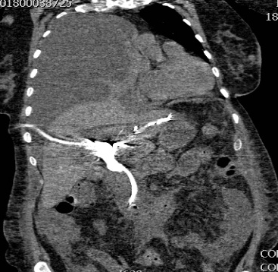
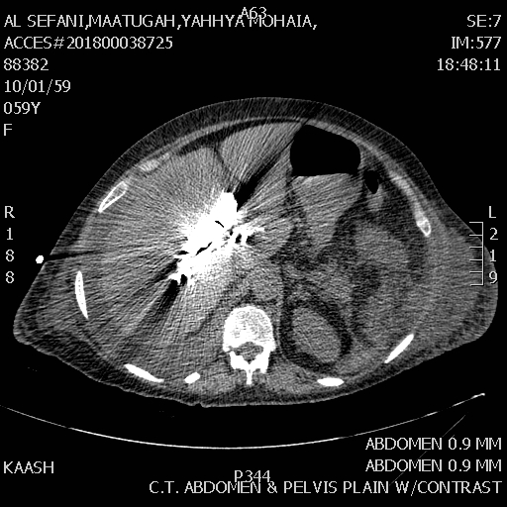
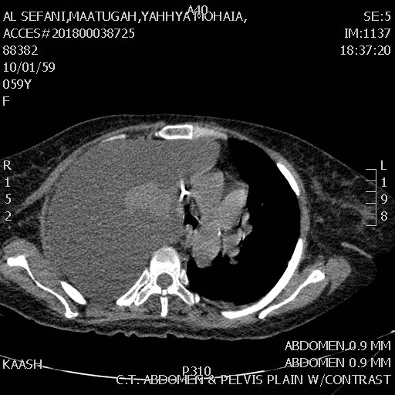
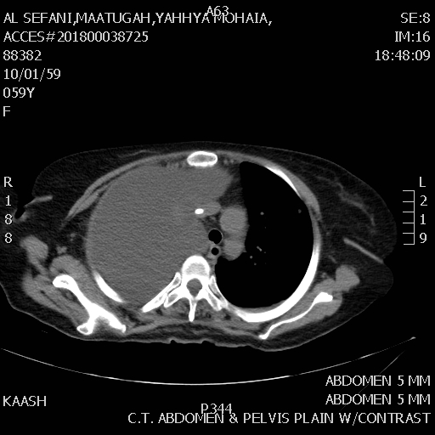
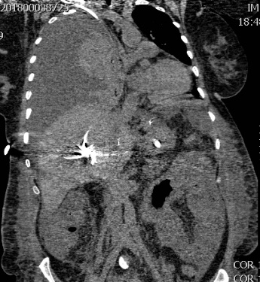
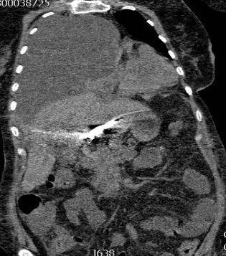
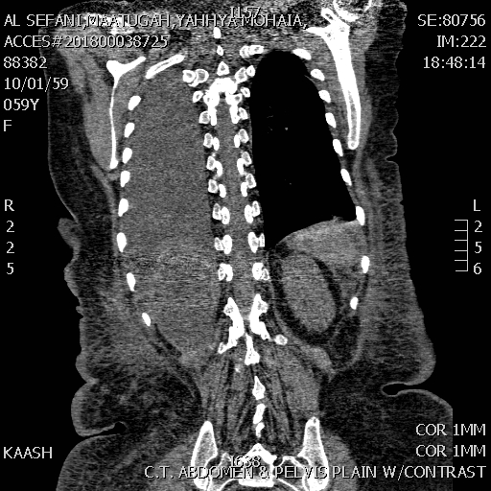
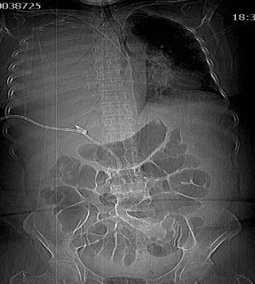
Figure 4:Representative slides from CT abdomen and chest with no leakage from PTBD.

ICT was inserted next day (after discussion with both thoracic surgeon and patient about the hazards of this condition and risk of postponed procedure) and drained through the next 48 hours about 3000 ml yellow brownish fluid figure 5.
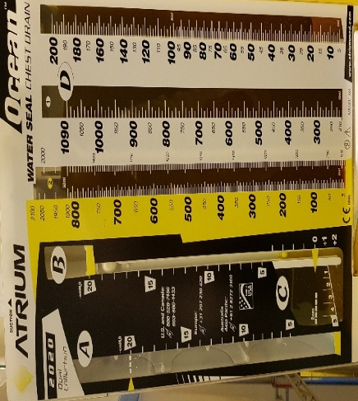
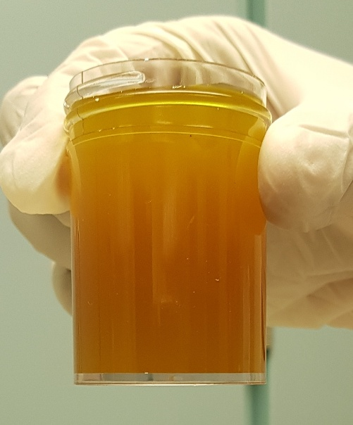

A B Figure 5 A,B: Fluid drained by ICT.
Later on ICT was removed after being sure about the functioning of abdominal drain with CXR post removal of ICT showed fully expanded lung figure 6 and oxygen saturation is 93% on room air. Patient then referred for her original facility to continue her management.
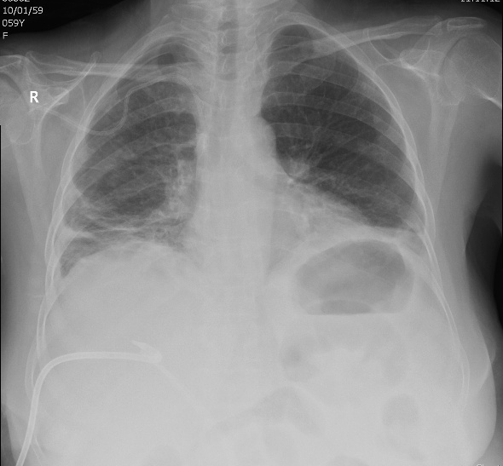

Figure 6: CXR after removal of ICT before discharge.

Discussion
Large volumes of intra-abdominal air, ascitic fluid or blood are capable of directly traversing the diaphragm through a congenital, traumatic, or erosive defects to enter the pleural space (5,6,7). Also indirect routes as tissue sheaths of the oesophagus and great vessels (8), via the lymphatics or transfer through gaps in the muscle fibres and bundles of the diaphragm were suggested (9,10).
Because of the anatomical position of the liver directly under right hemidiaphragm, the right-sided bilothorax is the most frequently reported although left-sided bilothorax has been reported also (11). Spontaneous bilio‑pleural fistula can occur in patients with gall stones (12). Also bile can reach directly bronchial tree very rarely by a broncho‑biliary fistula and results in bilioptysis (13).
As the role that emphasise “fluid will follow the path of least resistance” the bilothoracic fistula only develops when intra-abdominal accumulation of bile is inadequately drained and no direct bilio‑pleural fistula and when the biliary system was adequately drained by an intra-abdominal tube, bile leakage into the pleural cavity ceased and the chest tube could be removed without recurrence of biltohorax (14) and this is exactly what happened in our case.
Most cases of pleurobiliary fistula have been reported after hepatic abscess formation or biliary tract obstruction (15) and in some rare cases result from abdominal trauma (16) specially iatrogenic after percutaneous transhepatic biliary drainage (17).
Percutaneous transhepatic biliary drainage (PTBD) commonly used for obstructive jaundice and cholecystitis with a reported 0.5% of cases complicated by pleural effusion (17). Although lung injury can be easily avoided during PTBD with the use of ultrasonography or CT together with estimation of the extent of the pleural space prior to the procedure (18), the PTBD catheter my be mis-inserted through the pleural space as the liver is anatomically surrounded by the thoracic cavity (19,20). Also bile leakage along the drain has been reported after PTBD as a late complication in 18.8%–21.7% of patients (21).
Bile is a strong inflammatory stimulus due to both a direct corrosive effect on the pleural layers and also a very good soil for bacterial infection with empyema formation causing a therapeutic challenge for the clinicians (22,23). Moreover bile is a fibrogenic agent that can cause fibrothorax for this any delay in drainage of pleural fluid can rapidly give rise to a permanent compromised lung function and also acute respiratory distress syndrome (ARDS) is a rare but fatal complication that can be result from this condition (2).
There is no much experience in treatment of bilothorax (24) but early drainage of the bilious pleural fluid either by intercostal tube or pig‑tail catheter is the standard recommendation for the management (2,25) and if associated with infection, should be treated as same as pleural empyema (26). For bilio‑pleural fistula, usually the fistulous tract heals spontaneously without any surgical intervention (25,16).

Conclusion
Although not a common problem and benign course of our case without peritonitis or residual morbidity till discharge, cholethorax should be suspected in any patient with respiratory manifestation with history of hepatobiliary manipulation or problem because of its fatal complications and morbidity. The course of this condition depend on the early diagnosis and careful care. Radiologist should take all measures to prevent lung injury or false insertion of catcher during PTBD due to intimate anatomical relation of the lung to liver.
Biblography
1 Basu S, Bhadani S, Shukla VK. A dangerous pleural effusion. Ann R Coll Surg Engl 2010;92:W53‑4.
2 Aydogan A, Sukru Erden E, Akkucuk S, Davran R, Yetim I, Veli Ozkan O. Cholethorax (bilious Effusion in the Thorax): An unusual complication of laparoscopic cholecystectomy. Arch Iran Med 2013;16:489‑90.
3 Hamers LA, Bosscha K, van Leuken MH, Moviat MA, de Jager CP. Bilothorax: A bitter complication of liver surgery. Case Rep Surg 2013;2013:372827.
4 MRJ Jenkinson, W Campbell, MA Taylor. Bilothorax as a rare sign of intra-abdominal bile leak in a patient without peritonitis. Ann R Coll Surg Engl 2013; 95:96.
5 Meigs J V, Cass J W. Fibroma of the ovary with ascites and hydro-thorax: with a report of 7 cases. AmJ Obstet Gynec 1973; 33 :249.
6 Pratt JH, Shamblin WR. Spontaneous haemothorax as a direct complication of haemoperitoneum. Ann Surg 1968; 167: 867-71.
7 Banyai AL, Jurgens GH. Accidental pneumothorax during pneumoperitoneum treatment. Am Rev Tuberculosis 1940; 42: 688.
8 P. H. Rowe, “Bilothorax–an unusual problem,” Journal of the Royal Society of Medicine, vol. 82, no. 11, pp. 687–688, 1989.
9 Lang AE. Haemothorax in relation to benign pelvic tumours. Calif Med 1948; 68: 338.
10 Kaya s, Hasanoglu C, Demirbas B, Aydin R. An unusual complication of the surgery of pyloric stenosis: bilothorax. Chest 2006; 130: 302s–303s.
11 E.E. Vink, A. Kröner, P.E. Spronk. A secondary left-sided bilothorax after a car accident. NETH J CRIT CARE - VOLUME 24 - NO 2 - MARCH 2016.
12 Cunningham LW, Grobman M, Paz HL, Hanlon CA, Promisloff RA. Cholecystopleural fistula with cholelithiasis presenting as a right sided pleural effusion. Chest 1990;97:751‑2.
13 Fröbe M, Kullmann F, Schölmerich J, Böhme T, Müller‑Ladner U. Bronchobiliary fistula associated with combined abscess of lung and liver. Med Klin (Munich) 2004;99:391‑5.
14 L. A. C. Hamers, K. Bosscha, M. H.vanLeuken, M.A.M.Movia and C.P.C.deJager .Bilothorax: A Bitter Complication of Liver Surgery. Case Reports in Surgery Volume 2013.
15 Oparah SS, Mandai AK. Traumatic thoracobiliary (pleurobiliary and bronchobiliary) stulas: clinical and review study. J Trauma 1978;18:539–44.
16 Sheik-Gafoor MH, Singh B, Moodley J. Traumatic thoracobiliary stula: report of a case successfully managed conservatively, with an overview of current diagnostic and therapeutic options. J Trauma 1998;45:819–21.
17 Tsuyuguchi T, Takada T, Kawarada Y, et al. Techniques of biliary drainage for acute cholangitis: Tokyo Guidelines. J Hepatobiliary Pancreat Surg 2007; 14: 35–45.
18 Atsushi Sano and Takuma Yotsumoto. Bilothorax as a complication of percutaneous transhepatic biliary drainage .Asian Cardiovascular & Thoracic Annals 2016 24(1) 101–103.
19 Gothlin J and Tranberg K. Complications of percutaneous transhepatic cholangiography (PTC). Am J Roentgenol Radium Ther Nucl Med 1973; 117: 426–431.
20 Suehiro M, Ishimura J and Fukuchi M. Detection of bile leakage into the thoracic cavity by hepatobiliary scintigraphy. Ann Nucl Med 1991; 5: 167–169.
21 Garcarek J, Kurcz J, Guzinski M, Janczak D and Sasiadek M. Ten years single center experience in percutaneous transhepatic decompression of biliary tree in patients with malignant obstructive jaundice. Adv Clin Exp Med 2012; 21: 621–632.
22 D. de Luca, A. Minucci, E. Zecca et al., “Bile acids cause secretory phospholipase A2 activity enhancement, revertible by exogenous surfactant administration,” Intensive Care Medicine, vol.35,no.2,pp.321–326,200.
23 Lee MT, Hsi SC, Hu P, Liu KY. Biliopleural fistula: A rare complication of percutaneous transhepatic gallbladder drainage. World J Gastroenterol 2007;13:3268‑70.
24 Cooper AZ, Gupta A, Odom SR. Conservative management of a bilothorax resulting from blunt hepatic trauma. Ann Surg 2012; 93: 2043‑4.
25Singh B, Moodley J, Sheik‑Gafoor MH, Dhooma N, Reddi A. Conservative management of thoracobiliary fistula. Ann Thorac Surg 2002;73:1088‑91.
26 Davies HE, Davies RJ and Davies CW. BTS Pleural Disease Guideline Group. Management of pleural infection in adults: British Thoracic Society Pleural Disease Guideline 2010. Thorax 2010; 65(Suppl 2): ii41–53.

