Complications of A Fenestrated Endovascular Aortic Aneurysm Repair (EVAR): A Case Study And First experience of National Institute of Cardiovascular Diseases Hospital, Dhaka

M. Islam 1, N.C. Mandal 1, A.H.M. Bashar 1, A. Hoque 2, M.M. Rahman 1, S.K. Ghosh 1.
1Department of Vascular Surgery, National Institute of Cardiovascular Diseases Hospital (NICVD), Dhaka, Bangladesh - Dhaka (Bangladesh), 2Department of Cardiac Surgery, National Institute of Cardiovascular Diseases Hospital (NICVD), Dhaka, Bangladesh. - Dhaka (Bangladesh).
AUTHOR(S)
M. Islam1 , N.C. Mandal1 , A.H.M. Bashar1 , A. Hoque2 , M.M. Rahman1, S.K. Ghosh1
1Department of Vascular Surgery, National Institute of Cardiovascular Diseases Hospital (NICVD), Dhaka, Bangladesh.
2Department of Cardiac Surgery, National Institute of Cardiovascular Diseases Hospital (NICVD), Dhaka, Bangladesh.
BACKGROUND:
Endovascular aneurysm repair (EVAR) has revolutionized the therapeutic strategy for abdominal aortic aneurysm (AAA). However, hostile proximal neck and tortousity of access remain a challenge in selecting optimal stent grafts in AAA. Although EVAR is obviously less invasive then open surgical procedure, it is not free of complications. This can potentially result in severe morbidity and mortality.
CASE REPORT:
A 54 year old man complained of intermittent abdominal pain with a pulsatile mass for the last 7 months. Contrast computed tomography angiogram demonstrated mid aneurysmal dilatation of descending thoracic aorta & a fusiform aneurysmal dilatation in mid & lower AA. ( Length of aneurysm 89 mm, diameter- 66 mm, true lumen without thrombus-37 mm, thrombus -27 mm) & critical angulation and tortousity in aorto-iliac access (Fig:1). Approach- Bifemoral (Cutdown) & Bibrachial(percutenuous). Diagnostic angiography revealed normal epicardial coronaries with Para-renal AA.Per table fenestrations were made. Endurant P-II (Medtronic, USA) 36mmX16mmX166mm(20F),endograft was used. On table ring supported fenestrations done ( Two renals, one for SMA).A 20F Sheath was negotiated through Rt CFA and endograft was deployed over The Amplatz Ultra Stiff guide wire (Boston Scientific inc.) (.035 inchx180cm).Rt renal covered stent could not be deployed because it lost its access. Later left renal stent (8x37 mm, Life stream, BARD Inc.) tried in lt renal artery but before full deployment, it dittached and migrated 5 cm distally in lt renal artery(Fig:2). Then it was repositioned with coronary snare. SMA covered stent was deployed (7x27mm).Lt iliac (16x156mm)extension was deployed via rt iliac limb wheather Rt iliac extension (16x82mm) was also deployed via rt iliac limb resulting rt iliac extension compressed by inflation of lt iliac extension. No pulse found in Rt CFA & Lt iliac limb of endograft remained open within AAA sac(Fig:3). So patient underwent urgent revascularization with 7 mm PTFE ring graft (Zotec) on the same day. As Vascular Plug was unavailable that time in our country, it was brought from Delhi, India, 2000 Km from Dhaka on the next day. 3rd day morning,lt iliac extension was concealed by Aplatzer Vascular Plug 2 (18mm, St Judes Medical Inc.) with no leaking. Whole procedure was eventful & dramatic,though there was no morbidity & mortality afyer procedure except slight rise in S.Creatinine level for few days. Patient was discharged on 7th POD with a happy smile and was advised for routine follow-up.
CONCLUSION:
Complications related with fenestrated endograft (EVAR) should be always in mind. Though it is the first EVAR experience in our centre, there are pitfalls those can puzzle you and through you an unlikely challenge anytime!
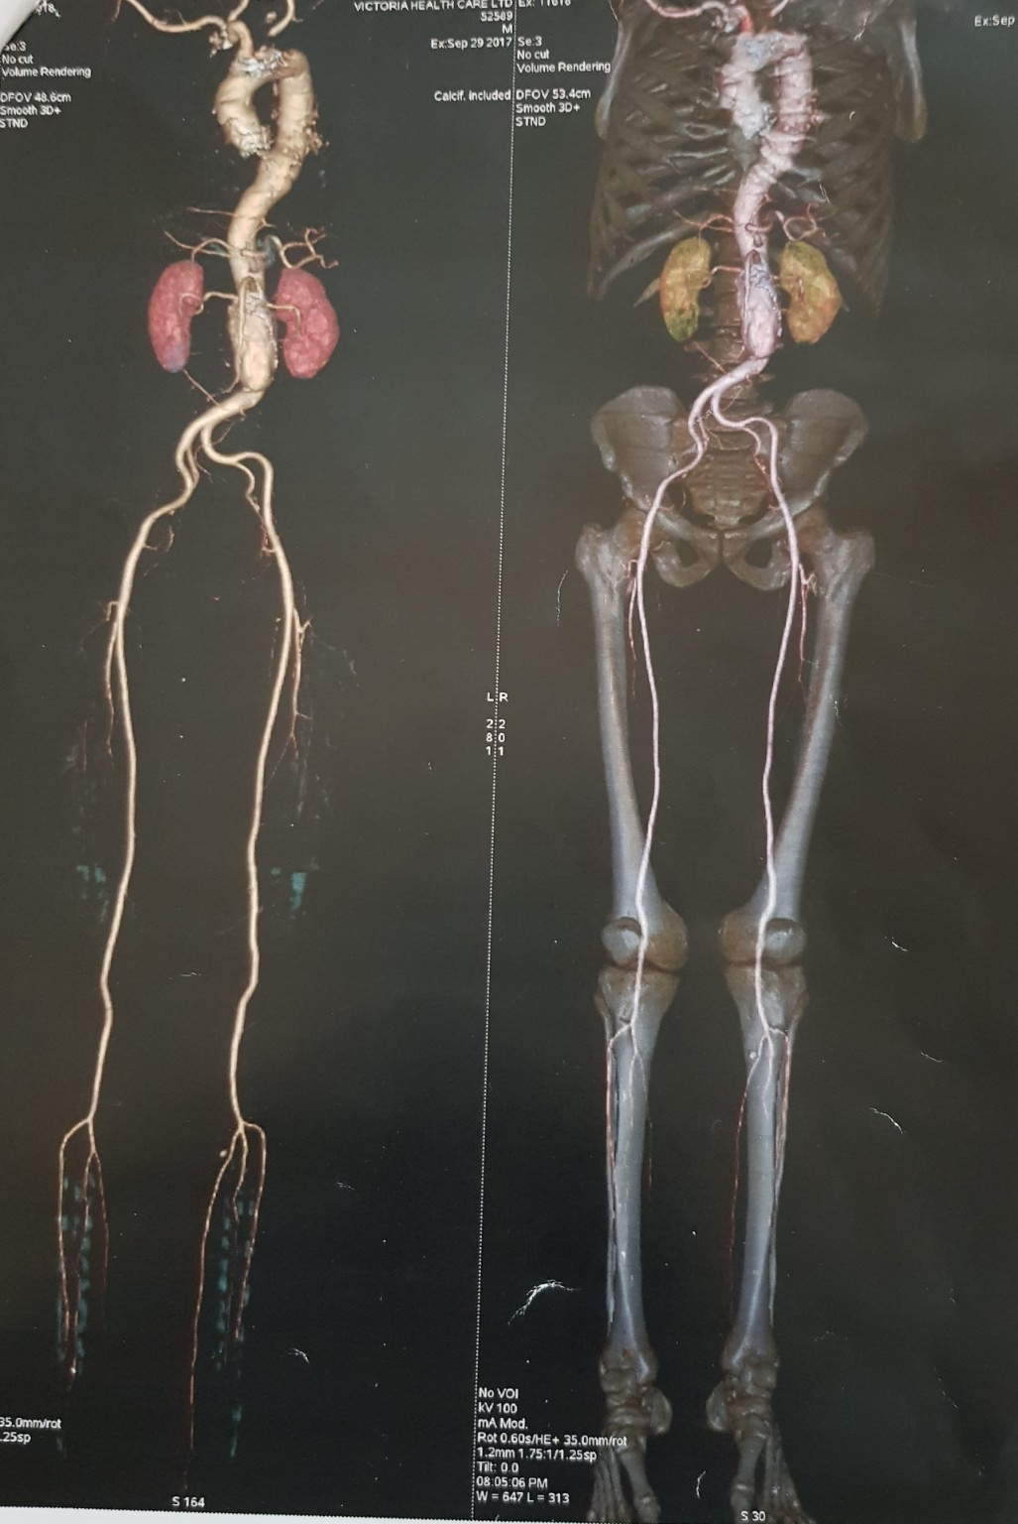(Fig-1): CT angiography revealed fusiform aneurysmal dilatation of mid AA & lower AA
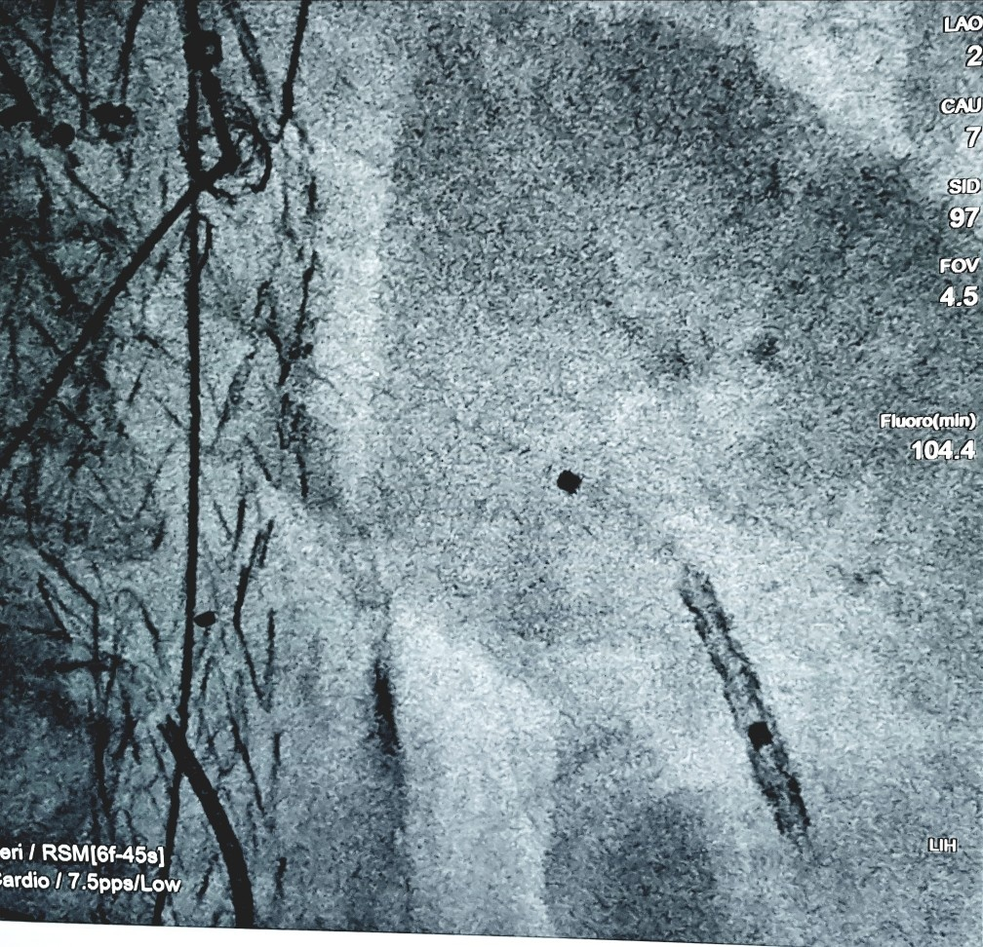(Fig:2): Distal displacement of lt renal stent within lt renal A.
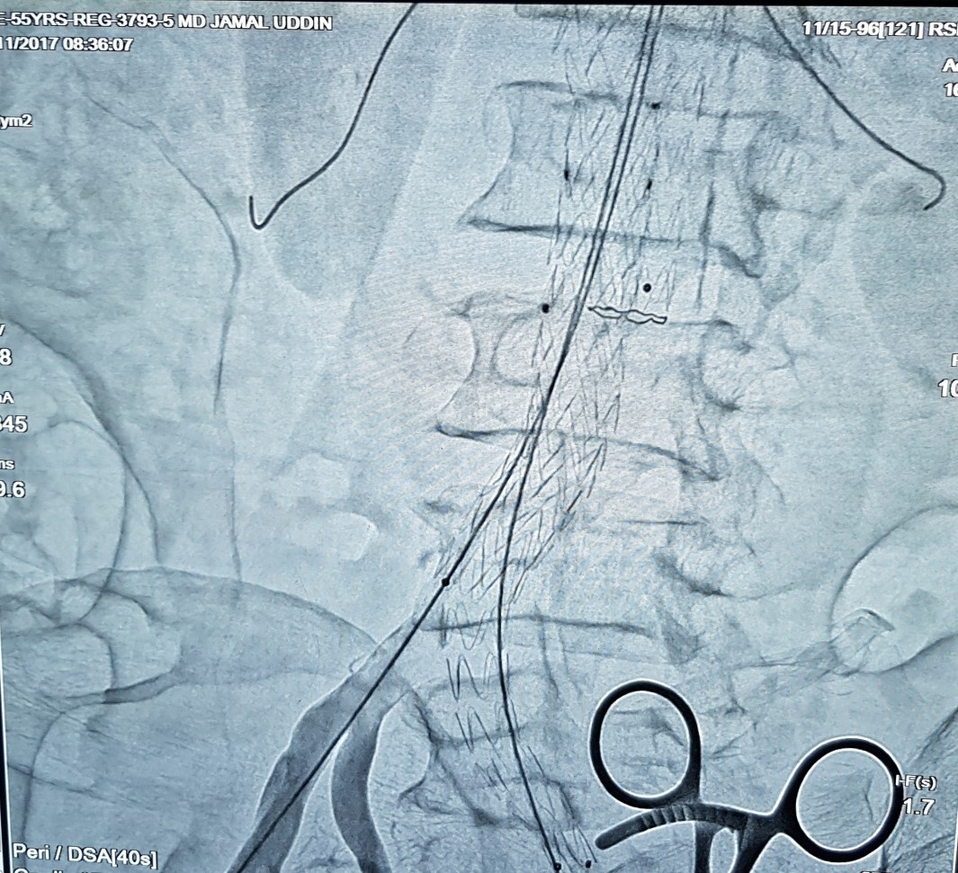(Fig:3): Lt iliac limb of endograft remained opened after deploymeyment of both iliac extension
REFERENCES:
1
B.M. Stanley, J.B. Semmens, M.M. Lawrence-Brown, M.A. Goodman, D.E. HartleyFenestration in endovascular grafts for aortic aneurysm repair: new horizons for preserving blood flow in branch vessels
J Endovasc Ther, 8 (1) (2001), pp. 16-24
CrossRefView Record in Scopus
2
T.F. Browne, D. Hartley, S. Purchas, M. Rosenberg, G.Van Schie, M. Lawrence-BrownA fenestrated covered suprarenal aortic stent
Eur J Vasc Endovasc Surg, 18 (5) (1999), pp. 445-449
ArticlePDF (1MB)View Record in Scopus
3
E.L.G. Veroeven, T.R. Prins, I.F.J. Tielliu, J.J.A.M. van den Dungen, C.J.A.M. Zeebregts, R.G. Hulsebos, et al.Treatment of short-necked infrarenal aortic aneurysms with fenestrated stent-grafts: short term results
Eur J Vasc Endovasc Surg, 27 (2004), pp. 477-483
4
J.L. Anderson, M. Berce, D.E. HartleyEndoluminal aortic grafting with renal and superior mesenteric artery incorporation by graft fenestration
J Endovasc Ther, 8 (1) (2001), pp. 3-15
CrossRefView Record in Scopus
5
R.K. Greenberg, S. Haulon, S. Lyden, K. OurielPrimary endovascular repair of juxtarenal aneurysms with fenestrated endovascular grafting
Eur J Vasc Endovasc Surg, 27 (2004), pp. 484-491
ArticlePDF (2MB)View Record in Scopus
6
B.M. StanleyFenestrated endoluminal grafting: early experience
Aust N Z J Surg, 74 (2004), pp. A145-A154
7
F. Haddad, R.K. Greenberg, E. Walker, S. O'Neill, G.Kolin, S.P. Lyden, et al.Fenestrated endovascular grafting: the renal side of the story
J Vasc Surg, 41 (2) (2005), pp. 181-190
ArticlePDF (603KB)View Record in Scopus
8
B.M. Stanley, J.B. Semmens, Q. Mai, M.A. Goodman, D.E. Hartley, C. Wilkinson, et al.Evaluation of patient selection guidelines for endoluminal AAA repair with the Zenith stent-graft: the Australasian experience
J Endovasc Ther, 8 (5) (2001), pp. 457-464
CrossRefView Record in Scopus
9
R.K. Greenberg, S. Haulon, S.P. Lyden, S.D. Srivastava, A. Turc, M.J. Eagleton, et al.Endovascular management of juxtarenal aneurysm with fenestrated endovascular stenting
J Vasc Surg, 39 (2004), pp. 279-287
ArticlePDF (405KB)

