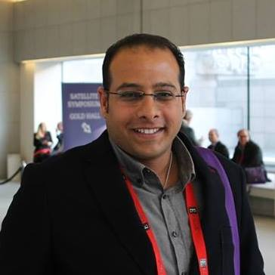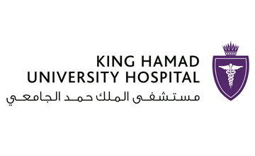
Title: SYSTEMIC VASCULAR RESISTANCE GUIDED VASOPRESSOR DOSE TITRATION IN A CASE OF PROFOUND METFORMIN TOXICITY

Author (s) Name: Mohamed Shirazy¹*, Karim Hakim¹, Anis Chaari¹, Kamel Bousselmi¹, Vipin Katus¹, Dhafir Alkhudairi¹, Muneera Jasim¹, Alaa Abdulaziz², and Shaikha Aljawder³
¹Department of Critical Care Medicine; King Hamad University Hospital in Kingdom of Bahrain, Bahrain
²Clinical Pharmacy Unit; King Hamad University Hospital in Kingdom of Bahrain, Bahrain
³Departement of Emergency Medicine; King Hamad University Hospital in Kingdom of Bahrain, Bahrain

Metformin-associated lactic acidosis (MALA) is the most serious and life threatening adverse effect of Metformine. It’s presentations vary from nausea, vomiting, abdominal pain, and cardiac arrhythmias up to vasodilator shock which is characterised decreased systemic vascular resistance (SVR). Vasopressors as Nor-epinephrine and Epinephrine are used to treat the vasodilator shock via increasing the SVR. SVR is measured using the formula {80*(Mean Arterial Pressure-Central Venous Pressure)/Cardiac Output}. In clinical practice, Transthoracic echocardiography (TTE) is a non-invasive and accurate modality for measuring the cardiac output (CO). A 57-year-old male patient was admitted to the ICU with the diagnosis of vasodilator shock induced by MALA. He had history of heavy alcohol consumption, type II Diabetes Mellitus on metformin, and hypertension on amlodipine. Serial measurments of SVR were obtained aided by the TTE and vasopressors doses were titrated accordingly. High doses of Nor-epinephrine and Epinephrine up to 4 mcg/kg/min, and 4 mcg/min respectively were reached. In addition to the standard supportive medical treatment, ninty hours of continuous renal replacement therapy (CRRT) were provided to improve all of the lactic acidosis, renal impairment, and hyperkalemia. By the tenth day of the patient’s ICU stay both vasopressors were weaned off and the patient was discharged to ward by the fifteenth day.

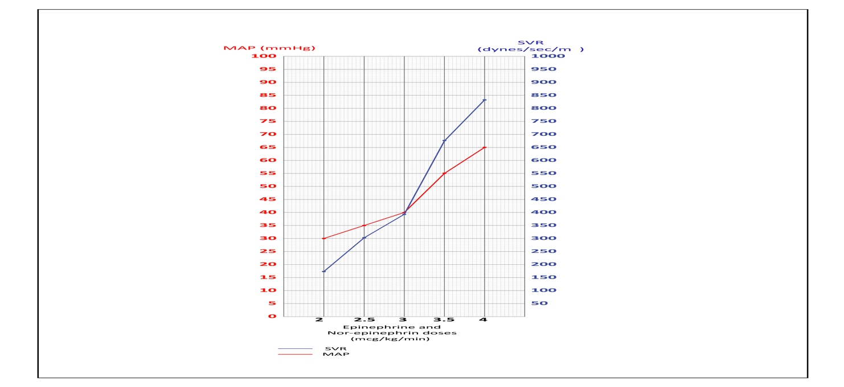
Figure 1: The relationship between the Epinephrine and Nor-epinephrine doses and the SVR measured by the ECHO

Biography

Mohamed Shirazy has completed his Master degree in Critical Care Medicine from Alexandria University. He then completed the Euorpean Diploma of Intensive Care Medicine (EDIC), and the Membership of the Royal Collage of Emergency Medicine (MRCEM). He is currently a Senior registrar of Critical Care Medicine in King Hamad University Hospital, Bahrain and Honorary lecturer in the Royal college of surgeons of Ireland (RCSI), Bahrain.
Presenting author details
Full name: Mohamed Salah Abdelkarim Shirazy
Contact number: +97333154887
Email id:Mohamed_shirazy@yahoo.com
Category: (Oral presentation/ Poster presentation)
Session name: Systemic Vascular Resistance Guided Vasopressor Dose Titration In A Case Of Profound Metformin Toxicity
Research interest: Critical Care Medicine

