Abstract Template

Percutaneous Intervention of CTO Iliac and SF arteries after failure of bypass, using radial and pedal arterial accesses
Iyad K. Azzam, MD, FACC, FSCAI

1 Kearney Regional Medical Center

66-year-old male with PVD presents with severe leg pain and numbness on exertion and at rest. In 2009, he underwent unsuccessful attempt at intervention of R. SFA. In 2010, he underwent right Fem-Pop and right to left fem-fem bypass. In 2011, he underwent bilateral aortobiprofunda bypass.

Arterial duplex shows occluded fem-fem graft, bilateral SFA with reconstituted flow in the peroneal and ATA. Abdominal CTA and run-off was performed: CTO iliac, CF and SF arteries. He was brought to the cath lab for percutaneous intervention of the right leg.

Under ultrasound guidance, right ATA access was obtained, 4 F sheath was placed. A right radial access was obtained and a 7F 90cm sheath was advanced into the distal aorta. Angiography revealed patent aorta-profunda femoris grafts. Severe bilateral CIA stenosis. Occluded EIA and SFA bilaterally with reconstitution at the popliteal arteries.

Intervention of the R. SFA was guided with injections through a long multipurpose from the radial access. 0.035’’ Navicross was advanced over a Glide Advantage retrogradely to cross the distal cap of the CTO SFA. However, it would not cross the proximal cap and was exchanged for a Gaia 3rd wire. This made some progress but did not cross into the true lumen of the EIA. We used 0.035’’ Trailblazer and different wires, we were able to cross into the true lumen.

Multiple balloons were inflated across the iliac system. 8.0 x 59mm Omnilink and 8.0 x 80mm Absolute Pro stents were deployed in the Right CIA and EIA.

Tibial sheath upgraded for 5/6F to stent the SFP/POP. 6.0 x 150mm and 6.5 x 60mm Self expanding stents were deployed in the distal SFA/POP artery.

Final angiography: 10% residual stenosis and three vessel runoff to the right foot.

Keywords: Radial-pedal access, CTO Iliac A, CTO SFA

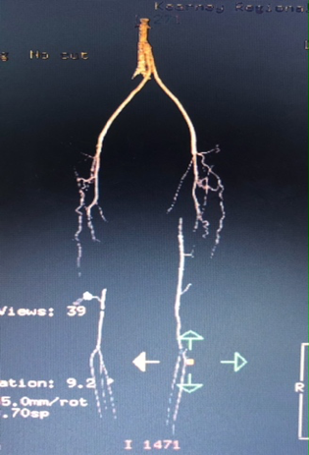

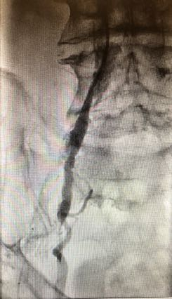
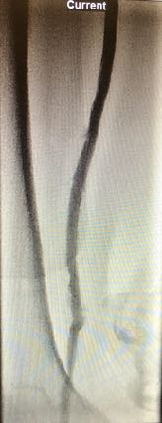
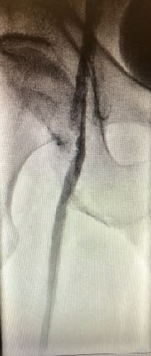
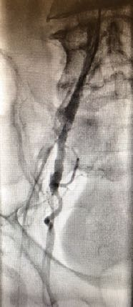
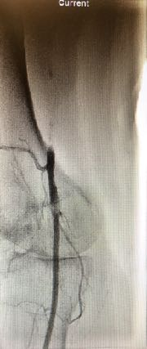

Professional Biography (100-150 words)

Dr. Azzam did his general cardiology training at Rutgers Medical School, Robert Wood Johnson University Hospital, New Brunswick, NJ, and his Interventional Cardiovascular training at Miller School of Medicine, Jackson Memorial and the University of Miami Hospitals, Miller School of Medicine, Miami, FL, USA. Currently, Dr. Azzam is the Medical Director, Interventional Cardiology, Kearney Regional Medical Center and Platte Valley Medical Group, Kearney, NE, USA.
Publications include:
- Brain natriuretic peptide and biomarkers of myocardial ischemia increased after defibrillation threshold testing. Pacing and clinical electrophysiology. 2011 Nov; 35(3):314-9
- Severe hemolytic anemia and acute kidney injury after percutaneous continuous-flow ventricular assistance (Impella). Circulation heart failure. 2011 Nov; 4(6):e20-2

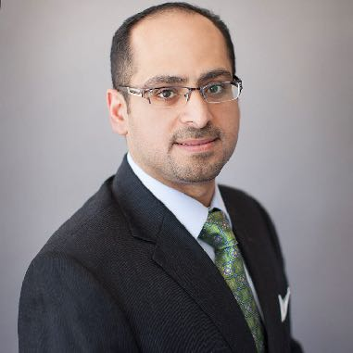

Email Id: iyadazzam@hotmail.com

