Abstract Template
Complex PCI and atherectomy of LM/LAD/LCX with Impella CP Support in the setting of Cardiogenic Shock
Iyad K. Azzam, MD, FACC, FSCAI

1 Kearney Regional Medical Center

85-year old female with increasing shortness of breath and chest tightness.
PMHx: chronic renal insufficiency, diabetes, hypertension, hypothyroidism, severe COPD and history of CVA. Echo: LVEF 25-30%, mild MR, moderate-severe TR, elevated RVSP and grade 3 diastolic dysfunction. Diagnostic coronary angiography: LM: 80% with heavy calcifications, LAD: heavily calcified 99% stenosis at the bifurcation of the diagonal which is subtotaled, Cx 100% occluded, RCA 60-70%, and LVEDP was 29-31. Surgical consult was requested, STS score > 9%.
Patient had severe acute hypoxemic respiratory failure, flash pulmonary edema and cardiogenic shock. She was intubated and was taken to the lab for high risk PCI. Temporary pacer was inserted, 7F 45cm destination sheath was placed in the right CFA, 14F sheath was placed in left CFA. Impella was used for hemodynamic support. 7F JL4 guiding catheter with side holes was used, long pilot 50 was advanced down the LAD, a short pilot 50 in the subtotaled diagonal. Simultaneous kissing angioplasty was performed on LAD/diag. Then we exchanged LAD wire out for a Rota floppy wire using Finecross catheter. Rotational atherectomy of the LM and LAD was performed. LAD was stented 3.0x38mm DES, LM/LAD with a 4.0x23mm DES. There was no flow in diagonal or distal LAD. We recrossed into the diagonal with a pilot 50 and performed PTCA restoring flow. Distal LAD was crossed with Finecross and Fielder, a 2.25x18 DES was deployed in the distal LAD restoring flow. 100% Cx was crossed with a pilot 200 supported with Finecross. 3.25x18 DES was placed in the LCX. SKB was then performed across the LM/LAD and LM/LCX. IVUS revealed full apposition and expansion of the stents.
A few days later she was discharged. Echo on discharge: LVEF 45%.

Keywords: cardiogenic shock, high risk complex PCI, bifurcation disease, Impella, Left main, multivessel CAD, Rotablator.

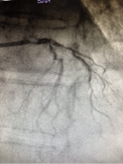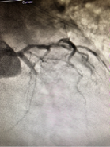

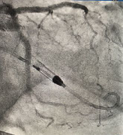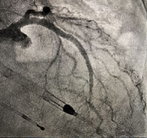

Professional Biography (100-150 words)
Dr. Azzam did his general cardiology training at Rutgers Medical School, Robert Wood Johnson University Hospital, New Brunswick, NJ, and his Interventional Cardiovascular training at Miller School of Medicine, Jackson Memorial and the University of Miami Hospitals, Miller School of Medicine, Miami, FL, USA.
Currently, Dr. Azzam is the Medical Director, Interventional Cardiology, Kearney Regional Medical Center and Platte Valley Medical Group, Kearney, NE, USA.
Publications include:
- Brain natriuretic peptide and biomarkers of myocardial ischemia increased after defibrillation threshold testing. Pacing and clinical electrophysiology. 2011 Nov; 35(3):314-9
- Severe hemolytic anemia and acute kidney injury after percutaneous continuous-flow ventricular assistance (Impella). Circulation heart failure. 2011 Nov; 4(6):e20-2

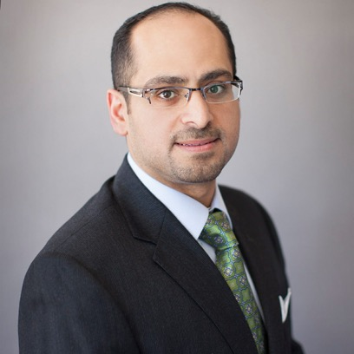

Email Id: iyadazzam@hotmail.com

