Abstract Template
PCI of CTO RCA via Apical LAD Collaterals
Iyad K. Azzam, MD, FACC, FSCAI

1 Kearney Regional Medical Center, Kearney, NE, USA

67-year-old man with recurrent episodes of chest pain, SOB, and exercise intolerance. PMHx: severe CAD, s/p CABG 1992, PCI of RCA 1999, severe ischemic cardiomyopathy, LVEF 30%, BIV ICD, HTN, dyslipidemia, severe PVD and tobacco abuse. Coronary angiography 2007: 60% pLAD, atretic LIMA-LAD, totaled RCA, 70% OM.
Angiography now: totaled RCA, and severe pLAD. LVEDP 23 mmHg.
6/7 slender sheath in the R radial artery, 7F EBU 3.75 short guide engaged LM.
6F sheath in the right CF vein for central access.
14F long sheath in the right CFA.
7F 45cm destination sheath in the left CFA after angioplasty of left CIA. A 7F JR4 short guide engaged RCA. Impella was placed.
Pilot 50 in LAD. IVUS-guided PCI using a 3.5x23 mm DES post dilated to 4.0 mm.
Then advanced Pilot 50 and corsair catheter into the dLAD and retrogradely into the right PDA. We were able to cross the distal cap of CTO-RCA but not the proximal. We exchanged the wire out for Sion. We were able to advance it in JR4 guide. Corsair would not cross the proximal cap. We attempted PCI anterogradely at this juncture then tried to snare the wire in the aorta, but this did not work. Therefore we trapped Sion wire in the guiding catheter using 3.25 mm balloon and were able to push corsair inside JR4 guide. We exchanged the wire out for a long Sion blue which we externalized.
IVUS-guided PCI of RCA: 3.0x38, 3.5x38, and 4.0x23mm drug-eluting stents. We post dilated the stents at up to 4.5 mm. IVUS reintroduced, which revealed full apposition and complete expansion. Impella was removed in the lab. Perclose, Angioseal and R band for hemostasis.
A week later, echo: LVEF 50%. Symptoms resolved.

Keywords: Apical LAD collaterals, CTO, high-risk PCI, Impella, Trap in the guide.

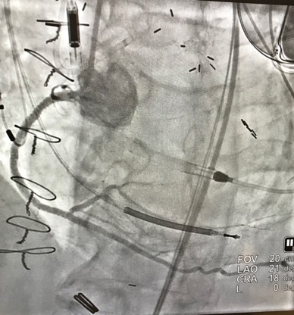
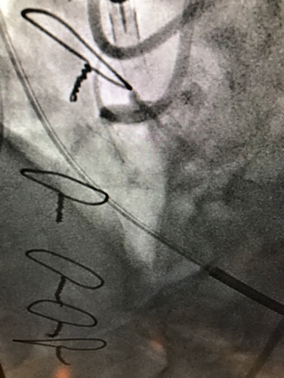
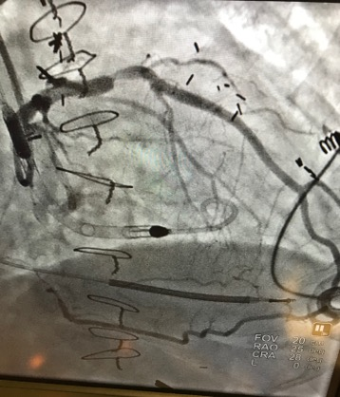

Professional Biography (100-150 words)

Dr. Azzam did his general cardiology training at Rutgers Medical School, Robert Wood Johnson University Hospital, New Brunswick, NJ, and his Interventional Cardiovascular training at Miller School of Medicine, Jackson Memorial and the University of Miami Hospitals, Miller School of Medicine, Miami, FL, USA. Currently, Dr. Azzam is the Medical Director, Interventional Cardiology, Kearney Regional Medical Center and Platte Valley Medical Group, Kearney, NE, USA.
Publications include:
- Brain natriuretic peptide and biomarkers of myocardial ischemia increased after defibrillation threshold testing. Pacing and clinical electrophysiology. 2011 Nov; 35(3):314-9
- Severe hemolytic anemia and acute kidney injury after percutaneous continuous-flow ventricular assistance (Impella). Circulation heart failure. 2011 Nov; 4(6):e20-2

.

Email Id: iyadazzam@hotmail.com

