Abstract Template
PCI of CTO RCA via Apical LAD Collaterals
Iyad K. Azzam, MD, FACC, FSCAI

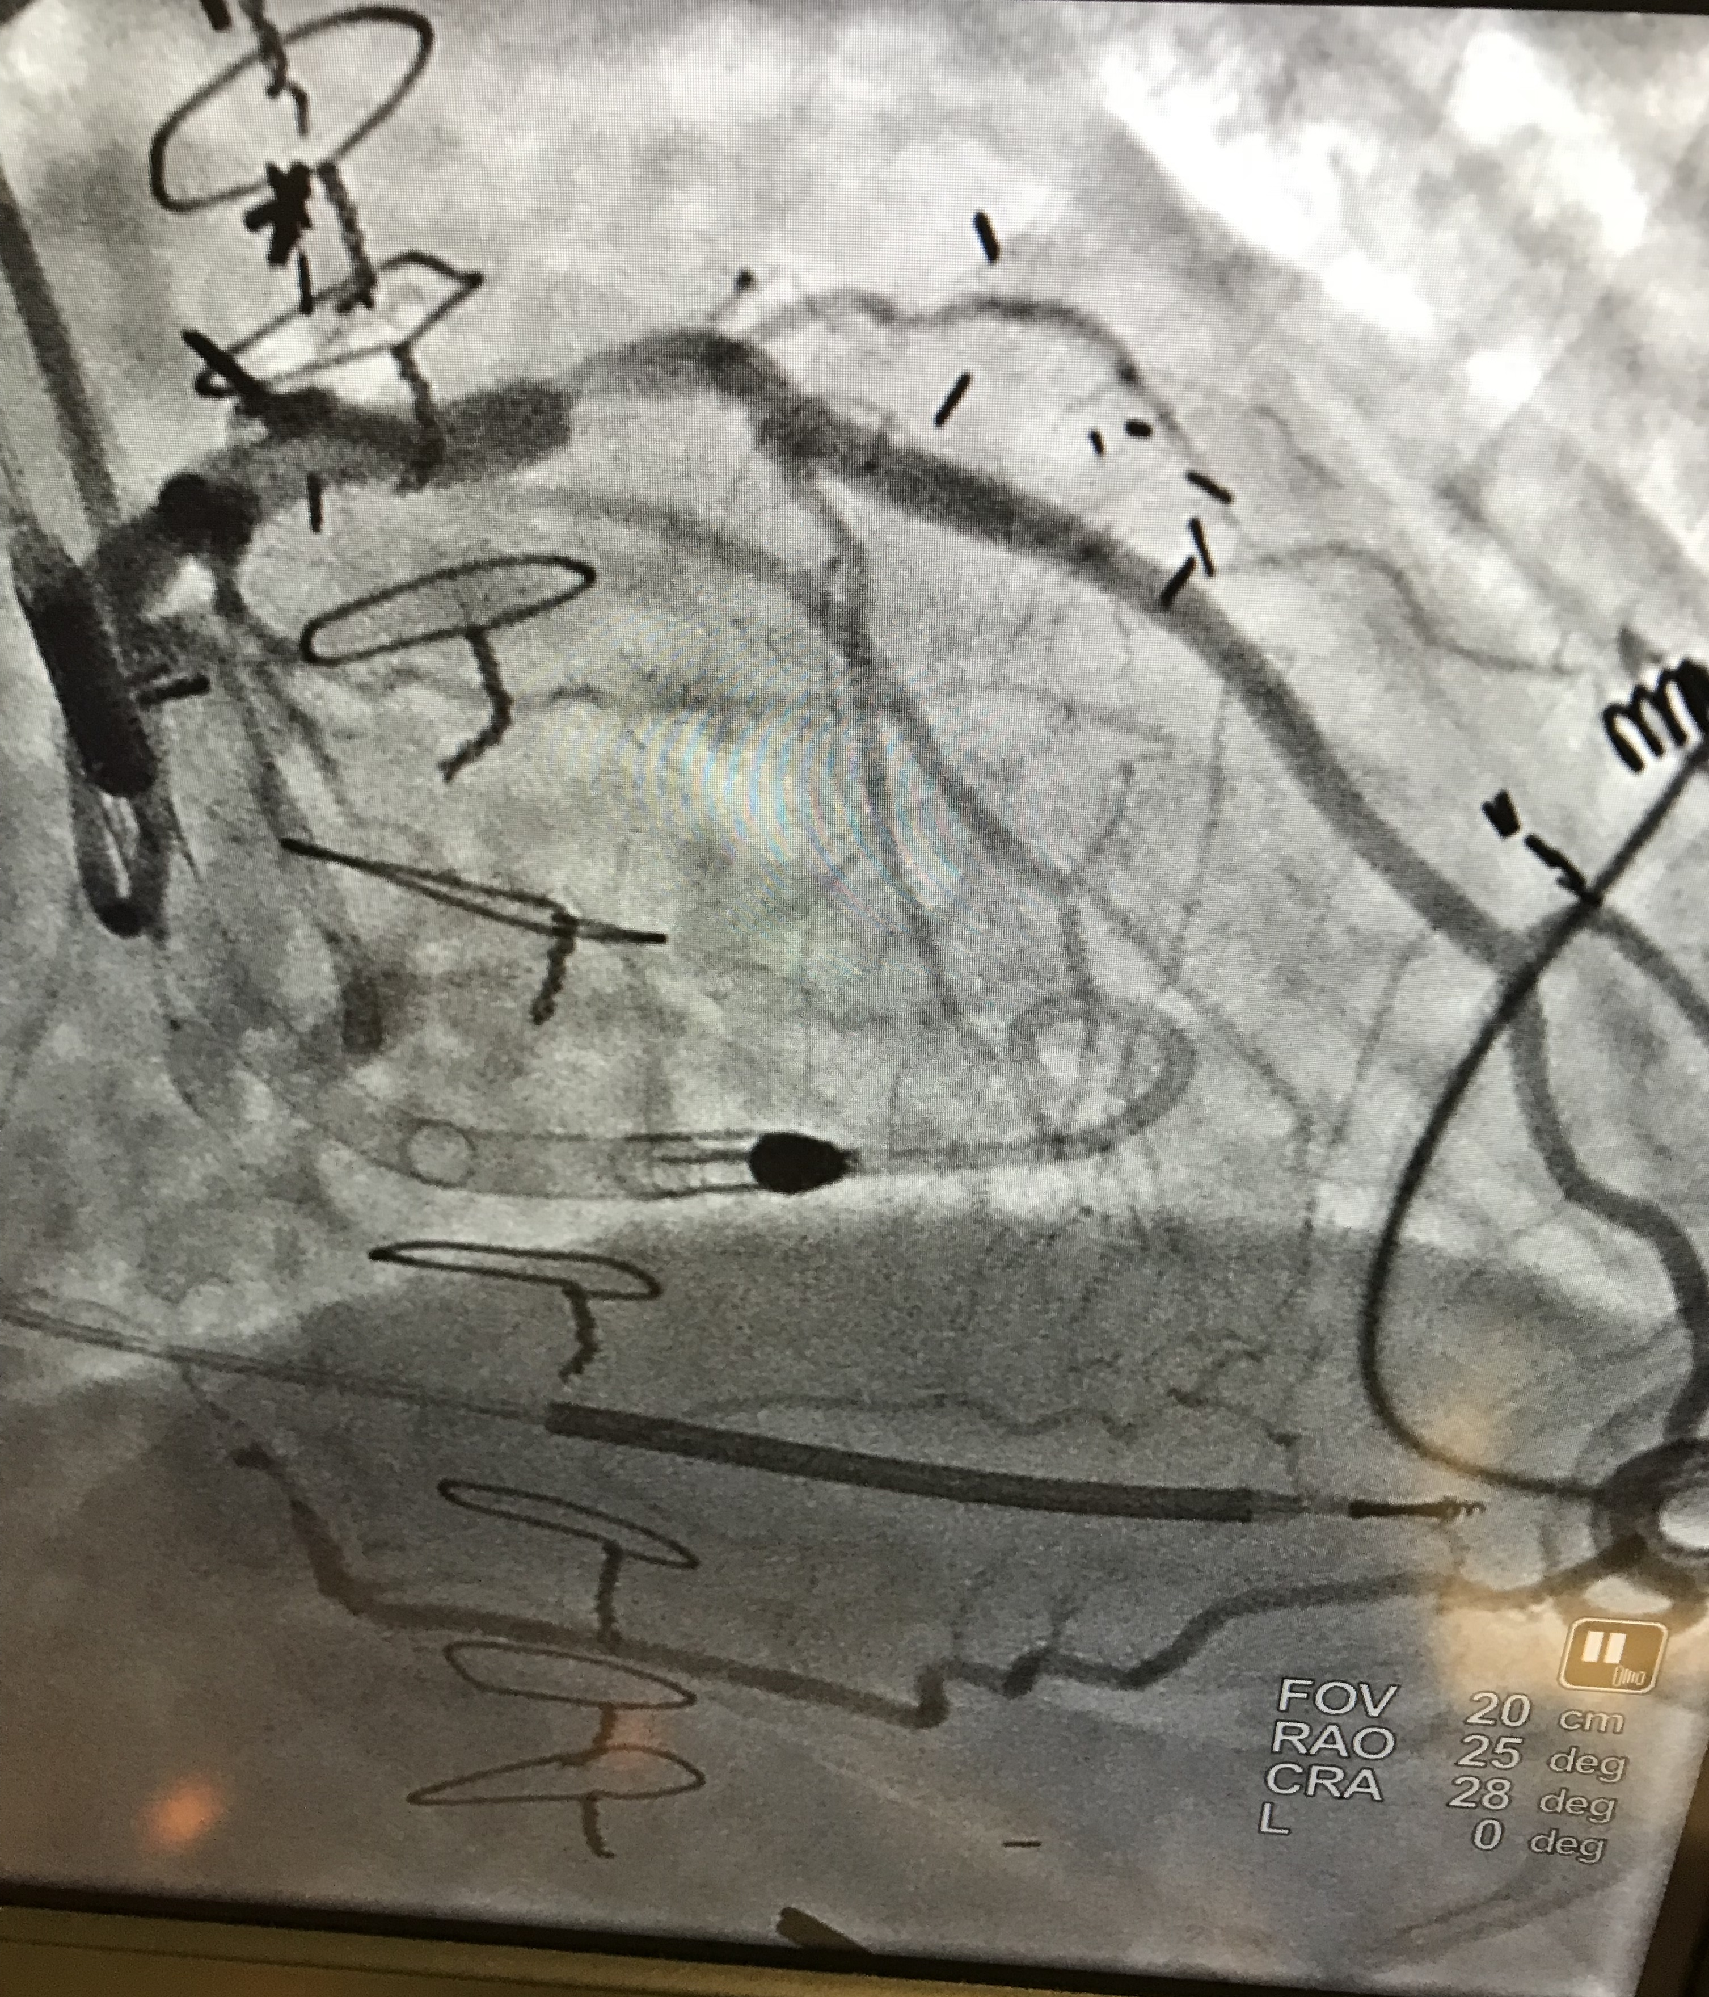
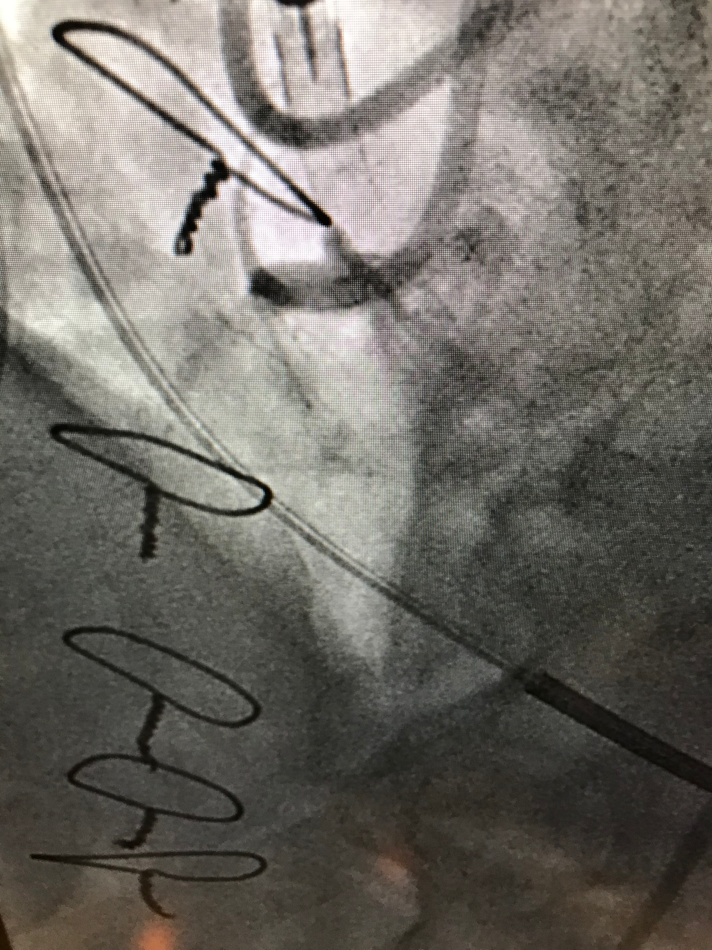
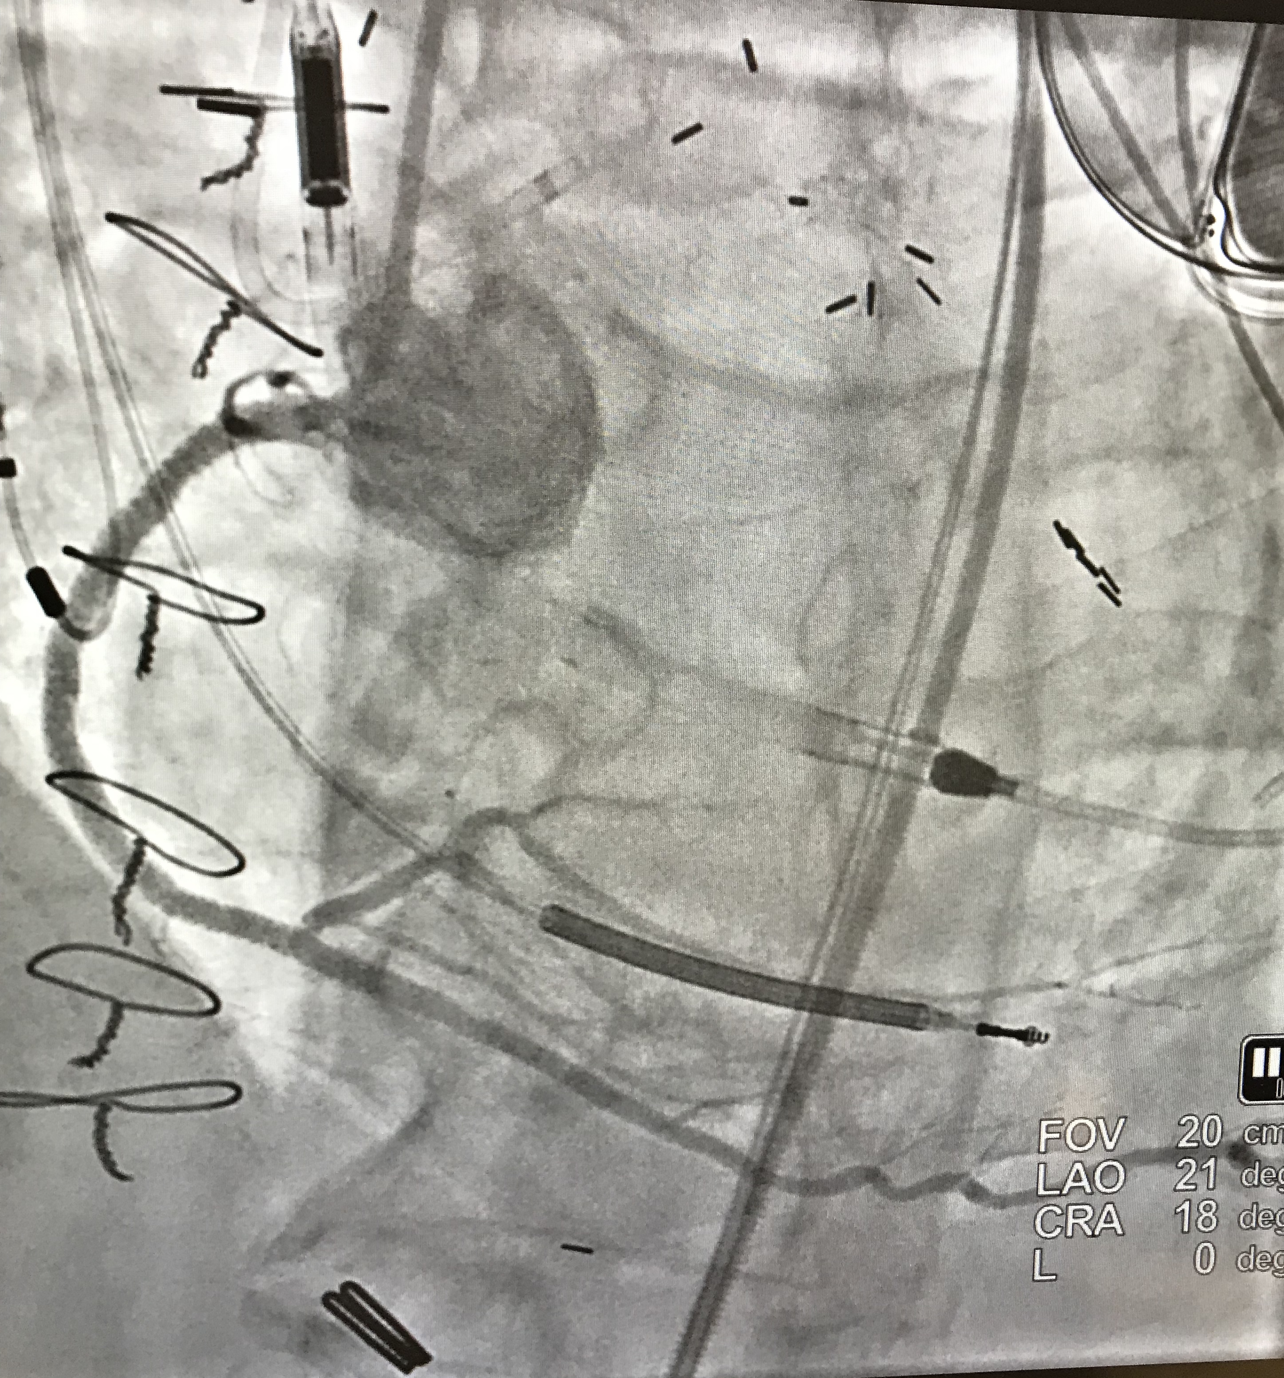
1 Kearney Regional Medical Center, Kearney, NE, USA

Professional Biography (100-150 words)

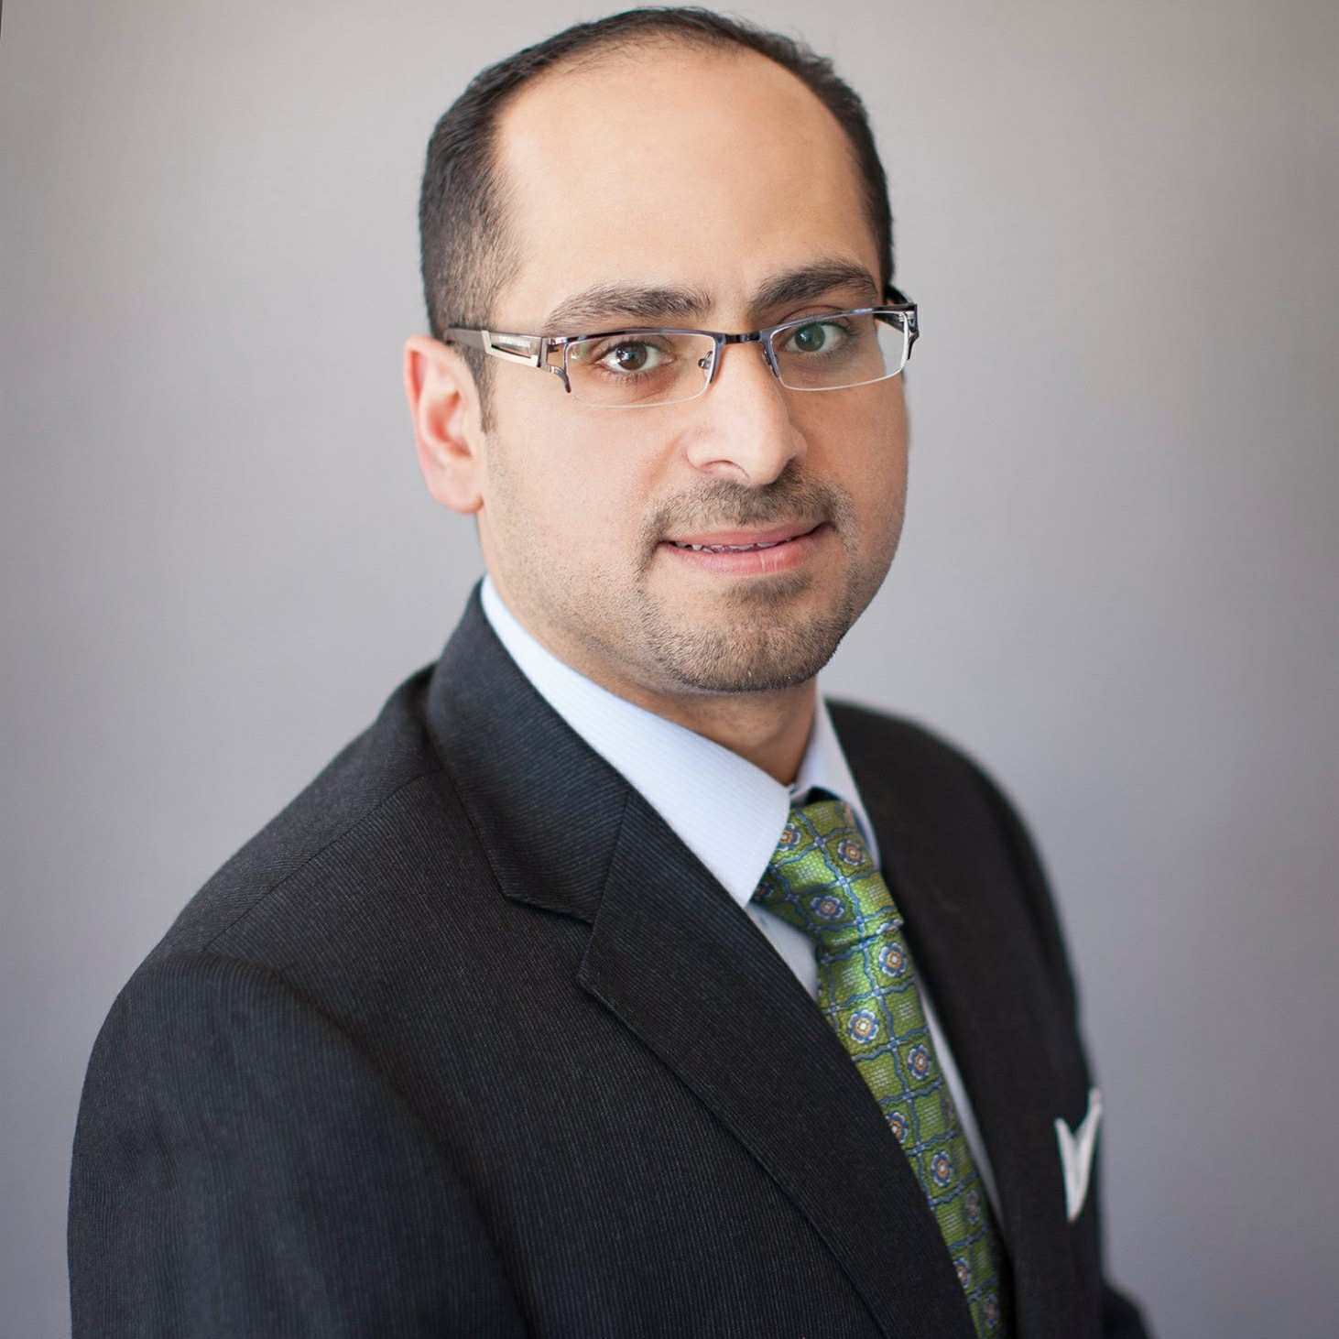
Dr. Azzam did his general cardiology training at Rutgers Medical School, Robert Wood Johnson University Hospital, New Brunswick, NJ, and his Interventional Cardiovascular training at Miller School of Medicine, Jackson Memorial and the University of Miami Hospitals, Miami, FL, USA.

Email Id: iyadazzam@hotmail.com

