Abstract Title - Prevention of CORONARY ARTERY DISEASE in India – Newer Insights [ novel theory]
Krishnamani, N.C. Fortis hospital, Shalimar bagh, Delhi.
THERE IS AN ALARMING INCREASE IN THE INCIDENCE OF CORONARY ARTERY DISEASE IN INDIA AND THE DISTURBING FACT IS THAT IT IS OCCURING IN THE YOUNG AND PRESENTING MORE AS ACUTE CORONARY SYNDROMES, DIFFUSE DISEASE AND THE INCIDENCE IS INCREASING NOT ONLY IN URBAN REGIONS BUT ALSO IN THE RURAL AREAS ALSO BUT THE MOST DISTURBING FACT IS THAT THIS EPIDEMIC IS OCCURING WITHOUTY ANY IDENTIFIABLE RISK FACTORS CONVENTIONAL OR NEWER. THE BURNING ISSUE IS TO REACH AT THE AETIOLOGY IN OUR COUNTRY SO THAT SOME PREVENTIVE MEASURES CAN BE INITIATED TO ATLEAST HALT THE GALLOPING PACE OF THE CAD EPIDEMIC. FIVE TYPICAL CASES OF ACUTE MYOCARDIAL INFARCTION WERE STUDIED IN DETAIL AND THEIR PERSONAL HISTORIES WERE ANALYSED AND VERY INTERESTING FACTS AND NOVEL THEORY DERIVED. THIS MAY EXPLAIN THE GAPS IN OUR UNDERSTANDING OF THE AETIOLOGY OF CAD IN OUR COUNTRY.THE PROPOSED THEORY IS OXIDANTS ARE SLOW TOXINS AND THE MECHANISM OF THEM CAUSING ATHEROSCLEROSIS IS BY ENDOTHELIAL DYSFUNCTION BY NITRIC OXIDE ANTAGONISM THUS LEADING TO A LOW GRADE AND CHRONIC INFLAMATION THESE CHEMICAL AGENTS HAVE ALSO BEEN IMPLICATED IN THE PROBABLE CAUSATION OF HYPERTENSION AND DIABETES WHICH THEMSELVES ARE A VERY STRONG RISK FACTORS FOR THE CORONARY ARTERY DISEASE.LOW GRADE BUT CONSTANT EXPOSURE OF VARIOUS CHEMICALS [from various routes and which can be below toxic levels-as tested in the labs before certifying safe for humans.], ARE OXIDANTS TO THE HUMAN TISSUES PARTICULARLY TO THE ENDOTHELIUM- LEAD TO ENDOTHELIAL DYSFUNCTION AND MAY BE THE CAUSE OF INCREASING INCIDENCE OF CAD, HT , DM,RENAL DISORDERS AND MALIGNANCIES .
KEY WORDS – CORONARY ARTERY DISEASE , ATHEROSCLEROSIS , OXIDANTS.
PROFESSIONAL BIOGRAPHY
DR N.C.KRISHNAMANI GREWUP RECEIVED THE DOCTORATE IN CARDIOLOGY FROM ALL INDIA INSTITUTE OF MEDICAL SCIENCES IN 1998 .HE CONTINUED WITH HIS TEACHING, RESEARCH AND CLINICAL WORK IN VARIOUS DELHI GOVERNMENT HOSPITALS AND PUBLISHED VARIOUS RESEARCH PAPERS IN NATIONAL AND INTERNATIONAL JOURNALS.HE HAS AUTHORED SEVERAL CHAPTERS IN CARDIOLOGY BOOKS.HE IS THE RECIPIENT OF PRESTIGIOUS INDIAN RASTRYA RATTAN GOLD MEDAL 2009.PRESENTLYHE IS SENIOR CONSULTANT IN DEPARTMENT OF CARDIOLOGY FORTISHOSPITASHALIMAR BAGH ,DELHI WITH CHIEF INTEREST IN PRIMARY ANGIOPLASSTY AND COMPLEX CORONARY INTERVENTIONS.

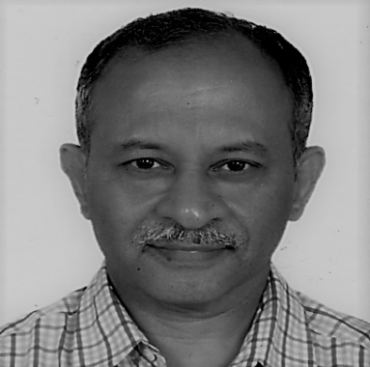 Krishnamani_nc@yahoo.com

