Changes in the Asian Summer Monsoon Circulation Linked with the Low Level Jetstream
K. Mohanakumar and Shinu Sheela Wilson

Advanced Centre for Atmospheric Radar Research, Cochin University of Science and Technology, Cochin 682022, India

Abstract

Several studies have shown that the changes in the intensity of monsoon circulation and the associated rainfall are connected with several local as well as remote factors. One of the major components is the low level jetstream (LLJ), which shows a statistically significant decreasing trend during the recent decades. It is noted that the low level circulation over the Indian Ocean becomes weak during the positive phase of ENSO leads to warmer sea surface temperature over the Indian Ocean. The strength of the LLJ over India depends on the convective heating of the atmosphere. During the recent decades, the flow of LLJ through peninsular India is weaker, and that over the south of peninsular India is stronger, with an increase in the number of break monsoon days. Through monsoon breaks, the axis of LLJ shifts poleward over the Arabian Sea and the intensity of wind over the south Indian Ocean increases. The strength of the LLJ is more in wet monsoon years than in dry monsoon years except in the Bay of Bengal zone. The core height of LLJ and TEJ vary depends on the terrain, as well as the strength of the monsoon circulation. The new monsoon circulation index (Shinu-Mohan Index) provides precise vertical shear at each grid, and represents a better spatial variability at different terrain conditions. The cross-equatorial flow over the west Pacific Ocean has a statistically significant increasing trend related to the increasing convection in the western Pacific Ocean. It is noted that the temperature variability in the tropical oceans creates profound changes in atmospheric circulation. The vertical wind shear and the regional meridional circulation are responsible for the monsoon condition over India rather than the external factors.
Keywords: Active and break phases, Asian summer monsoon, ENSO, Low level jetsream,

Professional Biography (100-150 words)

K. Mohanakumar has completed his PhD at the age of 29 years from University of Kerala and postdoctoral studies from Freie University, Berlin, Germany. He is the Hon. Director of the Advanced Centre for Atmospheric Radar Research, a unique ST radar facility at CUSAT. He authored a textbook entitled ‘Stratosphere Troposphere Interactions’, published in English by Springer, which won the ASLI Choice Award for the best book of the year in 2009. This book was translated and published in Russian and Chinese languages. He has published more than 100 papers in reputed journals and has supervised 23 students for their Ph D in the field of Atmospheric Sciences.

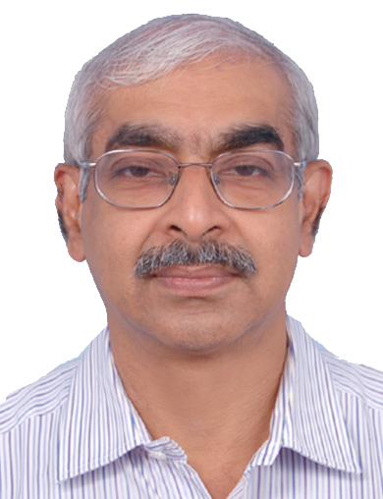
Email Id: kmkcusat@gmail.com

