Abstract Template
Abstract Title: Key Issues for Competitive CO2 life Cycle Management
JL Roux Dit Buisson, Dr. T. Gees
¹ MSC MIT
² EPhD ETH Zurich

Abstract (not more than 300 words)

CO₂ is retaining more and more attention as the potential future source of raw material for the Foods, Feeds, Chemical industries. International groups such as BASF have established corporate wide procedures to replace entrants from fossils with entrants from renewables. This Vth industrial revolution will be made possible only if the production of entrants is competitive against existing solutions, and does not generate retrofitting in downstream processing installations. NeoCarbons has patented the equipment that makes CO₂ recycling industrial in scale, real time, competitive and respectful of sustainable development principles. We plan to share and discuss our findings and thoughts concerning the design of equipment, and bring knowledge of the key technical success factor, by analogy with other worldwide industries, during our presentation.

Keywords—CO2 lifecycle, carbon cycle, competitive micro-algae farming, protein independence from CO2 recycling

Professional Biography (100-150 words)

Jean-Louis earned his MSc from MIT in Chemical Engineering Practice, and an MBA from INSEAD. He has been responsible for production units at EXXON and held C-suite positions within the pharma, biotech, medtech industries. He developed the patents on which NeoCArbons has based hids development. He publishes regularly articles on strategic issues related to global warming and CO2 , previously on strategic M&A issues in the pharma industry.

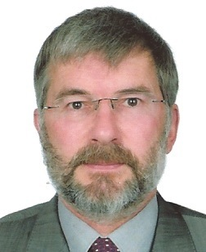

Paste your Photograph here

Email Id: jlrb@neocarbons.com

