Abstract Title: Floods impact on the lives of school children in Basse, Upper River Region of The Gambia.
Demba Baldeh1, Alagie Bah2, Momodou Njie3,
1. West African Science Service Center on Climate Change and Adapted Land Use (WASCAL), (University of The Gambia)
2. Consultant, 67 Ousman Jobe Street, Banjul, The Gambia
3. School of Agriculture and Environmental Science, University of The Gambia

In recent years, The Gambia has witnessed a shift in rainfall patterns, marked by the occurrence of annual flash floods in the low lying topographic communities such as Basse. This study investigates the impacts of the flood on the lives of school children in Basse and identifies the adaptation measures employed to overcome the challenges. Proportional sampling was used to select the sample size of 255 (138 from Kaba-Kama, 117 from Basse Layout communities) based on 95% confidence level and 5% margin of error.
Although the school children were not directly affected by floods at the school level, a considerable number of them have been found to be severely affected by floods either at home or during their journey to/from school. Chi-square test analysis showed that food supply and stationery loss varied significantly between the communities of Kaba Kama and Basse Layout, which may inadvertently cause low syllabus coverage and poor performance in examinations. The study revealed that although the civil society groups and school authorities were proactive in helping students to overcome the problems induced by floods, most of their efforts were derailed by other factors such as political interference, lack of resources and the prerequisite skills necessary to handle flood-induced problems. The findings provide important insights that can contribute to public policy formulation and reforms relevant to climate change resilience in The Gambia.
Key Words - climate change, floods, school children, vulnerability

Professional Biography
Demba Baldeh has completed his MSc. in Climate Change and Education in March 2018, from the University of The Gambia. He has also bagged a BA (Hons) degree in History and Geography from the same Institution, where he was the best graduating student in History during the 8th Convocation of the University in March 2014. Recently he has published a book on his research in Lambert Academic Publishing, Germany. He is presently a Lecturer in a College and a Reconciliation officer at the newly established Truth Reconciliation and Reparations Commission (TRRC) in The Gambia.

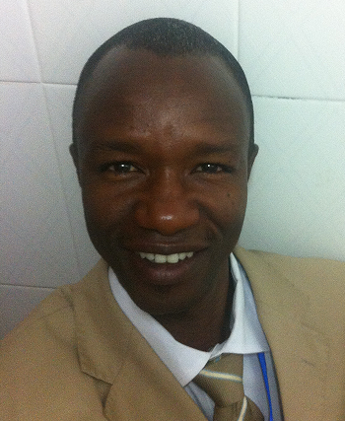 Email: ngandemba2007@gmail.com

