The introduce of an additive modeling responsive to temperature and precipitation variables: Applications to forest stand biomass of Picea spp. of Eurasia

Vladimir Andreevich Usoltsev^{1,2}, Seyed Omid Reza Shobairi^{2*}, Ivan Stepanovich Tsepordey¹, Viktor Petrovich Chasovskikh²
¹Botanical Garden, Russian Academy of Sciences, Ural Branch8 Marta str., 202a, Yekaterinburg, 620144 Russian Federation.
²Ural State Forest Engineering University Sibirskii trakt, 37, Yekaterinburg, 620100 Russian Federation.
*Corresponding Author E-mail: Omidshobeyri214@gmail.com

Abstract

The first attempt of modeling changes in the additive component composition of 900 spruce stands (genus Picea sp.) biomass (t/ha), according to the trans-Eurasian hydrothermal gradients of Eurasia using the database compiled on the structure of harvest biomass. It is found that the biomass of all components increases with the increase in the mean January temperature, regardless of mean annual precipitation. In warm zonal belts with increasing precipitation the biomass of all components increases, except for the needle mass, but the foliage biomass decreases under the same conditions. In process of the transition from the warm zone to the cold one, the dependence of all biomass components upon precipitation is leveled, and at the mean January temperature equal to –30 °C it becomes weak negative trend. With the increase in temperature by 1°C in different ecoregions, characterized by different values of temperature and precipitation, there is a general pattern of decrease, as the total biomass, and all its components, including roots. With the increase in precipitation by 100 mm in different ecoregions, characterized by different values of temperature and precipitation, in warm zonal belts biomass total, aboveground, stems and roots are increasing, and in cold ones is decreasing. The foliage biomass in cold zones increases regardless of regional levels of current precipitation, and in warm zones decreases. The branches biomass decreases in all ecoregions. The development of such models for the main forest-forming species of Eurasia will make it possible to predict changes in the productivity of the forest cover of Eurasia due to climate change.

Key words: spruce forests; biosphere role of forests; forest biomass; regression models; biological productivity; additive biomass equations; January mean temperature; mean annual precipitation.

Introduction

Since 1850 to the present, the amount of greenhouse gases in the atmosphere has doubled, threatening the planet with catastrophic climate change (Fatichi et al., 2018). At the UN climate summit in Paris in December 2015, 196 countries committed themselves to reducing CO₂ emissions and preventing annual temperatures from rising by more than 2°C by the end of the century. Forest ecosystems, as sinks of atmospheric carbon, play an important role in this perspective. The ability of forests to remove carbon from the atmosphere and produce organic matter is the basis of their functioning (Dylis, 1978). This decrease in the concentration of CO₂ in the atmosphere can be achieved due to the increase of carbon stock in vegetative cover by means of effective forest management. On the other hand, climate change has a significant impact on the biological productivity of vegetation, which in turn affects the transformation of the cycle of organic matter and gas exchange in the biosphere (Golubyatnikov, Denisenko, 2009).
Temperature and precipitation are the most informative climatic factors that determine not only the radial annual growth of tree stems, but also the biological productivity of forest stands (DeLucia et al., 2000; Ni et al., 2001; Stegen et al., 2011; D’Aprile et al., 2015; Fang et al., 2016). Numerous studies of stochastic relationships of biological productivity of stands with temperature and precipitation were carried out at the regional level for indices, depersonalized by age and morphology of stands, and at the global level even without considering the species composition (Lieth, 1974; Anderson et al., 2006; Keeling, Phillips, 2007; Huston, Wolverton, 2009). Analysis of the results of such studies revealed significant contradictions and uncertainties associated with the assessment of the dependence of these indices on temperature and precipitation using both empirical and functional models (Eggers et al., 2008; Shuman, Shugart, 2009; Poudel et al., 2011; Han et al., 2018). Contradictory results were obtained even within a single region, while the influence of the same climatic factors on the biological production of stands of certain tree species (genera) in the Trans-Eurasian climatic gradients of temperature and precipitation is still unknown, since the available information is fragmentary and contradictory (Strömgren, Linder 2002; Wilmking et al., 2004; Stegen et al., 2011; Fu et al., 2017).
In the development of such empirical models, the additivity of component composition is not provided, according to which the total biomass of components (stems, branches, needles, roots) obtained by component equations would be equal to the value of biomass obtained by the common equation (Dong et al., 2015). The influence of climatic changes on the biomass of a tree species in the format of additive models in accordance of transcontinental hydrothermal gradients has not been studied at all.
The purpose of this study is to develop a model of changes in the additive component composition of the Picea stand biomass on the Trans-Eurasian gradients of the mean January temperature and mean annual precipitation.

Materials and methods

The database on biomass of forest-forming species of Eurasia was used in the modeling process (Usoltsev, 2010; Usoltsev, 2013). The data is taken from it in the amount of 900 sample plots with the biomass harvesting and definitions of the Picea spp. forest stands (t/ha). Each sample plot on which the biomass determination was performed is positioned relatively to the isolines of the mean January temperature (Fig. 1) and relatively isolines of mean annual precipitation (Fig. 2). The matrix of harvest data is then compiled in which values of biomass component and morphological indices of forest stands are conjugated with the corresponding values of mean January temperature and precipitation. This matrix is included then in procedure of the regression analysis.
According to the structure of the disaggregation three-step additive biomass model (Tang et al., 2000; Dong et al., 2015), the total biomass estimated from the initial equation is divided into its components according to the scheme presented in Fig. 3 and Table 1.

Results

Calculated initial regression equations

lnP_{i} =a_{0i} +a_{1i} (lnA)+a_{2i} (lnV)+a_{3i} (lnN)+a_{4i} [ln(Tm+40)]+a_{5i}(lnPRm) +a_{6i}[ln(Tm+40)]·(lnPRm), (1)

where Pi - the mass of the i-th fraction, t / ha; A - the age of the stand, years; V - wood supply, m3 / ha; N - stand density, thousand ind./ha; i - phytomass fraction index: total (t), aboveground (a), roots (r), crowns (c), stem in bark (s), needles (f), branches (b), stem wood (w) and bark stem (bk); Tm is the average January temperature, ° С; РRm - average annual rainfall, mm.

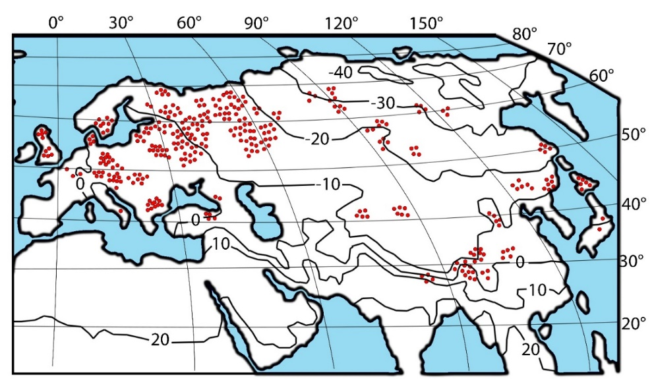
Figure 1. Distribution of biomass harvest data of 900 Picea sample plots on the map of the mean January temperature, °C (World Weather Maps, 2007).
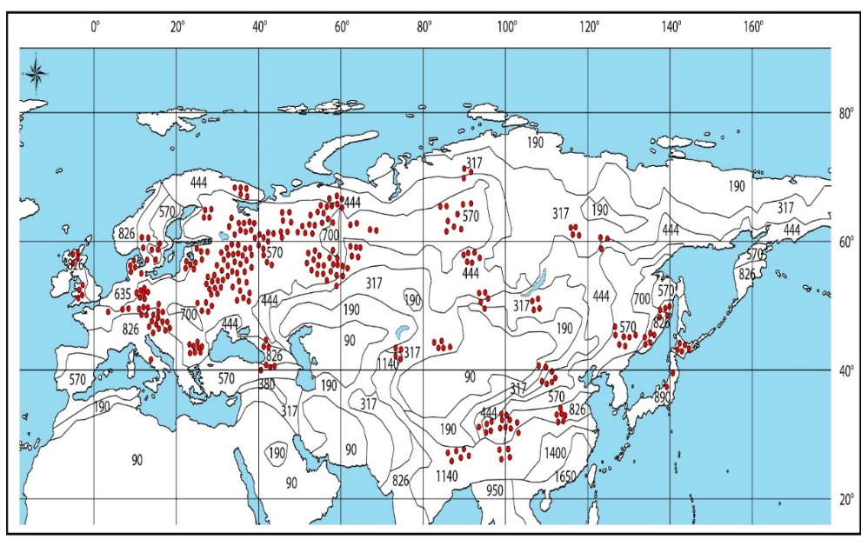
Figure 2. Distribution of biomass harvest data of 900 Picea sample plots on the map of the mean annual precipitation, mm sample trees on the map of the mean annual precipitation, mm (World Weather Maps, 2007): (http://www.mapmost.com/world-precipitation-map/free-world-precipitation-map/).

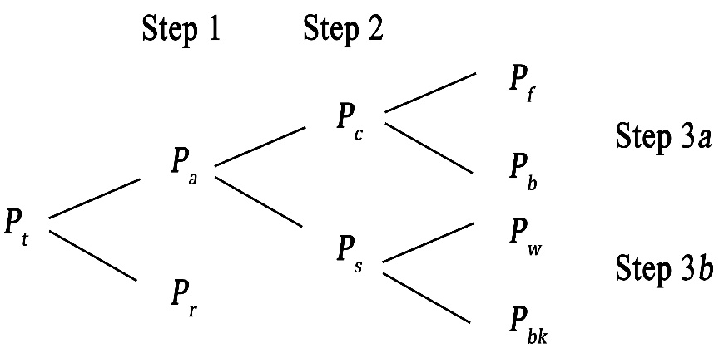
Figure 3. The pattern of disaggregating three-step proportional weighting additive model. Designation: P_{t}, P_{r}, P_{a}, P_{c}, P_{s}, P_{f}, P_{b}, P_{w} and P_{bk} are forest stand biomass respectively: total, underground (roots), aboveground, crown (foliage and branches), stems above bark (wood and bark), foliage, branches, stem wood and stem bark correspondingly, t per ha.

Table 1. The structure of the three-step additive model sold under proportional weighting when using 122 sample trees of Larix gmelinii Rupr. (Dong et al., 2015). Symbols here and further as per Fig. 3 and equation (1).
Step 1 | $$P_{a}=\frac{1}{1+\frac{a_{r}D^{b_{r}}H^{c_{r}}}{a_{a}D^{b_{a}}H^{c_{a}}}}×P_{t}$$ | $$P_{r}=\frac{1}{1+\frac{a_{a}D^{b_{a}}H^{c_{a}}}{a_{r}D^{b_{r}}H^{c_{r}}}}×P_{t}$$
Step 2 | $$P_{c}=\frac{1}{1+\frac{a_{s}D^{b_{s}}H^{c_{s}}}{a_{c}D^{b_{c}}H^{c_{c}}}}×P_{a}$$ | $$P_{s}=\frac{1}{1+\frac{a_{c}D^{b_{c}}H^{c_{c}}}{a_{s}D^{b_{s}}H^{c_{s}}}}×P_{a}$$
Step 3а | $$P_{f}=\frac{1}{1+\frac{a_{b}D^{b_{b}}H^{c_{b}}}{a_{f}D^{b_{f}}H^{c_{f}}}}×P_{c}$$ | $$P_{b}=\frac{1}{1+\frac{a_{f}D^{b_{f}}H^{c_{f}}}{a_{b}D^{b_{b}}H^{c_{b}}}}×P_{c}$$
Step 3b | $$P_{w}=\frac{1}{1+\frac{a_{bk}D^{b_{bk}}H^{c_{bk}}}{a_{w}D^{b_{w}}H^{c_{w}}}}×P_{s}$$ | $$P_{bk}=\frac{1}{1+\frac{a_{w}D^{b_{w}}H^{c_{w}}}{a_{bk}D^{b_{bk}}H^{c_{bk}}}}×P_{s}$$

We used a schematic map of the contours of the mean January temperature, rather than the mean annual temperature, as warming is most pronounced in the cold half of the year (Golubyatnikov, Denisenko, 2009; Laing, Binyamin, 2013). F. Schwarz (1899) showed at his time, the air temperature in the period from January to March to be decisive for the growth of trees is twice as strong as the precipitation in the period from May to June. Since the mean January temperature in the northern limit of Eurasia has negative values, the corresponding independent variable is modified to the form (Тm +40) which may be subjected to logarithmic procedure.
The coefficients of equations (1) are calculated using the Statgraphics software for multiple regression analysis and their characteristics are obtained. Equations after correcting on logarithmic transformation by G. L. Baskerville (1972) and anti-log transforming are given in the Table 2. They are characterized by the significance level of not lower than 0.05. The equations are adequate to the harvest data presented in the above-mentioned database. The equations obtained are modified to the additive form according to the above-mentioned algorithm (Fig. 3 and Table 1), and the final form of the transcontinental additive model of component composition of Picea biomass is shown in Table 3.

Table 2. Characteristics of initial model (1) after its anti-log transforming
Biomass components | The initial model characteristics
P_{t} | 1.6868 |  | A ^{-0.0631} | V ^{0.8917} |  | N ^{0.0303}
Step 1
P_{a} | 1.84E-01 |  | A ^{-0.0528} | V ^{0.8846} |  | N ^{0.0456}
P_{r} | 7.34E+01 |  | A ^{0.0144} | V ^{0.8453} |  | N ^{0.0528}
Step 2
P_{c} | 1.37E-05 |  | A ^{-0.2301} | V ^{0.7464} |  | N ^{0.2057}
P_{s} | 2.98E-01 |  | A ^{0.0435} | V ^{0.9822} |  | N ^{0.0235}
Step 3а
P_{f} | 1.83E-10 |  | A ^{-0.2702} | V ^{0.6718} |  | N ^{0.2592}
P_{b} | 1.84E-04 |  | A ^{-0.1596} | V ^{0.8371} |  | N ^{0.2046}
Step 3b
P_{w} | 7.05E-02 |  | A ^{0.0950} | V ^{0.9731} |  | N ^{-0.0138}
P_{bk} | 3.11E-01 |  | A ^{0.1663} | V ^{0.7954} |  | N ^{0.1152}
Continuation of Table 2.
Biomass components | The initial model characteristics |  |  |  |  |  | adjR^{2*} | SE*
P_{t} | (Tm+40) ^{0.4910} | (Tm+40) ^{-0.0924 ln(PRm)} |  |  | PRm ^{0.0487} |  | 0.974 | 1.25
Step 1
P_{a} | (Tm+40) ^{0.8254} | (Tm+40) ^{-0.1201 ln(PRm)} |  |  | PRm ^{0.2744} |  | 0.974 | 1.21
P_{r} | (Tm+40) ^{-0.7995} | (Tm+40) ^{0.0772 ln(PRm)} |  |  | PRm ^{-0.6934} |  | 0.913 | 1.49
Step 2
P_{c} | (Tm+40) ^{3.9073} | (Tm+40) ^{-0.6237 ln(PRm)} |  |  | PRm ^{1.8394} |  | 0.812 | 1.50
P_{s} | (Tm+40) ^{0.3354} | (Tm+40) ^{-0.0491 ln(PRm)} |  |  | PRm ^{0.0240} |  | 0.986 | 1.17
Step 3а
P_{f} | (Tm+40) ^{6.6083} | (Tm+40) ^{-1.0477 ln(PRm)} |  |  | PRm ^{3.5374} |  | 0.700 | 1.63
P_{b} | (Tm+40) ^{2.8783} | (Tm+40) ^{-0.4661 ln(PRm)} |  |  | PRm ^{1.2422} |  | 0.817 | 1.60
Step 3b
P_{w} | (Tm+40) ^{0.3654} | (Tm+40) ^{-0.0489 ln(PRm)} |  |  | PRm ^{0.1941} |  | 0.989 | 1.16
P_{bk} | (Tm+40) ^{-0.6774} | (Tm+40) ^{0.0880 ln(PRm)} |  |  | PRm ^{-0.1867} |  | 0.934 | 1.36
* adjR² – coefficient of determination adjusted for the number of parameters; SE – equation standard error.

Table 3. Final three-step additive model of Picea forest biomass
$$\text{Pt}\text{= } {\text{1}\text{.}\text{6868 }\text{A} }^{\text{-0}\text{.}\text{0631}}{\text{V} }^{\text{0}\text{.}\text{8917}}{\text{N} }^{\text{0}\text{.}\text{0303}}{\text{(}\text{Tm}\text{+40) }}^{\text{0}\text{.}\text{4910}}{\text{PRm}}^{\text{ 0}\text{.}\text{0487}}{\text{(}\text{Tm}\text{+40)}}^{ \text{-0}\text{.}\text{0924}\text{(ln}\text{PRm}\text{)}}$$
Step 1 | Pa=$\frac{\text{1}}{\text{1+}{\text{4}\text{.}\text{00E+02 }\text{A} }^{\text{0}\text{.}\text{0672}}{\text{V} }^{\text{-0}\text{.}\text{0393}}{\text{N} }^{\text{0}\text{.}\text{0072}}{\text{(}\text{Tm}\text{+40) }}^{\text{-1}\text{.}\text{6249}}{\text{PRm}}^{\text{ -0}\text{.}\text{9679}}{\text{(}\text{Tm}\text{+40)}}^{ \text{0}\text{.}\text{1973}\text{(ln}\text{PRm}\text{)}}}$×Pt
Step 1 | Pr=$\frac{\text{1}}{\text{1+}{\text{2}\text{.}\text{50E-03 }\text{A} }^{\text{-0}\text{.}\text{0672}}{\text{V}}^{\text{0}\text{.}\text{0393}}{\text{N} }^{\text{-0}\text{.}\text{0072}}{\text{(}\text{Tm}\text{+40) }}^{\text{1}\text{.}\text{6249}}{{\text{PRm}}^{\text{ 0}\text{.}\text{9679}}\text{(}\text{Tm}\text{+40)}}^{ \text{-0}\text{.}\text{1973}\text{(ln}\text{PRm}\text{)}}}$×Pt
Step 2 | Pc=$\frac{\text{1}}{\text{1+}{\text{2}\text{.}\text{18E+04 }\text{A} }^{\text{0}\text{.}\text{2737}}{\text{V}}^{\text{0}\text{.}\text{2358}}{\text{N} }^{\text{-0}\text{.}\text{1822}}{\text{(}\text{Tm}\text{+40) }}^{\text{-3}\text{.}\text{5683}}{\text{PRm}}^{\text{ -1}\text{.}\text{8154}}{\text{(}\text{Tm}\text{+40)}}^{ \text{0}\text{.}\text{5745}\text{(ln}\text{PRm}\text{)}}}$×Pa
Step 2 | Ps=×Pa
Step 3а | Pf=$\frac{\text{1}}{\text{1+}{\text{1}\text{.}\text{00E+06 }\text{A} }^{\text{0}\text{.}\text{1107}}{\text{V}}^{\text{0}\text{.}\text{1653}}{\text{N} }^{\text{-0}\text{.}\text{0546}}{\text{(}\text{Tm}\text{+40) }}^{\text{-3}\text{.}\text{7300}}{\text{PRm}}^{\text{ -2}\text{.}\text{2952}}{\text{(}\text{Tm}\text{+40)}}^{ \text{0}\text{.}\text{5817}\text{(ln}\text{PRm}\text{)}}}$×Pc
Step 3а | Pb=$\frac{\text{1}}{\text{1+}{\text{9}\text{.}\text{96E-07 }\text{A} }^{\text{-0}\text{.}\text{1107}}{\text{V} }^{\text{-0}\text{.}\text{1653}}{\text{N} }^{\text{0}\text{.}\text{0546}}{\text{(}\text{Tm}\text{+40) }}^{\text{3}\text{.}\text{7300}}{\text{PRm}}^{\text{ 2}\text{.}\text{2952}}{\text{(}\text{Tm}\text{+40)}}^{ \text{-0}\text{.}\text{5817}\text{(ln}\text{PRm}\text{)}}}$×Pc
Step 3b | Pw=$\frac{\text{1}}{\text{1+}{\text{4}\text{.}\text{4055 }\text{A} }^{\text{0}\text{.}\text{0713}}{\text{V} }^{\text{-0}\text{.}\text{1776}}{\text{N} }^{\text{0}\text{.}\text{1290}}{\text{(}\text{Tm}\text{+40) }}^{\text{-1}\text{.}\text{0428}}{\text{PRm}}^{\text{ -0}\text{.}\text{3808}}{\text{(}\text{Tm}\text{+40)}}^{ \text{0}\text{.}\text{1369}\text{(ln}\text{PRm}\text{)}}}$×Ps
Step 3b | Pbk=$\frac{\text{1}}{\text{1+}{\text{2}\text{.}\text{27E-01 }\text{A} }^{\text{-0}\text{.}\text{0713}}{\text{V} }^{\text{0}\text{.}\text{1776}}{\text{N} }^{\text{-0}\text{.}\text{1290}}{\text{(}\text{Tm}\text{+40) }}^{\text{1}\text{.}\text{0428}}{\text{PRm}}^{\text{ 0}\text{.}\text{3808}}{\text{(}\text{Tm}\text{+40)}}^{ \text{-0}\text{.}\text{1369}\text{(ln}\text{PRm}\text{)}}}$×Ps

For comparison of the adequacy of the initial (see Table 2) and additive (see Table 3) equations those and other are tabulated on the experimental mass-forming indices, and the predicted biomass values obtained are compared with the observed ones according to adjR² (Table 4). The results of the comparison shown in Table 4, indicate that the adequacy indices of the two systems of equations are close to each other. The ratio of harvest biomass data and values obtained by the calculation of initial and additive models of Picea biomass (Figure 4), shows the degree of correlation of these values and the absence of visible differences in the structure of residual dispersions obtained from the two models.
The problem of transforming the model (1) into a tabular variant is that we can specify only the indicators of the stand age, as well as temperature and precipitation, while the values of stem volume and tree density can be entered into the table in the form of calculated values obtained by a system of auxiliary recursive equations having the general form:
N = f [A, 1/A, (Tm+40), PRm], (2)
V = f [1/A, N, (Tm+40), PRm]. (3)
The results of calculating (2) and (3) are given in Table 5.

Table 4. Comparison of coefficients of determination of the initial and additive equations of Picea forest biomass
Coefficient of determination adjusted | Biomass components
Coefficient of determination adjusted | Pt | Pa | Pr | Ps | Pw | Pbk | Pc | Pb | Pf
Initial equations
adjR² | 0.883 | 0.898 | 0.595 | 0.912 | 0.956 | 0.533 | 0.410 | 0.363 | 0.249
Additive equations
adjR² | 0.883 | 0.899 | 0.595 | 0.919 | 0.947 | 0.541 | 0.448 | 0.443 | 0.349

The results of tabulating the equations in the sequence (2), (3) and (1) represent a rather cumbersome table. We took from it the component biomass for the age of 100 years and built the graphs of their dependence on temperature and precipitation (Fig. 5).

Discussion
As we can see on these graphs (Fig. 5), all the spruce biomass components, with some exceptions for foliage, change in one general scheme, but in different ratios. The biomass of all components increases with the increase in the mean January temperature from -30°С to +10°С, regardless of precipitation. In warm zonal belts (Тm = +10°С) with increasing precipitation from 300 to 900 мм the biomass of all components increases, except for the foliage biomass, but the latter decreases under the same conditions. As the transition from warm zone zones (Тm = +10°C) to cold (Tm = -30°C), the dependence of the biomass of all components, except for the foliage, upon precipitation is leveled, i.e. becomes less pronounced, and at the temperature Tm equal to -30°C acquires the weak negative trend. This is consistent with the increase in relative radial increment, depersonalized by species composition, in boreal forests in Canada as both annual mean temperature and annual precipitation increase (Miao, Li, 2011), but only in warm zones and with the exception of the foliage biomass.

Table 5. Characteristics of the recursive system of auxiliary equations for mass-forming indices of spruce stands
Mass-forming indices | The auxiliary equations characteristics
lnN | -6.9760 | -1.1359 lnA | -9.0578 (1/A) | - | 3.9808 ln(Tm+40)
lnV | 26.6476 | 0.4128 lnN | -55.2965 (1/A) | -0.0821 (lnN)(lnA) | -6.4361 ln(Tm+40)
Continuation of Table 5.
Mass-forming indices | Regression model coefficients |  | adjR² | SE
lnN | 2.4072 lnPRm | -0.7650 [ln(Tm+40)] ln(PRm) | 0.567 | 0.59
lnV | -4.2439 lnPRm | 1.3318 [ln(Tm+40)] ln(PRm) | 0.779 | 0.64

Biomass observed values, t/hа | Aboveground |  |  | Foliage
Biomass observed values, t/hа | Roots |  |  | Branches
Biomass observed values, t/hа | Crown |  |  | Stem wood
Biomass observed values, t/hа | Stems total |  |  | Stem bark
 |  | Biomass predicted values, t/hа
Figure 4. The ratio of the harvest biomass and its values obtained by calculating the inital (a) and additive (b) models of the Picea forest biomass.

Figure 5. The dependence of the spruce biomass upon the mean January temperatures (Tm) and annual precipitation (PRm). Designation: Pt, Ps, Pa, Pf, Pr, and Pb – respectively total biomass, stems, aboveground, foliage, roots and branches, t/ha.

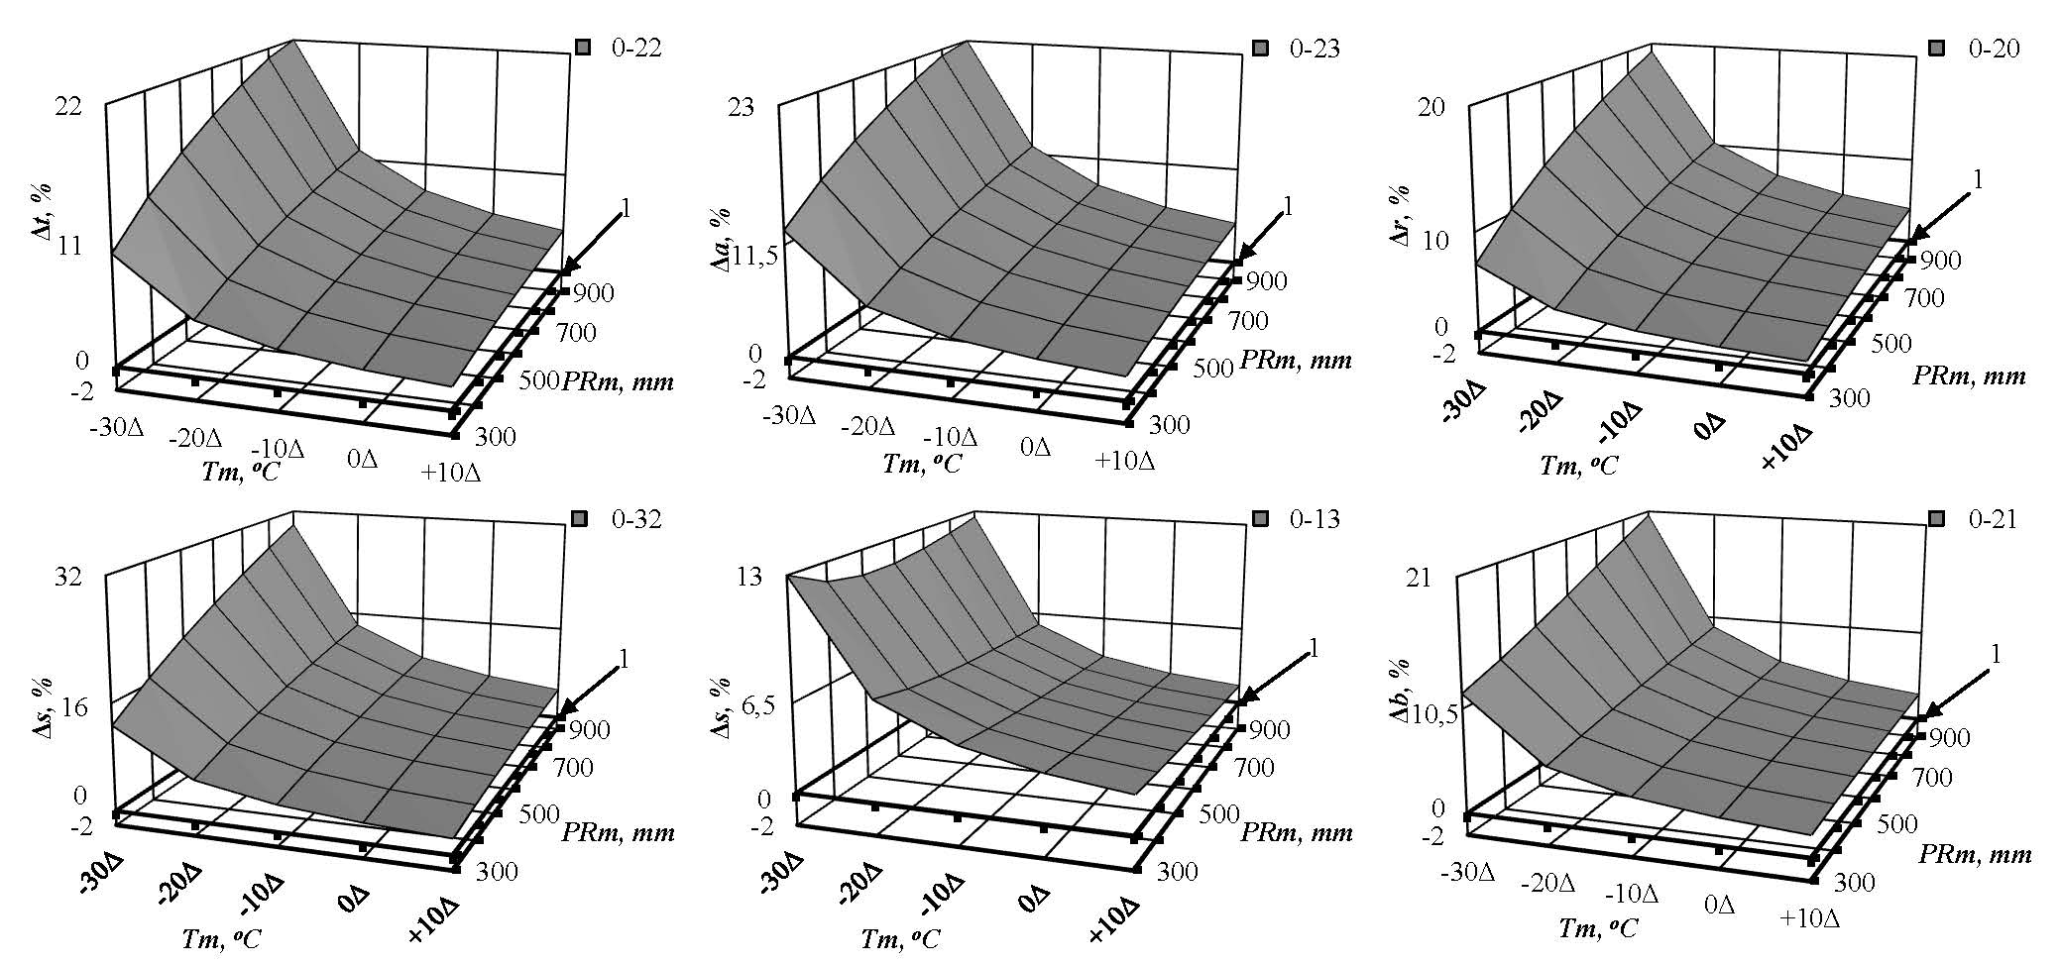
Figure 6. Changes in the spruce stand biomass with the temperature increase of 1°C due to the expected climate change at different territorial levels of temperature and precipitation. Tm - mean January temperature, °C; PRm - mean annual precipitation, mm. On the axes of ordinates the biomass components consistently marked, changing with increasing temperature by 1°C ( % ): total Δt, aboveground Δa, roots Δr, stems Δs, foliage Δf and branches Δb. 1 - the plane corresponding to zero change of biomass at the expected temperature increase by 1°C.

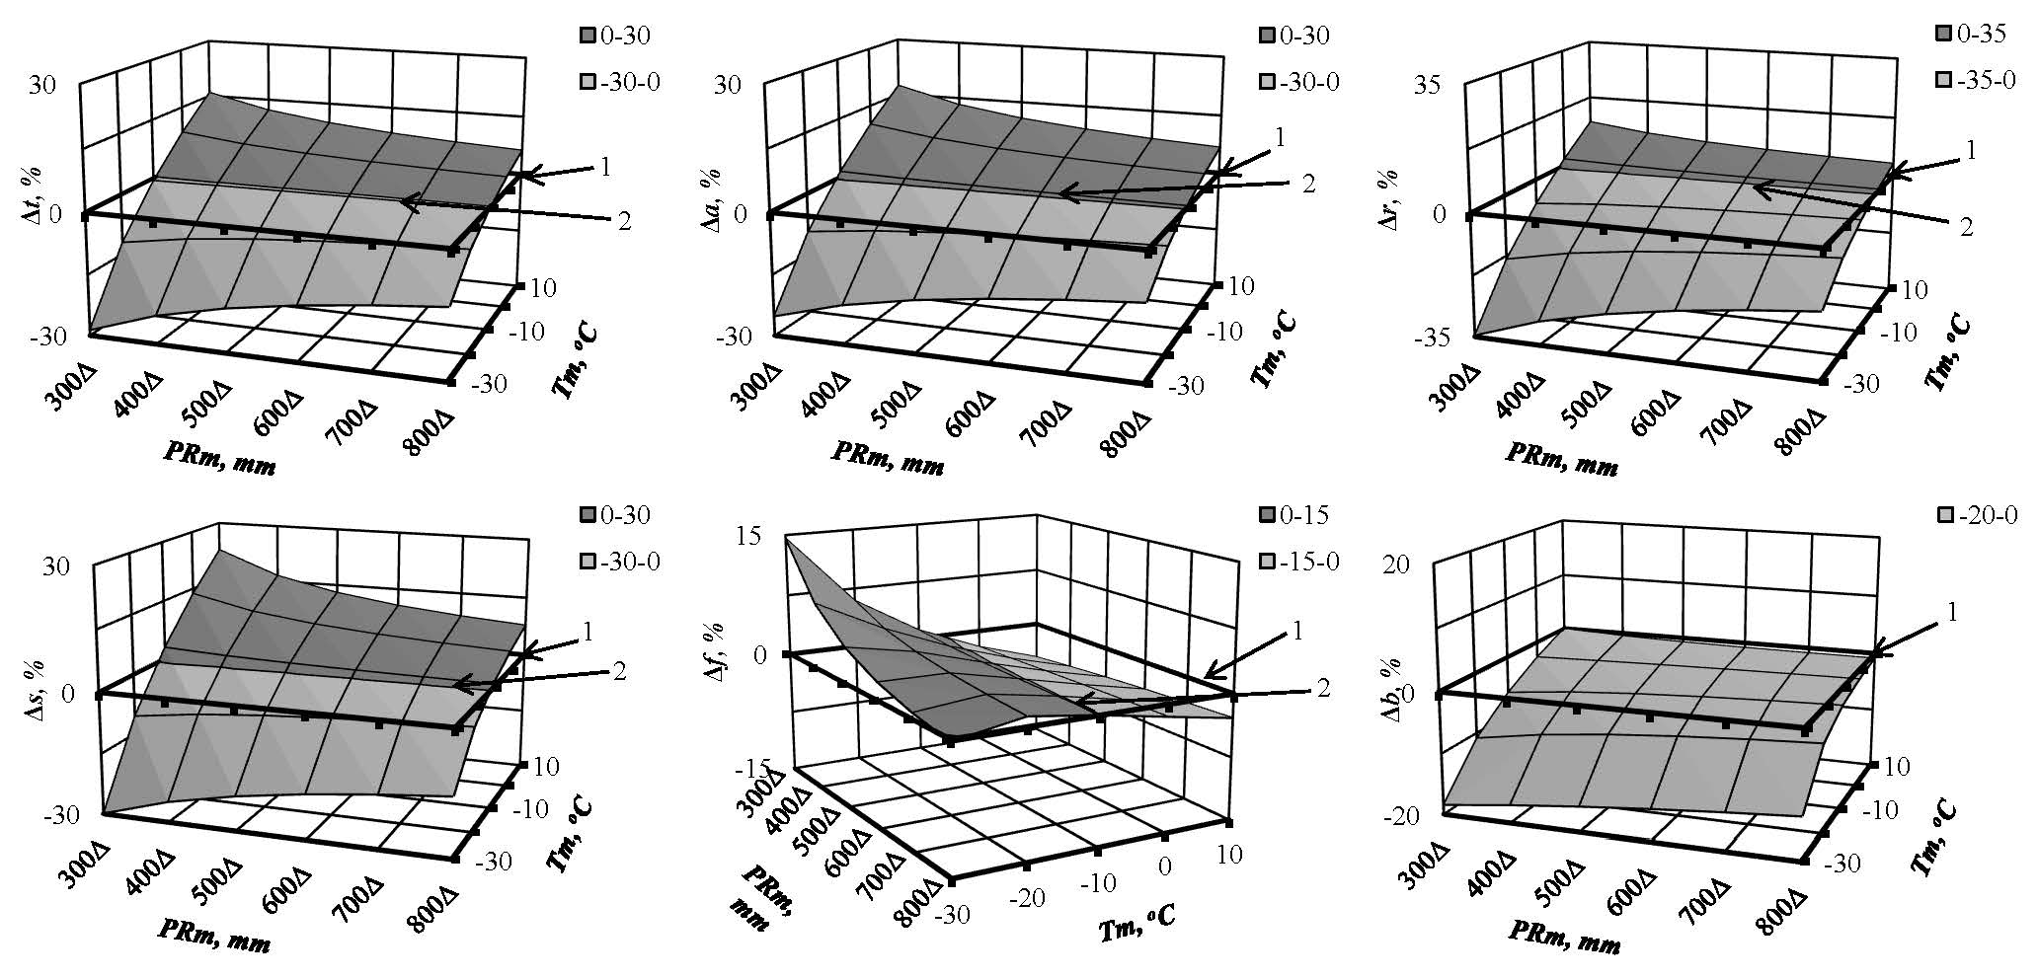
Figure 7. Changes in the spruce stand biomass with the precipitation increase of 100 mm due to the expected climate change at different territorial levels of temperature and precipitation. On the axes of ordinates the biomass components consistently marked, changing with increasing precipitation by 100 mm (% ): total Δt, aboveground Δa, roots Δr, stems Δs, foliage Δf and branches Δb. 1 - the plane corresponding to zero change of biomass at the expected precipitation increase by 100 mm; 2 – the line of differing of positive and negative changes in biomass (Δ,%) with an expected increase in precipitation by 100 mm.

The obtained additive models of spruce stand biomass make it possible to establish quantitative changes in the biomass structure due to climatic changes, in particular, the mean January temperature and mean annual precipitation. The percentage change in the biomass structure is associated with the ratio of these two climatic parameters.
Let’s take for example the central part of European Russia, characterized by the mean January temperature equal to -10°C and the mean annual precipitation equal to 500 mm. Then let’s tabulate the sequence of equations (2), (3) and (1) for each biomass component, substituting in the equations the values of the forest stand age equal to 100 years, mean January temperature equal to -10°C and mean annual precipitation equal to 500 mm. After that, we repeat the procedure by setting into the equations the same age and precipitation values, and the temperature value is not -10°C, but -9°C, i.e. we increase the temperature by 1°C. When using the difference between these two results, we conclude for Russia’s spruce stands at the age of 100 years that the increase in temperature by 1°C at a constant level of precipitation causes the increase in the biomass of all the components: total, aboveground, roots, stems, foliage and branches by 5.1; 5.4; 3.8; 5.8; 3.3 и 4.1 %, respectively.
Then, for the same region, we re-tabulate the sequence of equations (2), (3) and (1) for each biomass component, substituting into the equations the age of 100 years, mean January temperature -10°C and mean annual precipitation of 500 mm, and again, repeat the procedure, substituting in the equations the same values of age and temperature, but another value of precipitation, namely, not 500, but 600 mm, i.e. increase the amount of precipitation by 100 mm. The following result is obtained: the decrease in the total biomass, roots and branches by 0.4; 4.7 and 4.3 %, respectively, and increase in aboveground, trunks and needles respectively by 0.8; 1.6 and 0.4 %, respectively.
Now we apply the same principle to the whole set of ecoregions characterized by maximum temperature and precipitation ranges. Let’s pay our attention to the fact that in Figure 5 both temperature and precipitation trends of biomass have positive dependences. The exception is the foliage biomass, which during the transition from the regions of insufficient moisture (PRm = 300 mm) to the regions of increased moisture (PRm = 900 mm) in the warm zone (Тm = +10°C) does not increase but decreases.
In the geometric interpretation of the above-mentioned biomass increments of biomass dependences describing the temperature changes at a constant level of precipitation in one hand and describing the precipitation level changes at a constant temperature in the other hand, we can see some analogy with a geometric interpretation of the first derivative of a function: with positive trends of the dependencies shown in Fig. 5, the named increments have a sign ( + ), and with negative trends, the increments have a sign ( -).
Figure 6 shows the change (Δ, %) in the spruce forest biomass with the increase in temperature by 1°C in different ecoregions characterized by different values of temperature and precipitation. It is assumed that climate change does not affect precipitation, which changes only geographically (by ecoregions), while the temperature as a result of the expected climate change increases by 1°C at different territorial (zonal) temperature levels, designated as -30Δ... +10Δ. Thus, Figure 6 shows the common pattern of the increase (the location of the increment surface above the zero plane) in both the total biomass and all its components, including the roots, of spruce stands with the temperature increase by 1°C in all the temperature zones of Eurasia and in all the regions with different precipitation levels.
Figure 7 shows the change (Δ, %) in the spruce forest biomass with an increase in precipitation by 100 mm in different ecoregions. It is assumed that January temperature changes only geographically, while the precipitation as a result of the expected climate change increases by 100 mm at different territorial precipitation levels designated as 300Δ...800Δ. In warm zones (0°C...10°C) biomass total, aboveground, stems and roots with the increase in precipitation by 100 mm increases (the location of the increment surface above the zero plane), and in cold ones (-20°C...-30°C) decreases (the location of the increment surface under the zero plane). Biomass components of the crown respond to changes in precipitation ambiguous. Foliage biomass decreases in cold zones (-10°C...-30°C), but the branches biomass increases, regardless of regional levels of current precipitation. In warm zones (0°C...10°C), the foliage and branches biomass remains unchanged with the increase in precipitation by 100 mm at the current levels of precipitation in all the ecoregions (all the increment surface is under the zero plane).
It is known, the solution of each new problem and the corresponding removal of the associated uncertainty generates several new ones. In our case, there are at least three uncertainties that have arisen.
1) The patterns shown are hypothetical: they reflect the long-term adaptive responses of forest stands to regional climatic conditions and do not take into account the rapid trends of current environmental changes, which place serious constraints on the ability of forests to adapt to new climatic conditions (Alcamo et al., 2007).
2) Since the database used has a lot of "white spots" and does not completely cover the territory of Eurasia, the shown patterns are preliminary. As the database will be supplemented and climate maps will be updated, these patterns will be modified.
3) The patterns shown in accordance with the database used, are related to fir forests, pure or with slight admixture of other tree species. However, most of the forest area is represented by mixed tree coenoses. There is a lot of evidences that mixed tree coenoses are more resistant to stresses caused by abiotic factors and are more productive than pure coenoses (Liang et al., 2016). However, a recent study of net primary production (NPP) of aboveground biomass from forest phytocenoses in Spain and Canada over a wide range of biodiversity index as well as of mean temperature and moisture conditions (Paquette et al., 2018) led to a paradoxical conclusion. It was found that in pure forest stands (biodiversity index is zero), NPP reacts to temperature rise up to 1-2°C in different climatic zones in different ways: it grows in forests of the temperate zone, remained stable in boreal forests and declines in the rain forests of the Mediterranean, but as the biodiversity index increases in different zones, these trends gradually transformed into the unified negative trend, common for all zones (Paquette et al., 2018). This result calls into question all previously obtained regularities of changes in NPP of pure (or almost pure) forest communities in the conditions of variable climate: in forests with an increased biodiversity index, previously established patterns can be significantly modified and even reversed.

Conclusion
In this study, we found that the biomass of all components increases with the increase in the mean January temperature, regardless of mean annual precipitation. In warm zonal belts with increasing precipitation the biomass of all components increases, except for the needle mass, but the foliage biomass decreases under the same conditions. In process of the transition from the warm zone to the cold one, the dependence of all biomass components upon precipitation is leveled, and at the mean January temperature equal to -30°C it becomes weak negative trend. In addition, with the increase in temperature by 1°C in different ecoregions, characterized by different values of temperature and precipitation, there is a general pattern of decrease, as the total biomass, and all its components, including roots. With the increase in precipitation by 100 mm in different ecoregions, characterized by different values of temperature and precipitation, in warm zonal belts (0°C...10°C) biomass total, aboveground, stems and roots is increasing, and in cold ones (-20°C...-30°C) is decreasing. The foliage biomass in cold zones (-10°C...-30°C) increases regardless of regional levels of current precipitation, and in warm zones (0°C...10°C) decreases. As a consequence, the branches biomass decreases in all ecoregions.

References

Alcamo J., Moreno J.M., Nováky B., Bindi M., Corobov R., Devoy R.J.N., Giannakopoulos C., Martin E., Olesen J.E., Shvidenko A. (2007). Europe: impacts, adaptation and vulnerability. Contribution of Working Group II to the Fourth Assessment Report of the Intergovernmental Panel on Climate Change // Parry M.L., Canziani O.F., Palutikof J.P., van der Linden P.J., Hanson C.E. (eds.). Climate change. Cambridge University Press, Cambridge. P. 541–580.
Anderson K.J., Allen A.P., Gillooly J.F., Brown J.H. (2006). Temperature-dependence of biomass accumulation rates during secondary succession // Ecology Letters. 9: 673-682.
Baskerville G.L. (1972). Use of logarithmic regression in the estimation of plant biomass // Canadian Journal of Forest Research. 2: 49-53.
D’Aprile F., Tapper N., Marchetti M. (2015). Forestry under climate change. Is time a tool for sustainable forest management? // Open Journal of Forestry. 5: 329-336.
DeLucia E.H., Maherali H., Carey E.V. (2000). Climate-driven changes in biomass allocation in pines // Global Change Biology. 6 (5): 587-593. (DOI: 10.1046/j.1365-2486.2000.00338.x).
Dong L., Zhang L., Li F. (2015). A three-step proportional weighting system of nonlinear biomass equations // Forest Science. 61 (1): P. 35-45.
Dylis N.V. (1978). Fundamentals of biogeocenology. Moscow: Moscow State University Publ., 152 pp.
Eggers J., Lindner M., Zudin S., Zaehle S., Liski J. (2008). Impact of changing wood demand, climate and land use on European forest resources and carbon stocks during the 21st century // Global Change Biology. 14: 2288–2303.
Fang O., Yang Wang Y., Shao X. (2016). The effect of climate on the net primary productivity (NPP) of Pinus koraiensis in the Changbai Mountains over the past 50 years // Trees. 30: 281–294. DOI 10.1007/s00468-015-1300-6.
Fatichi S., Pappas C., Zscheischler J., Leuzinge S. (2018). Modelling carbon sources and sinks in terrestrial vegetation // New Phytologist. 1-17. DOI: 10.1111/nph.15451.
Fu L., Lei X., Hu Z., Zeng W., Tang Sh., Marshall P., Cao L., Song X., Yu Li., Liang J. (2017) Integrating regional climate change into allometric equations for estimating tree aboveground biomass of Masson pine in China // Annals of Forest Science. 74 (42): 1-15. DOI 10.1007/s13595-017-0636-z.
Golubyatnikov, L.L., Denisenko, Е.А. (2009). Influence of climatic changes on the vegetation of European Russia. News of Russian Academy of Sciences. Geographic series., 2: 57-68.
Han S.H., Kim S., Li G., Chang H., Yun S.J., Jiae An J., Son Y. (2018). Effects of warming and precipitation manipulation on fine root dynamics of Pinus densiﬂora Sieb. et Zucc. seedlings // Forests. 9, 14 (doi:10.3390/f9010014).
Huston M.A., Wolverton S. (2009). The global distribution of net primary production: resolving the paradox // Ecological Monographs. 79 (3): 343–377. DOI: 10.1890/08-0588.1.
Keeling H.C., Phillips O.L. (2007). The global relationship between forest productivity and biomass // Global Ecology and Biogeography. 16: 618-631. DOI: 10.1111/j.1466-8238.2007.00314.x.
Laing J., Binyamin J. (2013). Climate change effect on winter temperature and precipitation of Yellowknife, Northwest Territories, Canada from 1943 to 2011 // American Journal of Climate Change. 2: 275-283. DOI:10.4236/ajcc.2013.24027.
Liang J., Crowther T. W., Picard N., Wiser S., Zhou M., Alberti G., Schulze E.-D., McGuire A. D., Bozzato F., Pretzsch H., de-Miguel S., Paquette A., Hérault B., Scherer-Lorenzen M., Barrett C. B., Glick H. B., Hengeveld G. M., Nabuurs G.-J., Pfautsch S., Viana H., Vibrans A. C., Ammer C., Schall P., Verbyla D., Tchebakova N. M., Fischer M., Watson J. V., Chen H. Y. H., Lei X., Schelhaas M.-J., Lu H., Gianelle D., Parfenova E. I., Salas C., Lee E., Lee B., Kim H. S., Bruelheide H., Coomes D. A., Piotto D., Sunderland T., Schmid B., Gourlet-Fleury S., Sonké B., Tavani R., Zhu J., Brandl S., Vayreda J., Kitahara F., Searle E. B., Neldner V. J., Ngugi M. R., Baraloto C., Frizzera L., Bałazy R., Oleksyn J., Zawiła-Niedźwiecki T., Bouriaud O., Bussotti F., Finér L., Jaroszewicz B., Jucker T., Valladares F., Jagodzinski A. M., Peri P. L., Gonmadje C., Marthy W., O’Brien T., Martin E. H., Marshall A. R., Rovero F., Bitariho R., Niklaus P. A., Alvarez-Loayza P., Chamuya N., Valencia R., Mortier F., Wortel V., Engone-Obiang N. L., Ferreira L. V., Odeke D. E., Vasquez R. M., Lewis S. L., Reich P. B. (2016). Positive biodiversity - productivity relationship predominant in global forests // Science. 354 (6309): 196-208. (DOI: 10.1126/science.aaf/8957).
Lieth H. (1974). Modeling the primary productivity of the world // International Section for Ecology Bulletin. Vol. 4. P. 11-20.
Miao Z., Li C. (2011). Predicting tree growth dynamics of boreal forest in response to climate change // C. Li et al. (eds.). Landscape Ecology in Forest Management and Conservation. Berlin, Heidelberg: Higher Education Press, Beijing and Springer-Verlag, P. 176-205.
Ni J., Zhang X.-S., Scurlock J.M.O. (2001). Synthesis and analysis of biomass and net primary productivity in Chinese forests // Annals of Forest Science. 58: 351-384 (www.edpsciences.org).
Paquette A., Vayreda J., Coll L., Messier C., Retana J. (2018). Climate change could negate positive tree diversity effects on forest productivity: A study across five climate types in Spain and Canada // Ecosystems. 21 (5): 960–970 (DOI: 10.1007/s10021-017-0196-y).
Poudel B.C., Sathre R., Gustavsson L., Bergh J., Lundström A., Hyvönen R. (2011). Effects of climate change on biomass production and substitution in north-central Sweden // Biomass and Bioenergy. 35 (10): 4340–4355.
Schwarz F. (1899). Physiologische Untersuchungen über Dickenwachstum und Holzqualität von Pinus silvestris. Berlin: P. Parey, 404 S.
Shuman J.K., Shugart H.H. (2009). Evaluating the sensitivity of Eurasian forest biomass to climate change using a dynamic vegetation model // Environmental Research Letters. 4 (4): 1–7.
Stegen J.C., Swenson N.G., Enquist B.J., White E.P., Phillips O.L., Jorgensen P.M., Weiser M.D., Mendoza A.M., Vargas P.N. (2011). Variation in above-ground forest biomass across broad climatic gradients // Global Ecology and Biogeography. 20 (5):744–754 (https://doi.org/10.1111/j.1466-8238.2010.00645.x).
Strömgren M., Linder S. (2002). Effects of nutrition and soil warming on stem wood production of a boreal Norway spruce stand // Global Change Biology. 8: 1195–1204.
Tang S., Zhang H., Xu H. (2000). Study on establish and estimate method of compatible biomass model // Scientia Silvae Sinica. 36: 19–27 (in Chinese with English abstract).
Usoltsev V.A. (2010). Eurasian forest biomass and primary production data. Yekaterinburg: Ural Branch of Russian Academy of Sciences. 570 pp. ISBN 978-5-7691-2122-7. (http://elar.usfeu.ru/handle/123456789/2606).
Usoltsev V.A. (2013). Forest biomass and primary production database for Eurasia. CD-version. The second ed. enlarged and re-harmonized. Yekaterinburg: Ural State Forest Engineering University, (http://elar.usfeu.ru/handle/123456789/3059).
Wilmking M., Juday G.P., Barber V.A., Zald H.S.J. (2004). Recent climate warming forces contrasting growth responses of white spruce at treeline in Alaska through temperature thresholds // Global Change Biology. 10:1724–1736.
World Weather Maps (2007). URL: https://www.mapsofworld.com/referrals/weather/.

