Pasture and land degradation by weedy invasion on frost heave surfaces in Changthang region of Leh-Ladakh

Dr Mahendra Raghuwanshi, ICAR-NBSS-LUP, Nagpur-440033 Maharashtra India
Dr Pratap Moharana, ICAR-CAZRI, Jodhpur-342003, Rajasthan, India
Ms Stanzin Landol, ICAR-RRS,ICAR-CAZRI, Leh-Ladakh-194101, Jammu & Kashmir India
Mr. Ngawang Dorjay, ICAR-RRS,ICAR-CAZRI, Leh-Ladakh-194101, Jammu & Kashmir India
Dr Enoch Spalbar, ICAR-RRS,ICAR-CAZRI, Leh-Ladakh-194101, Jammu & Kashmir India
Dr R.K. Bhatt, ICAR-CAZRI, Jodhpur-342003, Rajasthan, India

Statement of the problem: Himalayan High Altitude Wetlands are the unique ecosystems of the world, supporting a wide variety of flora/ fauna, providing valuable pastures to the local communities who are dependent upon livestock and also the sources of various rivers, originating from the region. Ladakh, the cold desert located in NW Himalayas has a number of high altitude wetlands and pastures that are now facing high degree of degradation due to desiccation, salinity, feeding pressure and invasion by exotic weedy species. Such processes were observed on frost heave grounds which supported dominant steppes and alpine grasslands at elevations up to 5600 meter MSL.

Methodology & Theoretical Orientation: Frost heave sites were identified in Leh, Tangtse and Tsokar areas after a field survey supported with their interpretation from IRS LISS 4 satellite images. Samples were drawn and biomass of grass species was computed.

Findings: Frost heave grounds develop under the process of frequent swelling and shrinking of land/ soil. Grasses growing upon these surfaces are found to either dry or die during dry conditions or germinate again during humid condition. Assessment in Changthang grasslands fund that vegetation is mostly dominated by smallest Cyperaceae endemic, not taller than 2 to 3 cm high of covering more than 90%, and consist of only 8 to 10 tiny rosette, sedges, and other cohesive group of vegetation like Kobresia spp, Carex, Astragalus strictus, Helerpestus spp, Taraxacum spp, etc. Cirsium, an invasive weedy species has accidentally infiltrated in Changthang region due to increased tourism, is responsible for decreased plant biodiversity affecting due to its allelopathic effect. Cirsium arvense survives and establish themselves better under harsh conditions. Saline soils (Ec, 57.2) like at Tosokar also caused severe degradation of pastures.
Conclusion: The study made a basic inventory of frost heave patterned grounds in cold arid desert of Leh and found typical growth and association of weeds on such surfaces that are known to reduce the survival of palatable plant or grasses.

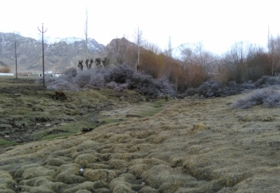 | 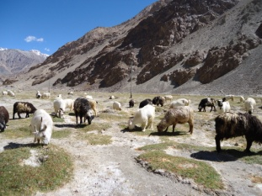
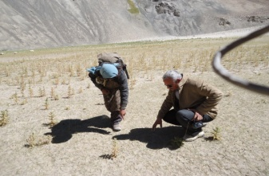 | 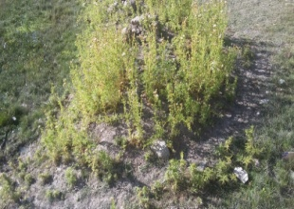

Recent publications
- Chandan, Pankaj, Chaterjee, Archana and gautam, Parikshit (2008) Management planning of Himalayan High Altitude Wetlands: A case study of Tsomoriri and Tsokar wetlands in Ladakh, India. Proc. TALL 2007: The 12th World Lake Conference: 1446-1452
- Rawat, Gopal S. and Adhikari, Bhupendra S. (2005) Floristics and Distribution of Plant Communities across Moisture and Topographic Gradients in Tso Kar Basin, Changthang Plateau, Eastern Ladakh. Arctic, Antarctic, and Alpine Research, 37(4):539-544.
- Williams, Peter J. (2013). Frost Heave. Encyclopaedia of Geomorphology. Vol 1&2: 415-416

Biography of authors
Dr Mahendra Raghuwanshi is a Principal Scientist (Agronomy) worked on Integrated weed management in Kymore Plateau and Satpura Hills of Central India and Ladakh Cold Arid region of Western Himalaya; Productivity and energetic of agricultural production systems in Leh; Evaluation of diverse methods for herbicide slow delivery and weed control; Biosafety research Trial Level-1 study on bio-efficacy of glyphosate in transgenic corn (MON 89034X NK 603), National Mission on Sustaining Himalayan Ecosystem Task Force-6 (Himalayan Agriculture) and National Mission on Sustaining Himalayan Ecosystem Task Force-5 (Traditional Knowledge Systems) at Western Himalaya. Established Community Seed Bank at Stakmo, Leh-Ladakh for preserving local germplasm. At present working for Land Use Planning at ICAR-National Bureau of Soil Survey and Land Use Planning, Nagpur, published 28 national research papers and 11 chapters, 4 review papers and many popular articles in the field of weed science and cold arid regions.

