Dangers of climate change and its impacts on economy and food security to developing countries – Case study Uganda.

Basiima Louis- Kampala International University

Abstract
Climate change and the threat of related extreme conditions like flood and droughts, have major implications for economic growth particularly in developing countries like Uganda which is already experiencing the negative effects of climate change and the situation is expected to worsen, as impending calamities which will affect agriculture, infrastructure, health among others.
There are worries that if everything continue to be the way they are and nothing is done at all to minimize possible causes of climate change especially manmade Uganda is likely to face serious disaster. This has started affecting the country’s development efforts and causing shifts in the spread of diseases like typhoid, malaria, rainfall patterns among others.
The country is highly vulnerable to climate change and variability thus, its economy and the wellbeing of its people are tightly bound to climate. Human induced climate change today has the potential to halt or reverse the country's development trajectory.
Climate change has a serious implications for the nation's economy previously, with for example, a shift in the viability of coffee growing areas potentially wiping out US $265.8 million or 40% of export revenue.
It is the poor and vulnerable people in remote and hard to reach areas who feel these impacts the hardest. In February 2017, at least 40 people died and unknown number of livestock in Moroto District (North-Eastern Uganda) due to hunger following the prolonged dry spells that rendered a food accessibility a nasty challenge.
The dry spell hit hard in neighboring districts of Katakwi, Amuria, Soroti, Kumi and Serere in Teso Sub region. The severe lack of food and drinking water for both humans and animals has compounded the already dreadful situation forcing multitude to flee to areas with food. Prolonged droughts have left many Ugandans in rural areas suffering and has result to hiking of prices for different food commodities due to their s
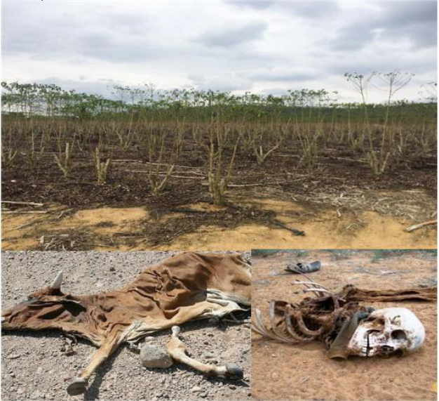
Figure 1: Effects of prolonged dry spells in Uganda has brought destruction of crop plantations, death of livestock and people.
References
1. Government of Uganda (2013) Uganda Climate Change Costed Implementation strategy (http://ccd.go.ug/index.php/accordion-b/level-2/2-uncategorised/120-Uganda-cc-costed-implementation -strategy-final-version-for-approval-14-10-2013).
2. NEMA (2015) State of Environmental Report for Uganda 2016. Kampala. National Environmental Management Authority.
3. Okori A, Emuria M & Ojuman P, Uganda Participatory Poverty Assessment Process, Soroti District Report, CDRN, MFPED, Uganda, 2002,21-24.
4. OPM (2016) Office of the Prime Minister: The 2010-2011 Integrated Rainfall Variability Impacts, Needs Assessment and Drought Risk Management Strategy. Kampala.

5. Stark,J.,2011, Climate change and conflict in Uganda. The cattle corridor and Karamoja: USAID Office of Conflict Management and Mitigation, Discussion No.3

