Atomic Energy – green and renewable
Vladimir A. Grachev, Adviser to the Director General of Rosatom State Nuclear Energy Corporation, Head of the Global Ecology Center at the Faculty of Global Processes, Lomonosov Moscow State University, Doctor of Technical Sciences, Professor, Corresponding Member of Russian Sciences Academy, Russia

Abstract
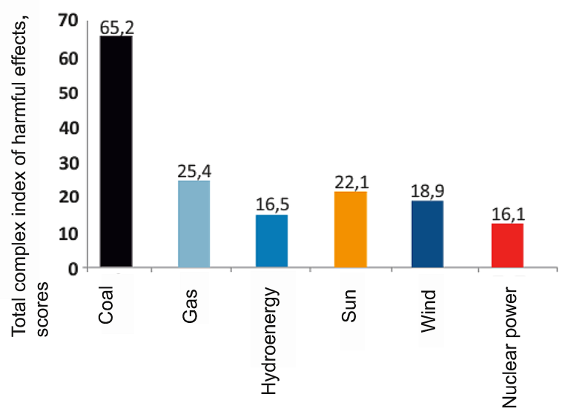
Global climate change is one of the three most important global environmental problems. It is closely connected with the development of energy, where “green” and “renewable” sources of energy are clearly indicated. At the same time the criteria of “greenness” and “renewability” are very vague. Renewable (RES) is usually considered solar, wind and similar, except for fuel, which, apparently, is justified. But why the nuclear energy is not considered as renewable? Because it is potentially dangerous, and for those who consider themselves to be “green”, it is not in high esteem. Is it so? The task is urgent, it is necessary to understand.
The second task is whether the nuclear energy is green or not? “The green” say that it is not green. “Greenness” is determined by environmental efficiency. The environmentl efficiency of energy technologies depends on what kind of energy is used and it is determined by the impact of this technology on the environment and environmental safety for personnel and the public.
The energy withdrawal for human needs is always associated with some environmental problems: climate change, pollution and depletion of natural resources.
It is clear that some energy technologies are not associated with the release of greenhouse gases and therefore do not affect global climate change. However, in order to create devices to convert the sun or wind energy, or to build a nuclear power plant, it is necessary to obtain construction materials, to manufacture equipment, to carry out construction work, to use materials and vehicles for their operation, etc., which in turn is associated with the greenhouse gases emission, and, consequently, with the global climate change.

Image
Fig. 1. The total complex indicator of harmful impact on the
environment and human by E2-E8
Recent publications (minimum 5)
- Blis T. The medicine for the planet. A painless remedy for an energy and environmental disaster. Public Council of the State Corporation "Rosatom", 2009. 512 p.
- Grachev V.A. Quality Of Cast Iron Smelted In A Gas Cupola Furnace As A Constructional Material. International Journal of Applied Engineering Research ISSN 0973-4562 Volume 11, Number 13, 2016.
- Galli A., Wiedmann T., Ercin E., Knoblauch D. Integrating Ecological, Carbon and Water footprint into a “Footprint Family” of indicators: Definition and role in tracking human pressure on the planet / Ecological Indicators 16, 2012. pp. 100 – 112.
- McDonald A., Nuclear power and sustainable development. IAEA. Planning and Economic Research Section. Department of Nuclear Energy International Atomic Energy Agency, Wagramer Strasse 5, P.O. Box 100 A-1400 Vienna, Austria
- Stechow C., Minx J., Riahi K., Jewell J., McCollum D., Callaghan M., Bertram C., Luderer G., Baiocchi G. 2°C and SDGs: united they stand, divided they fall? Environmental Research Letters (Journal). Environ. Res. Lett. 11 (2016) 034022 doi:10.1088/1748-9326/11/3/034022. Available: http://iopscience.iop.org/article/10.1088/1748-9326/11/3/034022/pdf

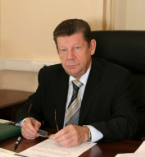
Biography
Adviser to Director General of Rosatom State Corporation, D.Sc., Professor, Member of the Russian Academy of Sciences
Vladimir Grachev started his career in 1960s as an engineer at Compressor Plant; later he held a chair at the Penza State Polytechnical Institute. In 1990 he was elected a Deputy Chairman of the Committee on Higher Education and Training at the Supreme Council of the Russian Federation. Later Grachev was the Chief of the Federation Council’s Committee on Science, Culture, Education, Health and Ecology. In 1999-2007 he was elected a deputy of the State Duma, the Chairman of the Committee on Ecology.Now he has been the Adviser to the Director General of Rosatom. Main research area is physic-chemical technological bases of non-organic materials.
V.A. Grachev is an honorary member of the PACE, Chairman of the Public Council under Rostekhnadzor, member of the Commission for UNESCO, President of Vernadsky Nongovernmental Ecological Foundation.
Email: vagrachev@gmail.com
Correspondence email: salganskaya@vernadsky.ru

Notes/Comments:

