Education and Engagement Needed to Drive Awareness and Action on Climate Change
Mr. Ashish Sachdeva, Founder President,
Green Dream Foundation, India
www.facebook.com/greendreamfoundation

Abstract
Climate change presents a borderless and intergenerational phenomenon, with diverse and far-reaching impacts across the global community. Human activities are irreversibly changing the environment in which society exists, requiring collective, immediate and profound action on climate change.
Highlights
- Governments to lead on addressing climate change and the use a multi-sectoral approach to policy development;
- Addressing climate change and effective integration into education requires an understanding of the root causes and the social, economic and environmental relationships at play;
- Education should be engaged as a mechanism to develop a workforce with the skills and knowledge to power green growth;
- Climate change be addressed through the use of formal, non-formal and informal education targeting a wide cross-section of stakeholders, including as students, communities, industries and governments;
- Climate change education should not be restricted by subject, but should be integrated across the curriculum, and requires emphasis on problem-solving and evidence-based thinking; and,
- Pursuit of a collaborative approach to teacher training to foster acceptance of new methodologies and integration of climate education across the system.

Image

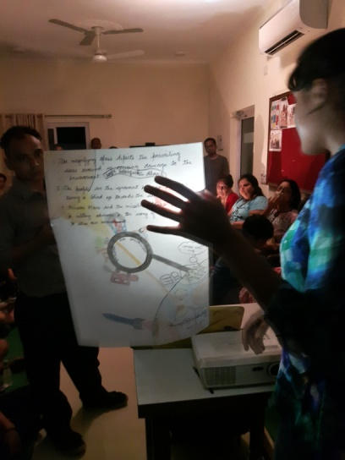
Recent Publications
- Talk at the Smart Cities India expo 2018: https://youtu.be/FlIfYE4JsJ8
- Talk at TEDxGurgaon: https://youtu.be/5_o5v84XDnU
- Work done to drive awareness on Earth Hour 2018: https://www.hindustantimes.com/noida/noida-residents-bodies-corporate-groups-to-observe-earth-hour-today/story-Bhssfj8qkC3DEqDlSJgclI.html
- Speaker profile for Global CSR Summit & Awards in Indonesia: http://globalcsr.pinnaclegroup.global/2018/speaker/ashish-sachdeva/
- Speaker profile for Water India Expo 2018: http://www.waterindia.com/speakers.aspx

Photograph


Biography
Ashish is the Founder President of Green Dream Foundation, a new-age NGO based in India. Before committing himself completely to the service of the planet and people, he also worked in ‘Customer Success’ leadership positions across different multi-national corporations for over 10 years.

His mission has been to create an educational and socially responsible advocacy platform for people to empower and engage their peers in environmental activities to ensure a healthier, cleaner and more sustainable planet for businesses, customers, employees, homeowners and families. As a young person, he realized that “not-knowing-how-to-get-things-done” was restricting young people from ‘taking the plunge’ and standing up for issues they felt deeply about. He felt a strong urge to develop a platform for young people across the world to synchronize their approach towards addressing these issues. His will to fight for the odds against the environment sowed the seeds of the Foundation.

Green Dream Foundation (GDF) was founded in March 2008. GDF is focused on generating awareness about environmental issues through effective channels. It engages with communities through social media primarily Facebook, Instagram, YouTube and also conducts workshops and seminars in person to educate people and then measure results. It facilitates steps that help reduce carbon footprint so not just education but also ‘end to end consultation’ as Ashish believes that learning should be followed by real action. GDF also supports companies with their CSR initiatives that really make a long lasting impact both in terms of education / awareness and actual impact on the environment and society.

Ashish has delivered thought-provoking talks at global leadership forums around environment, CSR and sustainability. Global CSR Summit, World Green Infrastructure Congress, Smart Cities India expo, TEDx and IIT Roorkee are the recent ones.

Email: reach@greendream.foundation, ashish.sachdeva007@gmail.com

