Enhanced land subsidence in Galveston Bay, Texas: Interaction between sediment accumulation rates and relative sea level rise
Mohammad E. Al Mukaimia
Timothy M. Dellapenna,
Joshua R. Williams

Abstract (300 word limit)
Galveston Bay is the second largest estuary along the northern Gulf of Mexico coast, with a watershed containing one of largest concentrations of petroleum and chemical industries globally, as well as Houston, the fifth largest metropolitan area in the USA. Throughout the last century, extensive groundwater extraction to support these industries and an expanding population has resulted in significantly enhanced land subsidence (0.6–3.0cmyr−1). The highest subsidence rates observed in the bay are within the lower 15km of the San Jacinto River/Houston Ship Channel region (SJR/HSC), with distal areas in East and West Galveston Bays having subsidence rates on the order of 0.2 cm yr−1. In order to investigate the impacts of subsidence on sedimentation, a series of 22 vibracores were collected throughout the bay, and 210Pb and 137Cs radioisotope geochronologies and grain size distributions were determined. Sediment accumulation rates are highest (1.9 ± 0.5 cm yr−1) in the SJR/HSC, and decrease (< 0.6 cm yr−1) both seaward and towards low subsidence regions. These results indicate sedimentation rates are significantly (p < 0.01) higher in areas with elevated Relative Sea Level Rise (RSLR). However, throughout most of Galveston Bay sedimentation rates are lower (as much as 50%) than estimated RSLR, indicating a sediment accretionary deficit. In areas (e.g., Scott Bay) within the SJR/HSC, the bay has deepened by more than 1.5 m, suggesting that sediment accumulation cannot keep pace with RSLR. Ultimately, this has resulted in a loss of coastal wetlands and a conversion of marine habitats from relatively shallow to deeper water settings.

Image
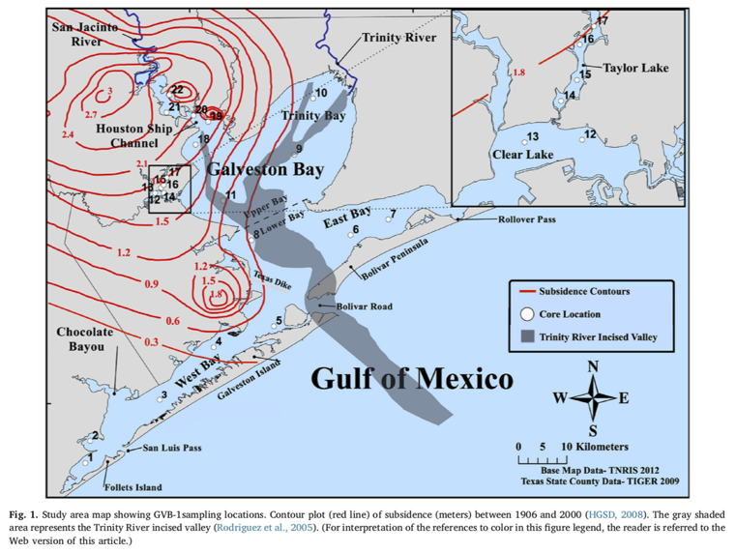
Recent Publications (minimum 5)
- Williams J., Clyne E., Kuehl S., Al Mukaimi M., (2019) Assessment of the high-resolution paleoseismicity record from sediment gravity flows in Prince William Sound, Alaska. Marine Geology 408 (110-122).
- Al Mukaimi M., Kaiser K., Williams J., Dellapenna T., Louchouarn P., Santschi P., (2018) Centennial record of anthropogenic impacts in Galveston Bay: Evidence from trace metals (Hg, Pb, Ni, Zn ) and lignin oxidation products. Environmental Pollution 237 (887-899).
- Al Mukaimi M., Dellapenna T., Williams J., (2018) Enhanced Land Subsidence in Galveston Bay, Texas: Interaction Between Sediment Accumulation Rates and Relative Sea Level Rise. Estuarine, Coastal and Shelf Science 207 (183-193).

 Biography (150-word limit)
Mohammad Al Mukaimi is a marine geochemist at the Marine Science Department of Kuwait University. He received his PhD in Oceanography from Texas A&M University 2016. During his PhD, he worked on Geochemical and Sedimentary Record of Urbanization and Industrialization of the Galveston Bay Watershed with Dr Dellapenna.His research focuses on: 1) Marine sediments geochemistry, 2) Seabed dynamics and sedimentary processes 3) Trace metals in aquatic system.
Email: malmukaimi@hotmail.com

Notes/Commen

