Abstract Template
Abstract Title:
Integral Management Plan to minimize the morbidity of the workers of the Wastewater Treatment Plant (WWTP) in Levapan Tuluá

Idrobo Idrobo, Guillermo¹; Popayán-Hernández, Juan Guillermo²
¹ Occupational Health Administrator, (University Corporation God's Minute)
² Environmental Engineer, Master in Environmental Engineering, PhD. Environmental Sciences (Universidad del Valle, Department of Exact Sciences)

Abstract
This research project shows the risks associated with the operation and the health status of the working population in the Wastewater Treatment Plant (WWTP) at LEVAPAN SA PLANTA TULUÁ, based on a detailed analysis of the risks associated with the processes, activities and tasks of the operation and maintenance of the same.
In the routine execution of the processes of the treatment plant, chemical products are handled and there is prolonged exposure to gases and vapors that are generated as a result of wastewater treatment, generating a high risk to the health of this population.
The research team has devoted all its efforts to prioritize the present risks and the adequate control mechanisms to guarantee a healthy and safe operation, as a result an Integral Plan For The Decrease Of The Morbidity Of The Working Population Of The Plant is presented.
Keywords: Residual Water, Exposure, Morbidity, Integral Management Plan

Professional biography

Guillermo Idrobo Idrobo, Occupational Health Administrator, Industrial Metrologist, Lead Auditor for Quality and Environmental Systems Technologist in electronics of the Universidad del Valle, Industrial Instrumentist of the Multisectorial Center of Barrancabermeja, Metrologo, President of the Colombian Red Cross Tuluá Municipal Unit, President of the Colombian Civil Defense Center del Valle Board, Rescuer during the emergency of the Earthquake in the Coffee Region in Colombia Year 1999, Rescueist in sinister emergency Airplane América Airlines in Cerro San Jose in Buga Valle del Cauca Colombia, Emergency Rescue by Avalanche in Mocoa Putumayo Colombia Year 2018.
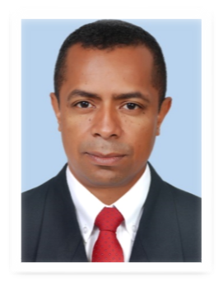
Email Id:gidroboidro@uniminuto.edu.co

Juan Guillermo Popayán-Hernández, environmental engineer (2010) and Master in environmental engineering with emphasis in research (2015) graduated from the Universidad Nacional de Colombia, and is currently a doctoral student in environmental sciences at the Universidad del Valle. He has focused on investigating the impacts of CO₂ on marine ecosystems in the maritime area of Colombia, specifically the relationships between social communities and abiotic factors.
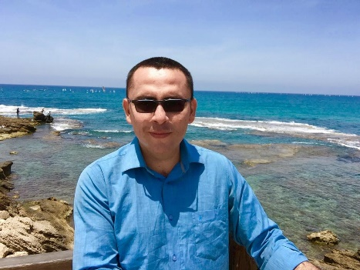
Email Id:jgpopayanh@unal.edu.co

