Abstract Template
Abstract Title:
Environmental sustainability assessment of the mangrove forests of San Andres Island, Colombia using fuzzy logic
Chavarriaga Rodriguez¹, Sarita; Calero Castrillon, John Anderson²; Popayán-Hernández, Juan Guillermo³

¹ Technologist in environmental control, Environmental engineering student (Central Unit of the Valley, UCEVA)
² Environmental engineering student (Central Unit of the Valley, UCEVA)
³ Environmental Engineer, Master in Environmental Engineering, PhD. Environmental Sciences (Universidad del Valle, Department of Exact Sciences)

Abstract (not more than 300 words)

Mangrove forests are strategic ecosystems that occupy less than 1% of tropical areas, which provide various ecosystem services essential for the survival of the various surrounding human communities. In the present study, the sustainability of the mangrove forests of San Andres Island, Colombia, located in the Sea Flower Reserve was evaluated. To do this, a description was first made of the biotic and abiotic variables of the study area, this using information derived from remote NASA sensors and geographically schematized through the QGis software, then community workshops were conducted with the local fishermen in the area, and the integral sustainability index was estimated applying the MESMIS methodology. Finally, the information collected was analyzed through a non-linear method of fuzzy logic through the FisPro software. The main findings were the unsustainable scenarios of mangrove forests due to the overexploitation of the fishery resource, unsustainable tourism and the effects of global climate change.

Keywords— fuzzy logic; mangrove forests; sustainability; MESMIS methodology.

Professional Biography

Sarita Chavarriaga Rodriguez, technologist in environmental control (2014), graduated from SENA , and is currently a environmental engineering student at UCEVA



Email Id: saritachr9515@hotmail.com

Jhon Anderson Calero Castrillón, student of environmental engineering, Central Unit of the Valley, UCEVA.



Email Id:jonandersonc@hotmail.com

Juan Guillermo Popayán, environmental engineer (2010) and Master in environmental engineering with emphasis in research (2015) graduated from the Universidad Nacional de Colombia, and is currently a doctoral student in environmental sciences at the Universidad del Valle. He has focused on investigating the impacts of CO₂ on marine ecosystems in the maritime area of Colombia, specifically the relationships between social communities and abiotic factors.
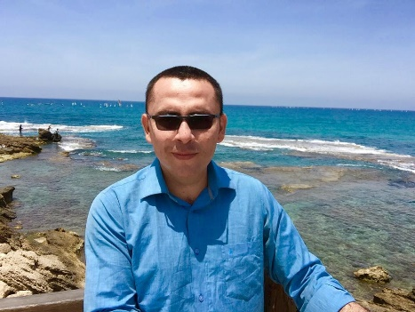
Email Id:jgpopayanh@unal.edu.co

