Abstract Template
Abstract Title:

CO₂ flux effect on the sustainability of coral reefs of San Andres Island, Colombia, using fuzzy logic

Popayán-Hernández, Juan Guillermo¹; Zúñiga Escobar, Orlando²

¹ Environmental Engineer, Master in Environmental Engineering, PhD. Environmental Sciences (Universidad del Valle, Department of Exact Sciences)
² Physicist, Master in technology and development, Master in geophysics, PhD in environmental technology (Universidad del Valle, Department of Exact Sciences).

Abstract

Coral reefs are strategic ecosystems that provide various encosystemic services for provision and regulation, which makes long-term conservation vital. These ecosystems are threatened by wastewater discharges, unsustainable tourism practices, and acidification on account of the incorporation of atmospheric CO₂ into the marine environment. In this sense, this research attempts to assess the effect of CO₂ on the coral reefs of the Island from San Andrés, Colombia, located in the Seaflower Biosphere Reserve, taking three sampling points where the species of coral acropora palmata, acropora cervicornis and copophyllia natans predominate. This evaluation was made from the complexity paradigm, using a non-linear method of fuzzy logic through MatLab and Fispro software. The behavior of the CO₂ flux was estimated through satellite data of sea surface temperature, viewing speed and in situ data such as salinity and dissolved oxygen. The variables associated with CO₂ were schematized through the QGis software for the months of January, March, July and October between 2017 and 2019. Finally, the main findings are presented, which were the factors that limit the sustainability of these ecosystems against to the phenomenon of CO₂ flux using artificial neural networks.

Keywords— Fuzzy logic; CO₂ flux; encosystemic services

Professional Biography

Juan Guillermo Popayán, environmental engineer (2010) and Master in environmental engineering with emphasis in research (2015) graduated from the Universidad Nacional de Colombia, and is currently a doctoral student in environmental sciences at the Universidad del Valle. He has focused on investigating the impacts of CO₂ on marine ecosystems in the maritime area of Colombia, specifically the relationships between social communities and abiotic factors.
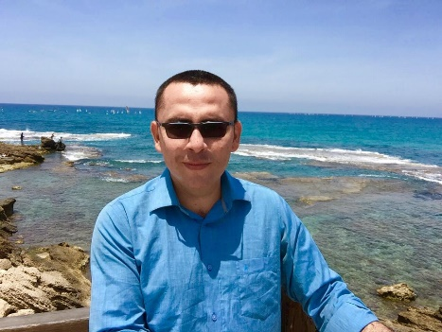
Email Id:jgpopayanh@unal.edu.co
Orlando Zuñiga Escobar, Physicist (1971) graduated from Universidad del Valle, Magister in geophysics (1981) graduated from Technische Universitat Berlin, and Doctor in Environmental Technology (1996) from the Polytechnic University of Madrid, is an emeritus researcher recognized by Colciencias for his extensive research career. Professor at the Universidad del Valle, associated with the Department of Exact Sciences

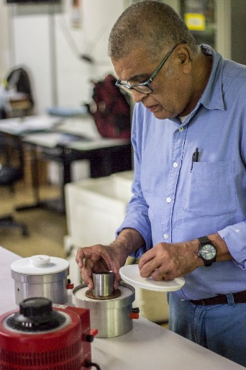

Email Id: orlando.zuniga@correounivalle.edu.co

