The 2019 Design of spray vessels for marine cloud brightening.
S. H. Salter.

(University of Edinburgh, Scotland)

Abstract

The idea from the 2008 design (doi10.1098/rsta.2008.0136) of Flettner rotor propulsion and drop generation by Rayleigh jet breakup remains unchanged. But COMSOL multi-physics software showed that Rayleigh jet breakup needed higher pressures and more energy than expected so the displacement hull and turbine has been replaced with a hydrofoil design with foil pitch-variation being used to generate 300 kW for spray pumping. The forces for power generation are now nearly square to the direction of travel so that there is much less drag. A key problem for Rayleigh spray generation is that nozzles can be clogged by particles one tenth of nozzle diameter forming an arch. We can reduce the problem by closing a hatch on the outside of the nozzle head and pumping a reverse flow back through the nozzle wafer with ultrasonic cavitation inducing a suction on the upstream side. All this needed more space than was available inside the Flettner rotors. We were also concerned about the number of changes of direction of the spray. The new design with just two rotors and a vertical line of wafers on a mizzen mast gives a direct spray path, plenty of room for hatch covers and allows a much large number of spray heads desirable for variations of energy input.

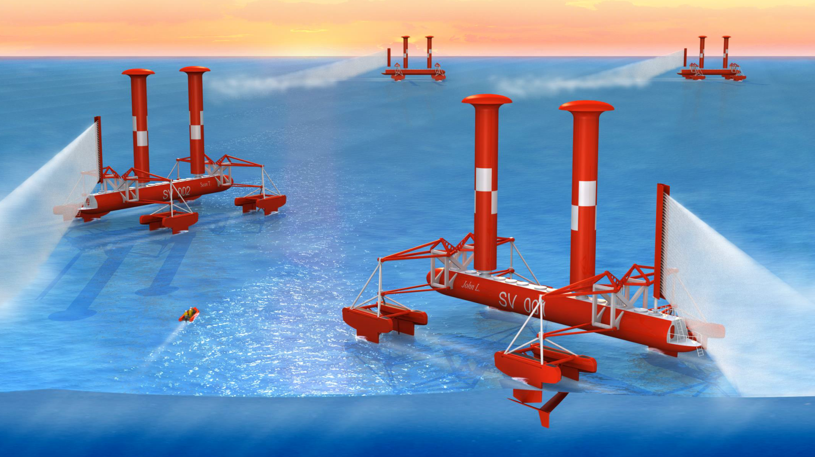

Keywords — cloud-brightening, climate-change, Flettner rotor, hydrofoil.

Professional Biography

Stephen Salter is emeritus Professor of Engineering Design. After an apprenticeship in the aircraft industry on the SR177 and Black Knight he did physics at Cambridge and stayed on as a research assistant/inventor’s mate to Richard Gregory working on microscopes and telescope cameras. He moved with Gregory to Edinburgh University to build robots for Artificial Intelligence and then to the School of Engineering to work on renewable energy.

Email Id: S.Salter@ed.ac.uk

