An everywhere to everywhere transfer function of marine cloud brightening
S. H. Salter.

(University of Edinburgh, Scotland)

Abstract

John Latham suggested that the Twomey effect could be used to increase the reflectivity of clouds and so reverse temperature increases if submicron spray of the right size was released into the troposphere. The two images are from Stjern et al doi:10.5194/acp-2017-629 give the combined results of nine leading climate models on temperature and precipitation changes following an increase in the concentration of cloud condensation nuclei by 50% in sea areas with low level cloud. The increases in precipitation in drought stricken regions would be beneficial. The biggest reductions are over the sea.
Temperature  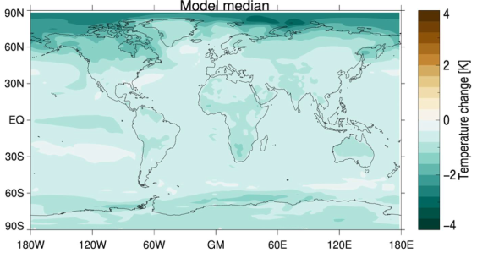 | Precipitation  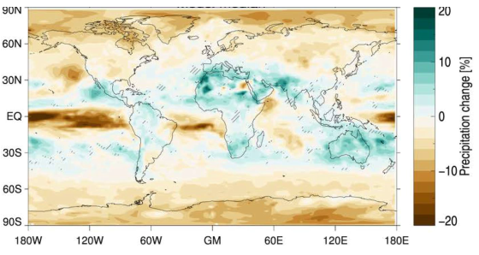
It would be very odd if all regions had the same effect all the year round. It follows that because of the high frequency response due to the short life of nuclei, judicious placing of spray vessels by intelligent fleet controllers with satellite data could avoid the less favourable times and places to give an even greater benefit. This presentation suggests a way to use a signal-processing idea from engineering to use climate models to identify optimum places and seasons depending on the phases of monsoons, El Niño events etc.. The method allows signal detection despite very poor signal-to-noise ratios. The model settings of condensation nuclei concentration would be increased or reduced in a number of sea areas, each with different pseudo-random sequences. Meteorological observations at stations round the world then be correlated with each sequence to give an everywhere-to-everywhere and season-by-season transfer function.
Keywords — transfer-function, cloud-brightening, climate-change. condensation nuclei.

Professional Biography

Stephen Salter is emeritus Professor of Engineering Design. After an apprenticeship in the aircraft industry on the SR177 and Black Knight he did physics at Cambridge and stayed on as a research assistant/inventor’s mate to Richard Gregory working on microscopes and telescope cameras. He moved with Gregory to Edinburgh University to build robots for Artificial Intelligence and then to the School of Engineering to work on renewable energy.

Keywords — transfer-function, cloud-brightening, climate-change. condensation nuclei.

Email Id: S.Salter@ed.ac.uk

