Abstract Template
Abstract Title: Effects of climate change on Brazil’s Sugarcane Agroecological Zoning
Marcellus Caldas, Gabriel Granco, Paulo De Marco Junior

¹ Marcellus Caldas (Kansas State University of Cambridge, USA)
² Gabriel Granco (Cal State University Pomona, USA)
³ Paulo De Marco Junior (Universidade Federal de Goias, Brazil)

Abstract (not more than 300 words)
One of the main objectives of the Brazilian Sugarcane Agroecological Zoning (SAZ) was centered in guiding the industry where to produce sugarcane for ethanol production. The SAZ, based on soil, climate, and land use conditions, deﬁnes as suitable 63 million hectares (Mha). Such an area would suffice the future demand for sugarcane. However, climate change impacts on the climate conditions necessary to grow sugarcane may promote a mismatch between the SAZ and potential suitable areas for production. Our goal is to examine the eﬀects of climate change on the SAZ policy. We developed ecological niche models to identify the suitability criteria and generate scenarios under 17 global climate models listed in the IPCC 5 for 2050. The results show that public and private sectors in Brazil need to develop large-scale adaptation strategies such as improving the research cycle of sugarcane varieties and reducing yield gaps by advancing the management of sugarcane ﬁelds to propel Brazil into full-ﬁlling its Paris Agreement commitment.

Keywords—Cerrado, Climate Change, Land Use Policy, Sugarcane

Professional Biography (100-150 words)
Caldas has a Ph.D. in Applied Economics from University of São Paulo College of Agriculture (Brazil), a Ph.D. in Geography from Michigan State University, and Post Doctoral training in the Center for International Development at Kennedy School of Government, Harvard University. Caldas is an environmental economic geographer who studies the interaction of social, economic, and environmental processes. His conceptual framework is derived from an economic and social perspective that considers the behavioral attitudes of agents, and implications for the environment. The research strategy he employs combines both qualitative and quantitative methodologies, utilizing data and insight gained from field investigation involving household surveys and key informant interviews. He has interest in Land Reform, Land Cover and Land Use Change (LCLUC), and Applications of GIS and Remote Sensing to LCLUC.

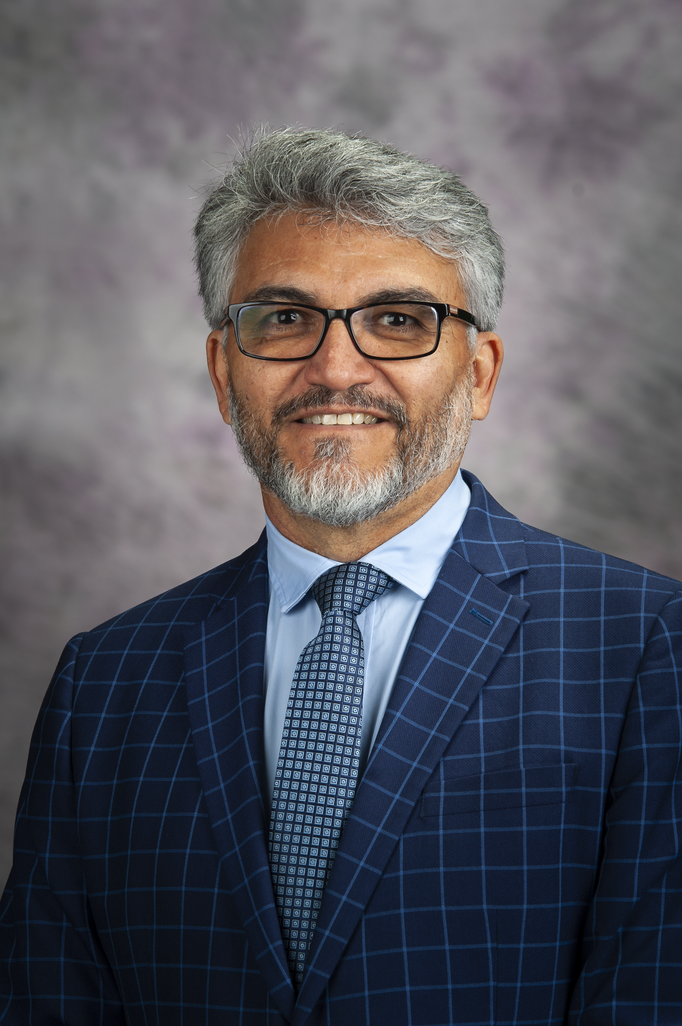
Email Id: caldasma@ksu.edu

Any Comments:

