Integrating Climate Resilience into Watershed Management in Flood-prone Areas of Sri Lanka: Identification of Critical Areas using a Spatial Model
Wickramaratne, C.¹, Chaminda, S. P.², Dissanayake, L.³, Senanayake, U.¹, Yaheya, R.¹, Wikramanayake, E¹.

¹ Environmental Foundation Limited, Kirilapone, Sri Lanka
² Department of Earth Resources Engineering, University of Moratuwa, Sri Lanka
3 Department of Geography, University of Peradeniya, Sri Lanka

Abstract (not more than 300 words)

Sri Lanka is increasingly experiencing impacts of climate change related disasters and the magnitude of these impacts is amplified by haphazard human development activities. Kalutara and Ratnapura are two regions located within the Kalu Ganga basin that is flooded under extreme precipitation events, causing loss of lives and significant economic damage. A spatially explicit approach is used in this study to identify critical areas that actively generate runoff and therefore are susceptible to flooding. Hydrologically sensitive areas are determined based on topographic characteristics, soil types and landuse patterns using geographic information system (GIS). Socio-economic information is incorporated to assess the vulnerability and exposure of upstream and downstream communities to floods. A range of low-impact development options and other soft engineering measures are explored to evaluate its applicability within the critical areas. Understanding the main drivers of increased runoff and vulnerabilities of certain regions, and determining potential interventions will inform effective long-term and short-term decision making processes to create climate resilience in the studied flood prone areas.

Keywords— floods, GIS, resilience, watershed

Professional Biography (100-150 words)

Chaturangi is an environmental scientist with a special interest in climate change and water resources. She is currently leading the division at the Environmental Foundation Limited (EFL), which is a non-profit environmental organization committed towards the conservation of Sri Lanka’s natural environment through scientific and legal means. She and her team work on a range of scientific environmental research projects to address knowledge gaps in the country, provide scientific input as support to battle national conservational issues and conduct awareness programs for a range of audiences on the importance of sustainable development and environmental protection. Chaturangi holds a PhD from the University of Adelaide, and a BSc (Hons) in Resource and Environmental Management from the Australian National University.

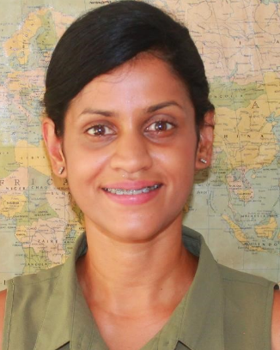
Paste your Photograph here

Email Id: chaturangi@efl.lk

Any Comments:

