Abstract Template
Carbon capture and utilization by mineral carbonation with Cement kiln dust in aqueous phase: Process simulation and sensitivity analysis
J. Pedraza^{1,3}, N. Rojas¹, J. Tobon², J. Ramirez¹

¹ Department of Chemical and Environmental Engineering. Faculty of Engineering.. Universidad Nacional de Colombia. Bogotá, Colombia
² Department of Materials and Minerals. Faculty of Mines.Universidad Nacional de Colombia. Medellín, Colombia.
³Technische Universität Berlin, Department of Chemistry, Berlin, Germany

Abstract (not more than 300 words)

The cement industry is a significant industrial source of carbon dioxide (CO₂), contributing to 9% of global emissions in 2010. The most common alternative for this industry to reduce their greenhouse emissions is through energy efficiency measures, reducing the clinker factor, and using alternative fuels. These measures are limited to mitigating emissions from combustion of fuels, which represents only 40% of total emissions. Limestone calcination is an important source of CO₂ emissions, inherent to chemical reactions of the raw material. Appropriate technologies to reduce these emissions are also needed.
Carbon dioxide capture and reuse techniques can be a suitable option for the cement sector to reduce CO₂ emissions. At the same time, it is possible to use industrial waste from cement manufacturing such as cement kiln dust (CKD). CKD has been used as an alternative material because its production rate represents a considerable fraction of the total clinker production rate. Because of its alkaline properties, CKD can be used to convert CO₂ into a usable material by the cement industry.
In this work, a hierarchical approach has been implemented to select the best configuration between pre-treatment/post-treatment materials and CO₂ conversion, and to estimate the total energy requirements for each process unit. The initially suggested system for mineral carbonation (MC) includes CKD pre-treatment, CO₂ compression, a CO₂ capture reactor, and post-treatment of the carbonated materials. In addition, a sensitivity analysis was performed to choose the best combination of operation variables for the capture process by mineral carbonation, according to simulation results. The energetic analysis corresponds to the energy demand of the capture process, from CKD to usable carbonates, considering mass and energy consumption.

Keywords—carbon capture and utilization, cement kiln dust, industrial waste, mineral carbonation.

Professional Biography (100-150 words)

Jenniffer Pedraza is a Chemical Engineering (Universidad Nacional de Colombia, 2009) and has a Master degree in Environmental Engineering (Universidad Nacional de Colombia, 2014). She is currently Ph.D. Student and Researcher at Universidad Nacional de Colombia. Her research is focused on technical economic and environmental management for carbon capture and utilization technologies mainly mineral carbonation. Their current project is 'Carbon capture and sequestration to obtain usable materials'.



Email Id: jipedrazav@unal,edu.co

Dr. Rojas is a Chemical Engineer (Universidad Nacional de Colombia, 1996) with a Ph.D. in Diesel Engines Emissions from the University of Leeds, United Kingdom. He held an Assistant Professor position at Universidad de Los Andes between 2002 and 2006. Currently, he is an Associate Professor at the Department of Chemical and Environmental Engineering of Universidad Nacional de Colombia at Bogota. Dr. Rojas’ research is focused on estimating and measuring air pollutant emissions, determining human exposure to particulate matter, chemically characterizing particulate matter to determine its source contributions and modeling air quality. He has published more than 40 papers in peer-reviewed journals.


Email Id: nyrojasr@unal,edu.co

Dr. Tobon received a BSc. in Geological Engineering in 1992, an MSc. in Engineering in 2003, and a Ph.D. in Science and Technology of Materials in 2011, from the Universidad Nacional de Colombia (UNal). From 1992 to 1999 he worked for different companies; at the same time from 1995 to 1999 he held a part-time professor position at UNal. Since 1999, he has worked full time for this University. Currently, he is a full professor in the Materials and Minerals Department of UNal. His research topics include the industrial application of minerals and rocks, chemistry and mineralogy of cement, nanotechnology in construction materials, alternative cementitious materials, and ultrahigh performance concretes. He is the Director of Cement and Construction Materials Research Group. He has graduated 6 Ph.D. students. He has published more than 60 papers in peer-reviewed journals and was granted a patent on CSA-cements in 2017.

Email Id: jitobon@unal.edu.co

Dr. Jose Herney Ramirez is a Chemical Engineer from the Universidad Nacional de Colombia (Manizales), Master in Chemical Engineering from the University of Sao Paulo (Brazil), PhD in Chemical Engineering from the Unviersity of Porto (Portugal). Since August 2008, he held an Associate Professor at the Department of Chemical and Environmental Engineering of Universidad Nacional de Colombia at Bogota. Currently he is co-director of the research group on materials catalysis and environment. Areas of interest: Environmental catalysis, reactor design, wastewater treatment, catalyst design and preparation.

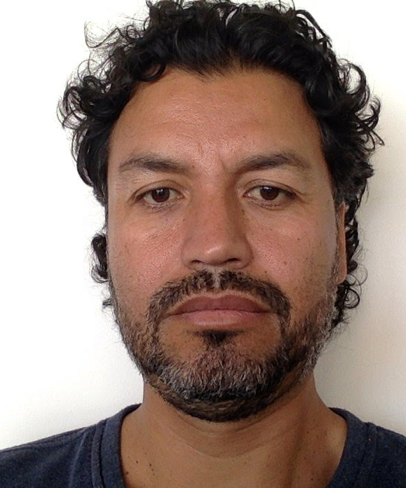
Email Id: jhramirezfra@unal,edu.co

Any Comments:

