IPCB’s Renewable Energy Engineering Expertise and the CENEA Project:
Background and Perspectives
Marcelo Gaspar, Pedro Torres, Rogério Dionísio, Paula Pereira

Escola Superior de Tecnologia (Instituto Politécnico de Castelo Branco, Portugal)

Abstract

The Polytechnic Institute of Castelo Branco (IPCB) has six schools that cover a wide range of scientific and technical disciplines, including Renewable Energy Engineering. This Portuguese Higher Education (HE) Institution aims at training professionals with applied technical-scientific skills and to promote its integration into the scientific and technological community. IPCB researchers and lecturers work and collaborate with other institutions through the participation in many national and international R&D projects and consortia. One of such partnerships is the CENEA project. This Erasmus+ Project Proposal for a Strategic Partnership in a Collaborative European Network for Energy Awareness (CENEA) aims to increase the awareness of energy issues and to offer a transnational view of target groups in partner countries. The project goal is to have a positive and long-lasting impact on the project participants, as well as on their background organizations and other target groups, as it is linked to educational policy goals at national and European levels.
Located in the centre of Portugal, the IPCB is surrounded by various different Renewable Energy Harvesting Sources - namely Solar, Bioenergy, Wind and Hydro – undertaking regular studies in these different domains. As a result of regular close cooperation with local companies - that either use or generate renewable energy and related solutions in their processes - the IPCB has been a privileged partner to carry-out the applied research projects and internships in such companies, involving IPCB students, teaching staff and researchers. Lecturing a wide range of engineering degrees and short cycle courses, namely Renewable Energy and Industrial Engineering, as well as Short Cycle courses in Renewable Energy, the IPCB is a reference Portuguese HE Institution with a large portfolio of technical and scientific publications on national and international journals and conferences that serve as a dedicated background for the participation on the CENEA Project.

Keywords — Polytechnic Institute of Castelo Branco, Renewable Energy, Erasmus+ Project, CENEA.

Professional Biography

Engineer and Adjunct Professor, Marcelo Gaspar holds a Master and a PhD degree in Mechanical Engineering completed at the University of Coimbra, Portugal. Currently he focuses his research efforts on Sustainability and Product Development, as well as on Engineering Education.

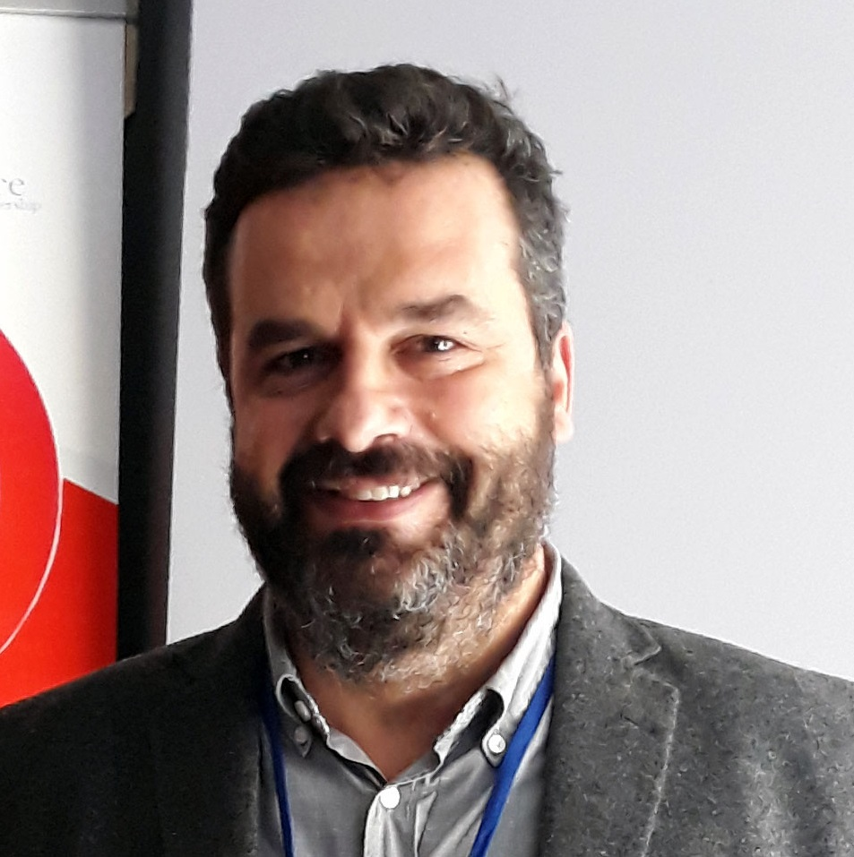
Paste your Photograph here

Email Id:

Any Comments:

