QUALITY OF MEDICAL CARE DELIVERED TO THE PATIENTS IN GOVERNMENT HOSPITALS IN THE CITY OF KARACHI
DR. HIRA SABIR MALIK, MBBS, MBA (HEALTH MANAGEMENT), BAHRIA UNIVERSITY KARACHI CAMPUS, PAKISTAN.

Abstract (300 word limit)
The first major objective of this study is to explore the service quality level of Public Hospitals in the city of KARACHI from perspective of patients. Secondly, the satisfactions level of the ailing patients towards the services provided by these health care government sectors in general is investigated. The measurement instrument used in this study is based on Questionnaires. Customer satisfaction and service quality are often treated together as functions of customer’s perceptions and expectations. Research has shown that high service quality contributes significantly to customer satisfaction and customer delight. This study empirically explores the relationship between hospital quality management and service quality performance for a sample of patients of government health care hospitals in the city of Karachi. SERVQUAL model has been adopted to encompass various aspects of service quality. The study has been undertaken to demonstrate the Gaps for measuring patient’s perceptions-expectation of health care services quality in GOVT hospitals in the city of Karachi. . In this study an attempt has been made to explore the service quality gap which is called ‘Gap Score’ by means of making a comparison between customers’ expectations and their actual perceptions towards the services and the government hospital patients are treated in. The purpose of this research is to provide review of the SERVQUAL research in measurement of health care service quality, to obtain information about quality parameters of services provided by GOVT hospitals of Karachi & to find out as to how much these parameters rate are as per the expectations of the patients.
A sample size of 150 ailing patients is taken from department to department in different government hospitals situated in the city of Karachi.
The results have shown an alarming situation where government hospitals are far away from the patients expectations. Furthermore there is an extreme need for training in the area of public hospital staff and their attitudes towards the ailing. Looking at the situation it is highly recommended that the government should take a country wide initiative to launch special programs where hospitals internal structures and work process are re-organized on the principles of quality management practices, through the introduction of ISO Programs. This would help in improving the service quality at each stage of the services provided by these hospitals.

Image

ENVIRONMENTAL HEALTH CARE
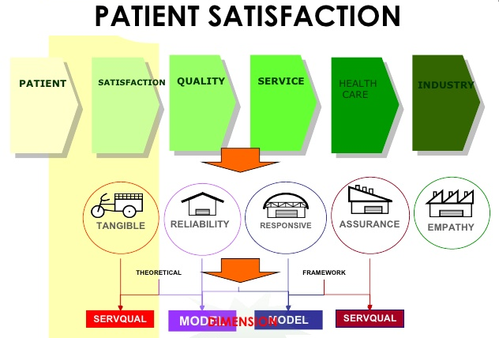
Recent Publications (minimum 5)
- Arzoo Saeed, Hajra Ibrahim (2005). Reasons for the Problems faced by Patients in Government Hospitals: results of a survey in a government hospital in Karachi, Pakistan. Journal of Pakistan Medical Association, Vol.55, No. 45, (http://jpma.org.pk/full_article_text.php?article_id=563)
- Irfan SM, Ijaz A. (2012) "Comparison of Service Quality between Private and Public Hospitals: Empirical Evidences from Pakistan", J Qual Tech Manag 2011; VII: 1-22.
- Donabedian, A. (1980). The Definition of Quality and Approaches to its Assessment. Ann Arbor: Health Administration Press. Economic Survey of Pakistan (2009).
- Pakdil, F., Harwood, T.N. (2005). Patient Satisfaction in a Preoperative Assessment Clinic: an Analysis Using SERVQUAL Dimensions. Total Quality Management and Business Excellence, Vol. 16, pp. 15-31.
- Naveed M., Hammad H. Mirza & Muhammad A. (2012) "Service Quality Gap And Customer Satisfaction Among Public Versus Private Hospitals Of Pakistan", SS International Journal of Business and Management Research, Vol2, Issue 1

Biography (150 word limit)
Dr. Hira Sabir Malik has her expertise in evaluation and passion in improving the health and wellbeing. Her open and contextual evaluation model based on responsive constructivists creates new pathways for improving healthcare. She built this model after years of experience in research, evaluation, teaching and administration both in hospital and education institutions. The foundation is based on years of evaluating services of the health care organization, which is a methodology that utilizes the previous generations of evaluation: measurement, description and judgment. It allows for value-pluralism. This approach is responsive to all stakeholders and has a different way of focusing.
Email: dr_hsmalik@hotmail.com

