Title of the Thesis
_______________________________________________________

A Thesis Submitted
In Partial Fulfillment of the Requirements
for the Degree of……….

Name of the Student: Anupam Kumar

Name of Supervisor(s): Dr. ShriRam Chaurasia



DEPARTMENT OF CIVIL ENGINEERING

Madan Mohan Malaviya University of Technology, Gorakhpur (U.P.)-
INDIA
05, 2019
CERTIFICATE

Certified that Name of student has carried out the research work presented in this thesis entitled “Efficiency of Various Curing System Horizontal and Vertical Surface” for the award of Doctor of Philosophy/ Master of Technology from Madan Mohan Malaviya University of Technology, Gorakhpur under my/our supervision. The thesis embodies result of original work and studies carried out by Student himself and the contents of the thesis do not form the basis for the award of any other degree to the candidate or to anybody else*.

Signature of Supervisor(s)
Name(s)
Department(s)
M. M. M. U. T. Gorakhpur

Date/Month/Year

 Candidate Declaration
I declare that written submission represents my work and ideas in my own words and where others ideas or words have been included; I have adequately cited and referenced the original sources. I also declare that I have adhered to all principles of academic honesty and integrity and have not misrepresented or fabricated or falsified any idea/data/source in my submission. I understand that any violation of the above will be cause for disciplinary action by the University and can also evoke penal action from the sources which have thus not been properly cited or from whom proper permission has not been taken when needed.

Anupam Kumar (2017013301 – STR.ENGG)

Civil Engineering Department
Date: 18/01/2019
Place: Gorakhpur

Approval Sheet
This thesis/dissertation/report entitled (Title) by (Author Name) is approved for the degree
of ____________ (Degree details).
Examiner
________________________
________________________
________________________
Supervisor (s) ________________________
Head of Department __________________________
Dean, Research & Development or
Other Dean/Professor to be nominated
by the Vice Chancellor in his absence
________________________

Date: ____________
Place: __________

Contents
Abstract………………………………………………………………………………………………………………………….……………..…1
Introduction…………………………………………………………………………………………………..……………………..…………2
Literature Review…………………………………………………………………………………….………………………………………3
Water adding Techniques……………………………………………….…………………………………………………………….…….3
Ponding………………………………………………………………………………………………………………………..………….………….3
Sprinkling……………………………………………………………………………………………………………….………….…………..…...3
Burlap…………………………………………………………………………………………………….…………………………………..……….4
Plastic Sheet……………………………………………………………………………..………..…………………..……………….…………4
Chemical Compound…………………………………………………………….……………………………………………….…..……….5
Objective……………………………………………………………………………..….……………………………………….….….………..6
Curing…………………………………………………………………………………………………………….……………..………..…..….…..6
Curing of Concrete………………………………………………………………………………………………………………………...…....6
Hydration of Cement………………………………………………………………….……………………………………………….…….…6
Object of Curing………………………………………………………………………….……………………………………………….……….7
Curing Period…………………………………………………………………………….……………………………………………….…………8
Mehod of Curing…………………………………………………………………………………………………………………….……..….8
methods which replenish partly the loss of water by interposing a source of water………………….……..…9
Ponding of water over the concrete surface after it has set………………………………………………………….………9
Covering the concrete with wet Burlap……………………………………………………………………………………………….…9
Sprinkling of water…………………………………………………………………………………………………………………………….…..9
methods preventing the loss of water by interposing an impermeable mrdium………………………………………………………………………………………………….………….…………………………………..9
Curing the surface with Waterproof paper……………………………………………..…………………………………………….9
Chemical curing Compound………………………………………………………………………………………………………………….10
MATERIALS USED:………………………………………………………………………………………………………………………....10
Cement…………………………………………………………………………………………………………………………………………………10
Coarse Aggregate………………………………………………………………………………………………………………………………….10
Fine Aggregate……………………………………………………………………………………………………………………………………..10
Water…………………………………………………………………………………………………………………………………………………..10
Plastisizer……………………………………………………………………………………………………………………………………………..11
Curing Compound…………………………………………………………………………………………………………………………………11
Test………………………………………………………………………………………………………………………………………………………11
Mix Proportion and mixing methods……………………………………………………………………………………………………12
Refrence……………………………………………………………………………………………………………………………………………….13

Efficiency of Various Curing System on Horizontal and Vertical Surface

Abstract:
Concrete is most generally utilized development material because of its quality, lastingness and sturdiness. Advancement in construction and chemical industry has paved a way for development of new curing techniques. This paper synthesizes finding from the review and experimental works in carrying out the strength and water in concrete. The present study of curing is to examine the curing efficiency of different five methods in concrete at vertical and horizontal surfaces. The experimental works of concrete cubes are concentrated at the mix design of M25 Grade Portland-Pozzolana cement. Five types of curing system in this paper review are studied. The desired objectives are to assess the curing efficiency and water by employing five methods at the horizontal and vertical surface. In ponding method, 5 cubes are cast in the cubical mould, then after 24 hours, specimens are demoulded, then specimens are put in curing tank for 7days and 28days, applied for each horizontal & vertical surface. After 7 days of curing, water Absorption test of cubes is carried out. In Burlap method, wet gunny bags are used at exposed surfaces, which is used at horizontal and vertical surface and canvas surface .some chemical curing at curing agent (wax, acrylic) compound used. Finally comparing the result of different curing mechanism, to the understand the efficiency of curing method and compared with conventional water curing and chemical curing compound. For trail concrete mix design with Portland pozzolana cement to achieve the compressive strength, M25. Concrete cast cube and cylinder to measure strength after 7, 28 day curing. At last comparison all method give better strength.

Introduction:
The physical properties of concrete depend largely on the extent of hydration of cement. Curing is the name given to the procedures used for promoting the hydration of the cement, and consists of a control of temperature and of moisture movement from and into the concrete. Curing allows continuous hydration of cement and consequently continuous gain in the strength, once curing stops strength gain of the concrete also stops. Proper moisture conditions are critical because the hydration of the cement virtually ceases when the relative humidity within the capillaries drops below 80%. 1 with insufficient water, the hydration will not proceed and the resulting concrete may not possess the desirable strength and impermeability. The continuous pore structure formed on the near surface may allow the ingress of deleterious agents and would cause various durability problems. Moreover due to early drying of the concrete micro-cracks or shrinkage cracks would develop on surface of the concrete. When concrete is exposed to the environment evaporation of water takes place and loss of moisture will reduce the initial water cement ratio which will result in the incomplete hydration of the cement and hence lowering the quality of the concrete. Various factors such as wind velocity, relative humidity, atmospheric temperature, water cement ratio of the mix and type of the cement used in the mix will affect the curing of concrete. Evaporation in the initial stage leads to plastic shrinkage cracking and at the final stage of setting it leads to drying shrinkage cracking .Curing temperature is one of the major factors that affect the strength development rate. At elevated temperature ordinary concrete losses its strength due to the formation of the cracks between two thermally incompatible ingredients, cement paste and aggregates. When concrete is cured at high temperature normally develops higher early strength than concrete produced and cured at lower temperature, but strength is generally lowered at 28 days and later stage. A uniform temperature should be maintained through the concrete section to avoid thermal cracking. Laboratory tests show that concrete in dry environment can lose as much as 50 percent of its potential strength compared to similar concrete that is moist cured .Curing of the concrete is also governed by the moist-curing period, longer the moist-curing period higher the strength of the concrete assuming that the hydration of the cement particles will go on. American Concrete Institute (ACI) Committee 301 recommends a minimum curing period corresponding to concrete attaining 70%of the specified compressive strength. Curing has a strong influence on the properties of hardened concrete; proper curing will increase the durability, strength, volume stability, abrasion resistance, impermeability and resistance to freezing and thawing. “Curing techniques and curing duration significantly affects curing efficiency” Various surface of efficiency can be achieved by various curing methods. The effectiveness of the concrete curing method depends on the material used, method of construction and the intended use of the hardened concrete.
Techniques used in concrete curing are mainly divided into two groups namely, Water adding techniques and Water- retraining techniques. Reliability and effectiveness of such curing methods are still under debate. The classification of chemical curing compound are include: curing agent; Wax and Acrylic
REVIEW OF LITERATURE:
Water adding technique:
Water adding techniques include Ponding, sprinkling or fogging, plastic sheet, chemical curing compound and saturated water covering.

Ponding:
is a curing method wherein the flat concrete surfaces such as slabs and pavements are cured by pounding of water around the perimeter of the surface with the help of sand dikes. It is an effective method as it maintains a uniform temperature in the concrete and also prevents the loss of the moisture from the concrete. This method is used in laboratory experiments wherein the specimens are dipped in water after 24 hours of casting. The specimens are than tested for the strength after 7 and 28 days. Since pounding require considerable supervision and labour, this method is generally used for small construction activity only.
Sprinkling:
is a curing method wherein a fine fog mist is frequently applied on the surface of the concrete through a system of sprayers or nozzles. It is an effective method of curing when the humidity is low or the ambient temperature is well above the freezing point. This method requires ample of water and a proper supervision.
Burlap:
Saturated wet covering is most often used curing method in the construction industry. In this method moisture retaining fabrics such as burlap cotton mats and rugs are used as wet covering to keep the concrete in a wet condition during the curing period, for if the drying is permitted, the cover will itself absorb the water from the concrete. Alternative cycles of wetting and drying during the early period of curing will cause cracking of the surface. The major disadvantage of this method is discoloring of concrete. Researchers are working in order to identify the effectiveness of the water curing methods over other curing methods. M.V. Krishna, Carried out an experimental study on the effect of elevated temperature on differently cured concrete of M25 grade and subjected to temperature of 150⁰C, 300⁰C and 450⁰C for 1 hour duration in muffle furnace. His study revealed that the 28-day compressive strength of the concrete specimen cured by water curing have been more than those cured by Membrane curing in both heated and high temperature exposure condition. Weight loss in both conventional water cured concrete and membrane cured concrete are comparable.

Plastic Sheet:
Plastic sheets such as polyethylene film are used to cure concrete. Polyethylene films are lightweight, impervious hence prevent the moisture movement from the concrete and can be applied to simple as well as on complex shapes. Major disadvantage of this type of curing is that it causes patchy discoloration especially if the concrete contains calcium chloride. Discoloration is more pronounced when the film develops wrinkles and it is difficult and time consuming on a large project to place the sheets without wrinkles. Polyethylene film should confirm to ASTM C171. Md. Safuddin Wrapping curing is more efficient than dry-air curing as it results in greater compressive strength, ultrasonic pulse velocity and dynamic modulus of elasticity and lower surface absorption. This is because wrapped curing moisture movement from the concrete surface was hindered due to the impervious layer f the film and as a result good amount of moisture was available to be used throughout the hydration process.

Chemical Curing Compound
Various types of curing compound are available in the market, mainly includes water-based, resin solvent based, chlorinated rubber, wax based etc. Water based curing compound is most used curing compound world-wide. These compounds are applied on the exposed surface of the concrete by the help of roller, brush or spray. Effectiveness of the chemical curing compound is remarkable dependent on their application, time and generic type. It is difficult to apply such compounds on the vertical surfaces.
Curing efficiency (E) for a particular method of curing can be determined by the following equation:

E=^{(K1 - K2) /}_{(K1- K3*100}
_
Where, k1 = studied property of a non-cured specimen, k2 = studied property of a specimen cured by the method being evaluated, and k3 = studied property of water-cured specimen till age of testing. If the curing method is equally good as water-curing (k2 = k3 ) then the value of E = 100%, while for poor curing method ( k2 > k3 ) the value of E tends to 0%.

This definition gives a convenient scale with which to assess the efficiency of chemical curing compounds or traditional methods. Curing compounds namely, acrylic and water based are effective in decreasing plastic and drying shrinkage strain for Portland Pozzolana Cement and the curing efficiency of such compounds with respect to compressive strength are water curing had a greater effect on the durability properties of the concrete (sorptivity and porosity) than on mechanical properties (strength and hardness). He also suggested that compressive strength. comparative study on different curing methods reported that the efficiency
Compared to conventional standard water curing and water based chemical curing compound.

OBJECTIVE
- The principal extent of this paper is to think about the impact of various curing system with horizontal and vertical surface.
- To consider the properties of concrete for strength, and curing efficiency of concrete.
- And compared with conventional water curing and chemical curing compounds

Curing: The use of high amount of water on the concrete structure members for gain of strength at differ time period. This process of creation of an environment during a relatively short period immediately after the placing and compaction of concrete, favorable to the setting and the hardening of concrete, is termed curing.
Curing of concrete: curing is define the maintains of moisture at favorable temperature, during of curing period placing, casting and finishing to hydration of cement. Curing an important role development of strength.
Hydration of cement: The chemical reaction of cement and water of called hydration of cement. These product are important the quality, quantity, stability and rate of formation of hydration.
When cement is mixed with water cement ratio 0.45, Chemical reaction between its major final compounds i.e.; tricalcium silicate (C₃S), dicalcium silicate (C₂S), tricalcium aluminate (C₃A),tetra calcium alumina ferrite(C₄Af) etc. and water take place. During this Chemical reaction i.e. cement hydration, new compounds of hydrated calcium silicate, hydrated calcium aluminate, and calcium hydroxide are formed.
- Then tricalcium silicate breakdown to Crystal of calcium silicate of lower basicity to form dicalcium silicate (C₂S) and release the excess lime as calcium hydrate.
- Both C₂S as originally present in cement and that resulting from hydrate (breaking down) of C₃S, combine directly with water in the process, known as hydration and form hydrate calcium silicate.

C₃S+H₂O=Hydrate calcium silicate +Ca (OH)₂
C₂S+H₂O=Hydrate calcium silicate +Ca (OH)₂
C₃A+H₂O=Hydrate calcium aluminate +Ca (OH)₂
- Aluminate, being highly soluble in plain water reacts immediately and rapidly deposition of calcium aluminates crystals takes place.
- This rapid deposition of calcium aluminate crystal is responsible for initial setting of cement.
- Whears C₃S react slower than C₃A, but faster than C₂S and is responsible for First 28 days strength.
- C₂S reacts slowly and it continuous for the to three years and contributes to the develop of later strength.
- All these properties of different compound during cement hydration are represent
Object of curing:
mainly below the fallowing step,
- It increases durability and impermeability of concrete
- It improves wear resisting and weather resisting qualities
- It reduces shrinkage of concrete.
- Proper curing will increase the strength.
CURING CONDITIONS:
Proper curing practice is one of the important steps in making high quality concrete. A good Mix design with low water cement ratio alone cannot ensure good concrete.
- Adequate moisture within concrete to ensure sufficient water for continuing hydration process
- Warm temperature to help the chemical reaction.
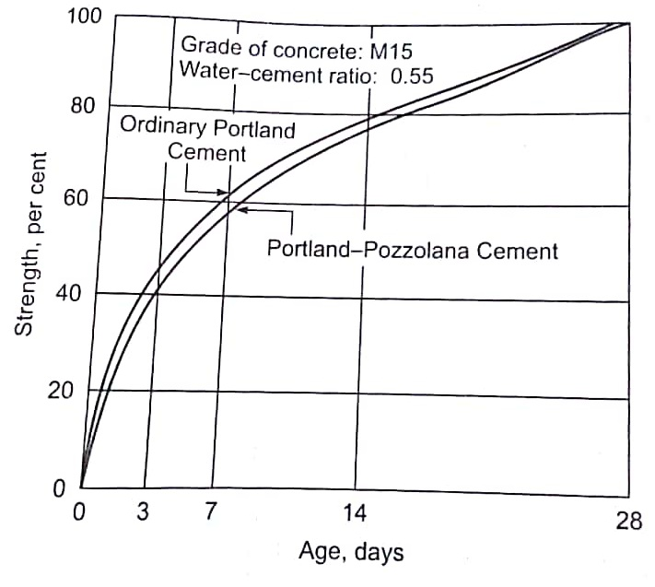
Figure: Development of strength with curing period
CURING PERIODS
To develop design strength, the concrete has to be cured for up to 28days. As the rate of hydration, and hence the rate of development of strength, reduces with time, it is not worthwhile to cure for the full period of 28 days.
ACCORDING; IS: 456-2000 stipulated a minimum of 7 days moist-curing, While IS: 7861 (part-1)-1975 stipulates a minimum of 10 days under hot weather condition. Generally, increased curing periods are desirable for high-quality concrete products, concrete floors, roads and airfield pavement.
METHOD OF CURING CONCRETE:
There are various methods available for curing. The actual procedures used vary widely depending on the conditions on the site, and on the size, shape and position of the member.
The methods can be broadly classified as:
The methods which replenish partly the loss of water by interposing a source of water, or prevent the evaporation,
Ponding of water over the concrete surface after it has set
This is the most common method of curing the concrete at horizontal surface; slab or pavements and consists of storing the water to a depth of 50mm on the surface by constructing small puddle clay bunds all around
Ponding may promote efflorescence by leaching.
Covering the concrete with wet Burlap
The concrete is covered with burlap (coarse jute or hemp) possible after placing, and the material is kept continuously moist for the curing period. The covering material can be used a number of times and, therefore, tends to be economical. The effectiveness of the method as compared with the ponding.
Sprinkling of water
This is a useful method for curing vertical in inclined surfaces of contere wherein the earlier methods cannot be adopted. The method is not very effective as it is difficult to ensure that all the part of concrete be moist all the time. The spraying can de done in fine streams through nozzles fixed to a pipe spaced at set interval.
The methods preventing or minimizing the loss of water by interposing an impermeable medium between concrete and the surrounding environment
Curing the surface with Waterproof paper
Waterproof paper prevents loss of water in concrete and protects the surface from damage. The method is satisfactory for concrete slabs or pavement. A good quality paper can be often reused. The paper is usually made of two sheets struck together by rubber latex composition. Plastic sheet is comparatively recent innovation as a protective cover for curing concrete. Being light and flexible. Which are guaranteed to give excellent result, Most plastic sheeting used in the concrete industry are milky or white in appearance, made airtight to prevent moisture evaporation from concrete.
Chemical curing
Chemical curing is accomplished by spraying the sodium slticate(Water Glass) solution .About 500g of sodium silicate mixed with water can cover 1m² of surface and forms a hard and insoluble calcium silicate film. It actually acts as a case hardener and curing agent.Thus sealing the surface and preventing the evaporation of water. Such as chemical curing(Wax,Acrylic)

.MATERIALS USED:
This examination includes the sort of material;
MATERIAL

CEMENT
Standard cement Portland Pozzolana Cement of Ultra tech Cement company conforming to requirement of IS: 1489 (part 1) code

COARSE AGGREGATE
Crushed coarse aggregate of nominal size 20mm with specific gravity 2.84 and water absorption .4 %

FINE AGGREGATE
Son river red sand having specific gravity 2.66 and conforming to zone III of IS:383-2016

WATER
Ordinary potable water from lab used throughout the experiment

PLASTICIZER
Commercially available plasticizer in order to increase the workability of concrete mix.
From Sonabhadra Quarry site (origin) and procure from local ICBP manufacturer in Rajhi Village.
CURING COMPOUND
Available in the market, mainly include water based Wax and Acrylic based compound with roller, brush.at different company like BASF, FOSROC VARDHAMAN.
MATERIAL TEST
The use of Portland pozzolana cement as well as mineral admixture for concrete mixes provided that there are satisfactory data on their suitability, such performance test on concrete IS:1489-1 (1991) The cement procured were tested for physical properties in accordance with IS: 4031-1988 and IS: 1489-1(1991) and are presented Table 1 chemical properties of cement are presented Table Coarse aggregate of physical properties Table accordance with:2386-1963.ASTM standard sand using and normal water used for concrete mixing.
Table 1.Physical properties of Portland Pozzalana Cement:
Property | Test Results PPC
Normal consistency | 33.5
Initial and Final setting time | 150 and 225 min
Fineness | 390

Table 2.Chemical composition of Portland Pozzolana Cement:
Constitute | PPC (wt.%)
Lime(Cao) | 41
Silica(Sio₂) | 28
Alumina(Al₂o₃₎ | 7
Iron Oxide(Fe₂o₃₎ | 4.9
Magnesia (Mgo) | 1
Sulphur Trioxide(So₃₎ | 2.4

Table 3.Physical properties of Fine aggregate:
Property | Test Results PPC
Specific Gravity | 2.8
Fineness modulus | 2.2

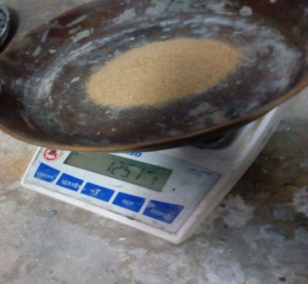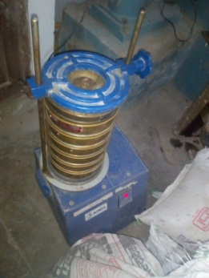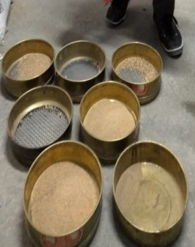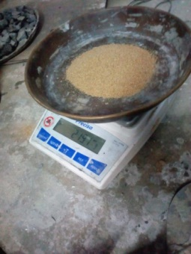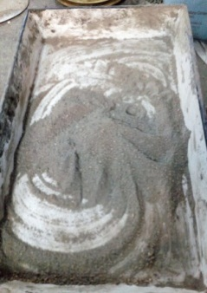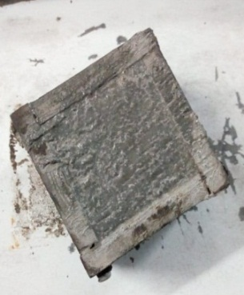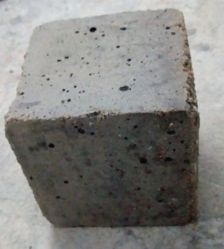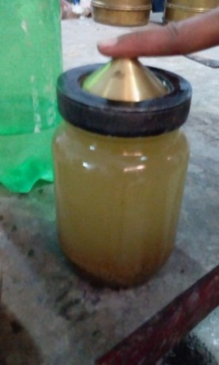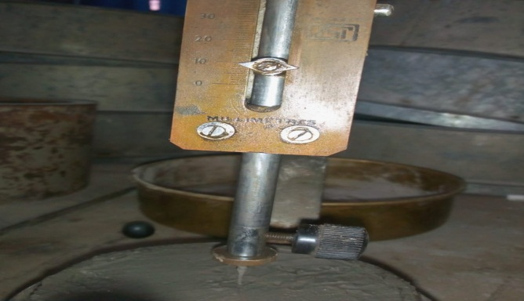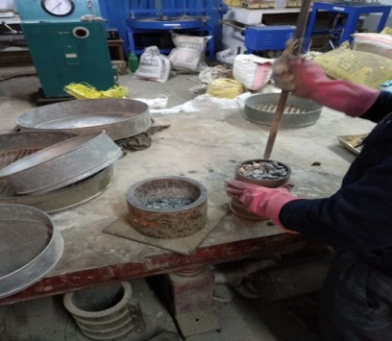 Figure: all material Test
Mix Proportion and mixing methods:
The mortar used consists if 1 part cement and 3 part sand proportioned by mass.water cement ratio of .45,.50,0.55,0.60 was selected for ascertaining efficiency of curing and curing compound. The cubes were cured one day in the moulds, unmould and immersed in water until 28 days. Cubes were tested after curing. Curing by ponding, sprinkling, burlap, and curing compound was carried out. Curing by compounds was performed by application of curing compound by means of paint brush on all side of the cube.
PROCEDURE FOR CAST OF CUBES
Clean the standard cube mould,6 Nos., thoroughly &tighten all the nut-boltsproperly.
Apply oil to all contact surface of the mould.
Size of the mould is normally 150mm*150mm*150mm.
Take random samples from the mix in a ghamela,while concreting.
Pour concrete in the cubes in 3 layers.
Compact each layer with 35 Nos. of strokes with the tamping rod.
Finish the top surface by thapi/trowel after compaction of the last layer.
Each specimen should be taken from different locations of the proposed concreting.
After 24 hours, remove the specimen from the mould.
While removing, take care to avoid breaking of the edges.
Code the cube with or marker. Coding should be self explanatory, building no. and the date of casting.
Submerge the specimenin clean, f

REFERENCE
A.M. Neville, 2007. Concrete technology, First, Eleventh and Twelfth Edition. J.J Brooks Education in South Asia.
M.L Gambhir, Concrete Technology Theory and Practice, Fourth Edition Planning and Resource Generation Thapar University, Patiala
Bentz D.P., Synder K.A. and Stutzman P.E., 1997, Hydration of Cement: The Effect of Curing Condition Proceeding of the 10thCongress on the chemistry of Cement.
Yash Nahata, Nirav Kholia and T.G Tank Effect of Curing Methods on Efficiency Of Curing of Cement Mortar (ICCEN2013)
ABSTRACT/SYNOPSIS

Name of Student………………………..Roll no………………… ) Centered on top of page )
Degree for which submitted ……………….Department…………..)
Thesis Title …………………………………………………………)
……………………………………………………….… )
Name(s) of Thesis Supervisor(s) ) Single spacing
1. ………………………………………………………………….. )
2. ………………………………………………………………….. )
Month and year of thesis submission……………………..…….. ) Double spacing
[Text of Synopsis/abstract begins here] )

