Professional Biography (100-150 words)

Dr. Forcellini completed his master’s degree from the University of Bologna in Civil and Environmental Engineering in 2006. His master’s thesis, titled, “Studi di Interazione Terreno – Struttura (Study of Soil Structure Interaction)” was collaboratively developed at the University of California, San Diego in collaboration with Prof. Ahmed Elgamal and Dr. Jinchi Lu. Since then, he has continued collaboration with Prof. Ahmed Elgamal and Prof. James M. Kelly at UC Berkeley. He worked as a bridge engineer between 2007 and 2009. Since 2009, he has been teaching at University of San Marino. He completed his Ph.D., “A structural optimized performance based earthquake engineering methodology and risk-management decision making” at the University of San Marino.

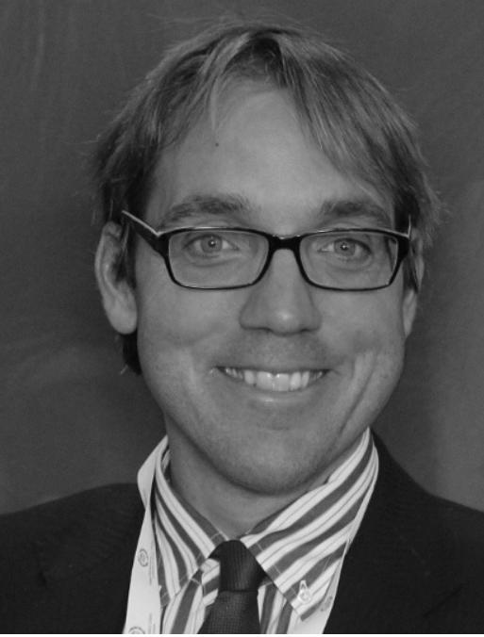
Paste your Photograph here

Email Id: davforc@omniway.sm

