Factors influencing healthcare providers’ attitude and willingness to use information technology in diabetes management.
Binyam Tariku Seboka, MPH-HI, Dilla University, Ethiopia
Tesfahun Melese Yilma, MPH-HI, Ph.D., University of Gondar, Ethiopia
Abraham Yeneneh Birhanu, Assistant professor, University of Gondar, Ethiopia

Abstract
Statement of the Problem: The traditional model of diabetes care in Ethiopia is discontinuous, which prevents providers from early interventions and effective communication. Besides this, patients have a problem in controlling their blood glucose level, the identified factors are inadequate home blood monitoring, non-adherence to medications, poor lifestyle management, and suboptimal education about the disease. However, the use of information technologies could help to improve communications between patients and care providers, might improve the quality of the patient's life while reducing healthcare costs and care providers' overload. This study aimed to describe the attitude and willingness of care providers towards the use of information technologies in diabetes management. Methodology & Theoretical Orientation: An institution-based cross-sectional quantitative survey was conducted by using a pretested self-administered questionnaire, where remote monitoring patients had not been implemented. The study used Technology Acceptance Model(TAM) to assess predictors of providers' willingness. Findings: The results indicated participants' technical skills (computer and internet utilization), attitude and awareness towards remote monitoring , and perceived usefulness of the system associated with their willingneParticipants'ants innovativeness, and practice of supporting patient by electronic technologies (means) were associated with attitude to remote monitoring. Conclusion & Significance: Improving the intention and skill of using computers should be a major point of attention to improve care providers' attitudes to remote monitoring and willingness in using information technologies. Besides, the awareness of professionals is crucial for improving willingness.

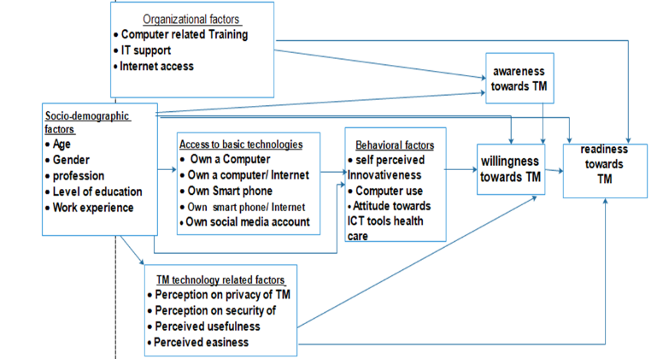

Figure 1: The conceptual framework that was used to assess attitude and willingness

Publications
1. Seboka, B., T. Yilma, and A. Yeneneh, Factors influencing healthcare providers’ attitude and willingness to use information technology in diabetes management. BMC Medical Informatics and Decision Making, 2021. 21.
2. Seboka, B., T. Melesse, and A. Yeneneh, Awareness and readiness to use telemonitoring to support diabetes care among care providers at teaching hospitals in Ethiopia: An institution-based cross-sectional study. 2021.
3. Seboka, B., et al., Tracking Progress in Anthropometric Failure Among Under-five Children in Ethiopia: A Geospatial and Multilevel Analysis. 2020.
4. Emwodew, D., et al., Barriers to the Adoption of Electronic Medical Record System in Ethiopia: A Systematic Review. 2021.
5. Seboka, B., et al., Factors associated with stigma and discrimination towards people living with HIV/AIDS in Ethiopia. 2020.


I am a strong advocate and driven researcher about Tele-monitoring/remote monitoring, electronic health, Evidence-based medicine, and spatial analysis. My early have focused on understanding the application of Information communication technology (ICT) for Remote monitoring/Tele-monitoring of chronic patient care. In particular, I was interested in health care professionals' perspectives regarding the use of innovative technology solutions to manage diabetes patients remotely in resource-limited settings like Ethiopia. Our seminal contributions in this area provided information about health professionals' readiness regarding this technology and potential factors for consideration during implementation. I have content and methodological expertise in studies incorporating geographic information systems (GIS) and spatial analysis approaches.
Email: bini555tar@gmail.com or binyamt@du,edu.et
.

