Does green space matter? Exploring relationships between green space type, physical activity, quality of life, and cardiovascular disease prevalence
Abdullah Akpinar, PhD, MSc, Adnan Menderes University Turkey

Abstract (300 word limit)
This study explores whether specific types of green spaces (i.e. urban green spaces, forests, agricultural lands, rangelands, and wetlands) are associated with physical activity, quality of life, and cardiovascular disease prevalence. A sample of 8,976 respondents from the Behavioral Risk Factor Surveillance System, conducted in 2006 in Washington State across 291 zip-codes, was analyzed. Measures included physical activity status, quality of life, and cardiovascular disease prevalence (i.e. heart attack, angina, and stroke). Percentage of green spaces was derived from the National Land Cover Dataset. Multilevel regression analyses were conducted to analyze the data while controlling for age, sex, race, weight, marital status, occupation, income, education level, and zip-code population and socio-economic situation. Regression results reveal that no green space types were not associated with physical activity, quality of life, and cardiovascular disease prevalence. On the other hand, the analysis shows that physical activity was associated with quality of life, and cardiovascular disease prevalence. The findings suggest that other factors such as naturalness, structure and distribution (sprawled or concentrated, large or small), quality, and characteristics of green space might be important in quality of life and cardiovascular disease prevalence rather than green space types. Therefore, further investigations are needed.

Image
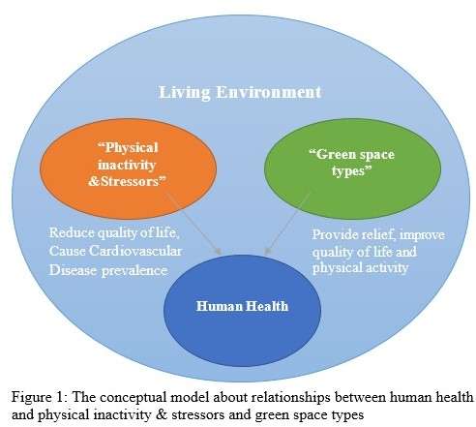
Recent Publications (minimum 5)
- Buscemi, S., Giordano, C., 2017. Physical activity and cardiovascular prevention: Is healthy urban living a possible reality or utopia? European Journal of Internal Medicine
- Akpinar, A., Barbosa-Leiker, C., Brooks, K.R., 2016. Does green space matter? Exploring relationships between green space type and health indicators. Urban For. Urban Green. 20, 407–418.
- Picavet, H.S., Milder, I., Kruize, H., de Vries, S., Hermans, T., Wendel-Vos, W., 2016. Greener living environment healthier people? Exploring green space, physical activity and health in the Doetinchem Cohort Study. Prev. Med. 89, 7–14
- Akpinar, A., 2016. How is quality of urban green spaces associated with physical activity and health? Urban For. Urban Greening 16, 76–83.
- Kuo, M., 2015. How might contact with nature promote human health? Promising mechanisms and a possible central pathway. Front. Psychol. 6 (1093)

Biography (150 word limit)
Abdullah Akpinar, PhD is an Assistant Professor in the Department of Landscape Architecture at Adnan Menderes University, Turkey. His interests include human health and built/natural systems, eco-therapy and healing gardens, environmental psychology, perceived restoration, physical activity, greenway/green infrastructure design, parks/ recreational area design, design and planning urban open/green spaces, landscape design, design thinking, and GeoDesign. Dr. Akpinar`s researches focus on identifying the ideal green space characteristics that help people reduce mental health issues and improve physical health. Dr. Akpinar has led and collaborated in 3 grants and 22 manuscripts and is currently working with colleagues on grant projects about the effect of green space on mentally ill people and school aged students.
Email: drXXXXXXX@xxxmail.com
Notes/Comments:

