Home monitoring of sleep and exposure to black carbon in patients with COPD and healthy controls

Joren Buekers^{1,2}, Erika Lutin², Anouk Vaes^{1,3}, Patrick De Boever¹, Emiel Wouters³, Martijn Spruit³, Jan Theunis¹, Jean-Marie Aerts²

¹ Environmental Risk and Health unit (MRG), Flemish Institute for Technological Research (VITO), Mol, Belgium
² Division Measure, Model & Manage Bioresponses (M3-BIORES), Department of Biosystems, KU Leuven, Leuven, Belgium
³ Department of Research and Education, CIRO, Horn, the Netherlands

Abstract (300 word limit)
Statement of the Problem: Chronic obstructive pulmonary disease (COPD) is a highly prevalent chronic disease¹ which is anticipated to become the third leading cause of death worldwide in 2030². A promising new method for chronic disease management is home telemonitoring³. Although both quality of sleep and exposure to air pollution are linked with quality of life and mortality^{4–6}, little attention has been directed towards home monitoring of these variables. Therefore, the aim of this study is to explore the feasibility and value of home monitoring of sleep and exposure to air pollution. Exposure to air pollution will be assessed as exposure to black carbon (BC), as this is considered a valuable air pollution indicator⁷. Methodology & Theoretical Orientation: An observational case-control study was conducted. COPD patients (n=13) and age-sex matched healthy controls (n=8; six healthy partners and two additional healthy controls) registered sleep for one week using a pulse oximeter and a multi-sensor activity monitor. Personal exposure to BC was measured using an aethalometer. A GPS and travel diary linked their whereabouts with the measured BC values. Findings: Sleep and BC were on average measured for 6.0 nights and 3.7 days respectively. COPD patients were found to have poorer sleep quality, e.g. higher time awake after sleep onset (84.66 min. versus 36.35 min.), and worse oxygen saturation levels, e.g. average saturation level (89.65% versus 93.34%) in comparison with healthy controls. Both patients and healthy controls spent most time at home (91%), which resulted in a low average exposure to BC (1249 ng/m³). However, BC levels ranged from 198 ng/m³ to 3093 ng/m³, indicating large individual differences. Conclusion & Significance: The results suggest that home monitoring of both sleep and BC provide potential valuable information for managing the health status of CODP patients.
Figure 1: Methodology and results of an observational case-control study monitoring sleep and exposure to black carbon (BC) in patients with COPD and healthy controls

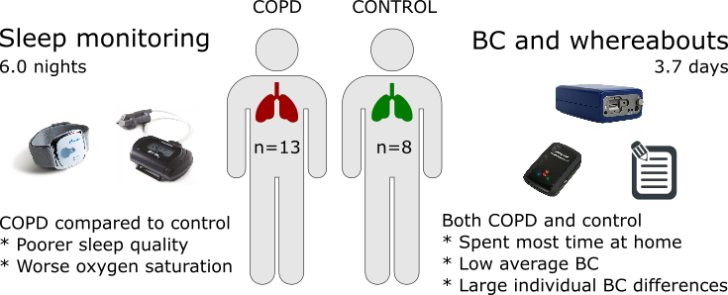
Image

Recent Publications (minimum 5)

1. Global Initiative for Chronic Obstructive Lung Disease (GOLD). Global strategy for the diagnosis, management, and prevention of chronic obstructive pulmonary disease. 2016. www.goldcopd.org. Accessed October 1, 2016.
2. World Health Organization. COPD. http://www.who.int/respiratory/copd/en/. Accessed November 3, 2016.
3. Stroetmann KA, Kubitschke L, Robinson S, Stroetmann V, Cullen K, McDaid D. How can telehealth help in the provision of integrated care? World Heal Organ. 2010:39. http://www.euro.who.int/__data/assets/pdf_file/0011/120998/E94265.pdf.
4. Omachi TA, Blanc PD, Claman DM, et al. Disturbed sleep among COPD patients is longitudinally associated with mortality and adverse COPD outcomes. Sleep Med. 2012;13(5):476-483. doi:10.1016/j.sleep.2011.12.007.
5. Scharf S, Maimon N, Simon-Tuval T, Bernhard-Scharf B, Reuveni H, Tarasiuk A. Sleep quality predicts quality of life in chronic obstructive pulmonary disease. Int J Chron Obstruct Pulmon Dis. 2010:1. doi:10.2147/COPD.S15666.
6. Li MH, Fan LC, Mao B, et al. Short-term exposure to ambient fine particulate matter increases hospitalizations and mortality in COPD: A systematic review and meta-analysis. Chest. 2016;149(2):447-458. doi:10.1378/chest.15-0513.
7. Janssen NAH, Hoek G, Simic-Lawson M, et al. Black Carbon as an Additional Indicator of the Adverse Health Effects of Airborne Particles Compared with PM10 and PM2.5. Environ Health Perspect. 2011;119(12):1691-1699. doi:10.1289/ehp.1003369.

Biography (150 word limit)
Joren Buekers is working as a PhD Researcher in a joint project between the University of Leuven (Leuven, Belgium), VITO (Mol, Belgium) and CIRO (Horn, the Netherlands). His research focusses on home monitoring of patients with COPD, in order to follow up their health status and predict exacerbations. The novelty of his approach can be found in the use of continuous measurements of a variety of variables (e.g. oxygen saturation or exposure to black carbon), instead of only performing daily spot checks of these variables. Dynamic analyses of the resulting time series contain valuable information for future developments in home monitoring and managing of patients with COPD.

Email: joren.buekers@vito.be

