Diagnosis of overtraining and overreaching syndrome in athletes
Grivas Gerasimos PhD, 1st Orthopaedical Clinic, "ATTIKON" General University Hospital, Greece

Overtraining (OT) is one of the most popular topics between coaches and researchers. The problem of this syndrome has been well-known for 70-years, however, the mechanism that induces OT remains unclear. Many recent papers have referred to the work of Kreider et al for the definitions of overreaching (OR) and OT. Overreaching: An accumulation of training and/or non-training stress resulting in short-term decrement in performance capacity with or without related physiological and psychological signs and symptoms of maladaptation in which restoration of performance capacity may take from several days to several weeks. Overtraining: An accumulation of training and/or non-training stress resulting in long-term decrement in performance capacity with or without related physiological and psychological signs and symptoms of maladaptation in which restoration of performance capacity may take several weeks or months. Diagnosis of OTS and OR is not simple. Unfortunately, diagnosis of OTS cannot be made definitively with one biomarker, there are a few markers that may be considered in the elite athlete. From the literature the most used biomarkers are urea (5-7 mmol/L), uric acid (237-449 μmol/L), ammonia (70-80 μmol/L), and creatine kinase (100-250 U/L).8 However, there are many others biomarkers that should be examined. However, one may be able to estimate training load and the body’s response with the following: salivary immunoglobulin A, serum testosterone: cortisol and overnight urinary cortisol: cortisol ratio. Diagnosis of OT or OR is difficult, authors agree that is important to prevent them. Moreover, one proposed method it is of utmost importance that athletes record daily their training load, using a daily training diary or training log. History of athletes should include inquiry about training (monotony, excessive load, sudden increase, caloric/hydration needs in relation to load) and personal stressors (interpersonal, family, sleep, travel).

Image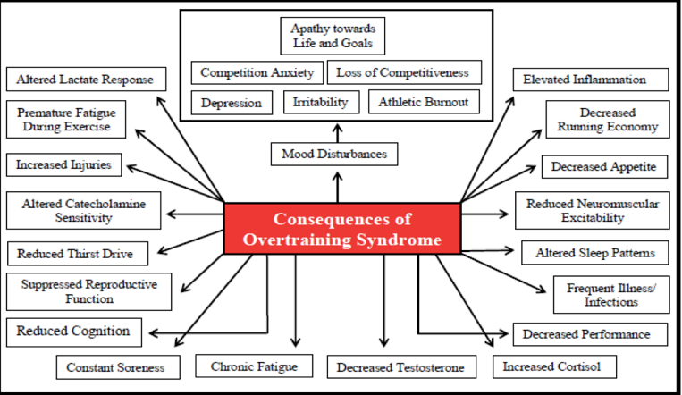
Recent Publications
- Harper C (2009) The neuropathology of alcohol-related braindamage. Alcohol Alcohol 44:136-140.
- Halson S, Jeukendrup A (2004) Does overtraining exist? An analysis of overreaching and overtraining research. Sports Med 34:967-981.
- Armstrong L, VanHeest, J (2002) The unknown mechanisms of the overtraining syndrome: Clues from depression and psychoneuroimmunology. Sports Med 32: 185-209.
- Meeusen R, et al (2013) Prevention, diagnosis, and treatment of the overtraining syndrome: Joint consensus statement of the European College of Sport Science and the American College of Sports Medicine. Med Sci Sports Exerc 45:186-205.
- Meeusen R, et al (2004) Hormonal responses in athletes: The use of a two bout exercise protocol to detect subtle differences in (over) training status. Eur J Appl Physiol 91:140-146.
- Urhausen A, Kindermann W (2002) Diagnosis of overtraining: What tools do we have? Sports Med 32: 95-102.
- Kreher JB, Schwartz JB (2012) Overtraining syndrome: A practical guide. Sports Health 4:128-138.
- Kreher JB (2016) Diagnosis and prevention of overtraining syndrome: An opinion on education strategies. Open Access J Sports Med 8: 115-122.

Photograph

 Biography (150 word limit)
Dr Grivas research interests include: a) how to maximize the performance of athletes, b) to examine physiological and biomechanical factors, c) to examine different training methods, d) nutrition protocols before and after a game or a race, e) recovery, environmental conditions, shoes, and equipment and f) physical activity in untrained individuals. Dr Grivas is the author or the co-author in more than 15 papers published and has presented more than 35 papers in international conferences in the areas of physical conditioning, team sports, evaluation and health.
Email: grivasger@hotmail.com

Notes/Comments:

