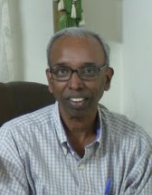
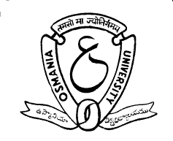

Study of resonance delocalization in benzyl carbocations: A detaild and lucid protocol in a Physical-Organic Chemistry Classroom

R. Sanjeev¹ and V. Jagannadham^{2*}

¹Department of Chemistry, Geethanjali College of Engineering and Technology, Cheeryal-501301, India

²Department of Chemistry, Osmania University, Hyderabad 500007, India

Abstract:

A detaild and lucid protocol would be described to calculate what fractions of the positive charge is shared between two hetero atoms in a carbocation taking 1-[4-(N-methyl-N-alkylamino)phenyl]-2,2,2-trfluoroethyl carbocations.
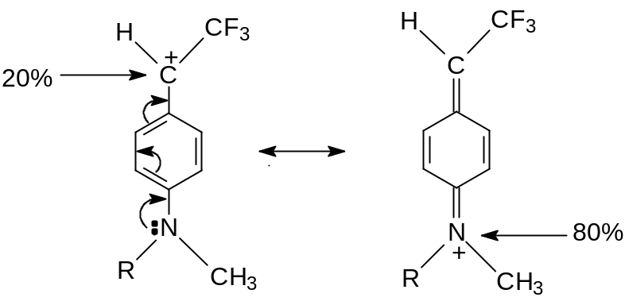

Keywords: Carbocations, Iminium ions

Biography(100-150 words)
Dr. V. Jagannadham, MSc PhD DSc, Professor of Physical Chemistry (Retired)
Prof. Jagannadham had all his university education right from BSc (1973), and MSc (1975) to PhD (1979) from Osmania University campus. Then he obtained his DSc from Sambalpur University, Orissa in 2009. Prof. Jagannadham joined Osmania University in 1983 after a brief serving as lecturer during 1978-83 at Sardar Patel College, Secunderabad. He was a CSIR-New Delhi - Junior Research Fellowship Holder - 1976-1978. He visited Germany as Post Doctoral Fellow (Max-Planck-Institute for Radiation Chemistry) and USA (University of Kentucky), (University at Buffalo). He was a Summer Professor (Rutgers University, New Jersey, USA) and Visiting NSF(USA)-DST(India) Summer Research Professor at the University of Connecticut, USA). He has published 126 papers and 4 review articles with an average impact factor of 2.1 and more than 2000 citations.

His research interests were reaction kinetics and mechanisms (India), radiation chemistry and fast reaction kinetics (Germany), organic cation reactivity (USA). After retirement in 2010 he shifted his research interest toward “Chemical Education”. Since 2010 he has published over 60 research papers in the field of “Chemical Education” alone.

Now he is Editor-in-Chief of “World Journal of Chemical Education” published by Science & Educational Publishing, USA.

Presenting author details
Full name: Prof. V. Jagannadham
Session name/number: Track1: Fundamentals of chemistry education
Category: Oral
Email id: jagannadham1950@yahoo.com
Contact number: 91-9866987955

