
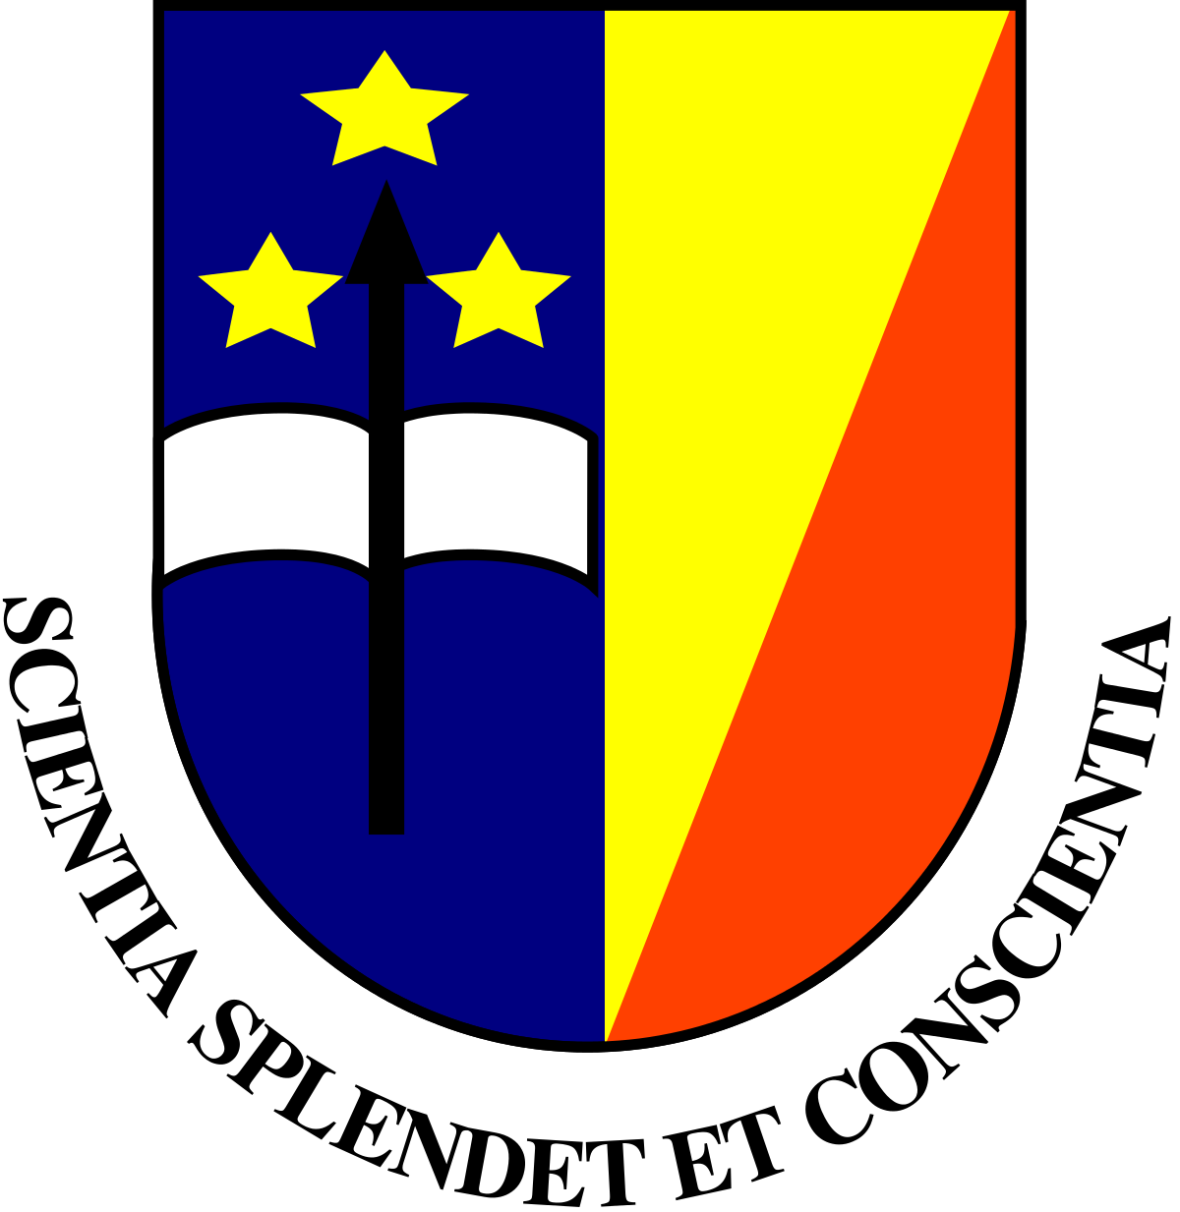

Paste your L ogo of your Company / University

Title: PHYTOCHEMICAL STUDIES AND IN VITRO ANTIOXIDANT, ANTIPROLIFERATIVE AND ANTIFUNGAL ACTIVITIES OF THE STEM BARK OF BOSWELLIA DALZIELII HUTCH

Name: Yves S Kafuti¹ and Kalulu M. Taba²

¹ Department of Chemistry and industry, Faculty of Sciences, University of Kinshasa, Congo-DR

Boswellia Dalzielii (B. dalzielii) Hutch is from the genius Boswellia and the family of Burseraceae. It is a tree plant abundantly found in North-western Nigeria and very common among the locals as a potent source of ethnomedicine. This work aims at evaluating the phytochemical, antioxidant, antiproliferative and antifungal activities of the stem bark of Boswellia dalzielii.
The phytochemical screening of the stem bark of B. dalzielii indicated the presence of tannins, saponins, flavonoids, steroids, carbohydrate. The phenolic content was found to be highest in sub-fraction C (481.20 ± 10.13mg GAE/g) and flavonoid contents were found to be highest in methanolic extract (142.17 ± 4.82 mg RE/g).
Boswellia dalzielii stem bark extracts, fractions and sub-fractions B, C and D exhibited antioxidant capacity; and the highest antioxidant activities were recorded from aqueous fraction and methanol extract for the DPPH; and aqueous fraction and sub-fraction D for the FRAP assay. Antiproliferative, sub-fractions C and D at the concentration of 125µg/ml gave the highest percentage of inhibition (90%) followed by sub-fraction B (50%) at 250 µg/ml. The antifungal screening of the bark methanolic extract, fractions and sub-fractions showed activity against Candida albicans; ethyl acetate and aqueous fractions showed activity against Penicilum notatum, while there was no activity shown by methanolic extract, fractions and sub-fractions against Aspergillus niger.
These results further showed that the stem bark of Boswellia dalzielii has high growth inhibitory activity on the seeds of Guinea corn; and therefore may possess anticancer component(s) which need(s) further investigation.

Biography

Yves S. Kafuti, I’m a lecture in the Department of Chemistry and Industry, Faculty of Sciences, University of Kinshasa, I have a Master degree in Pharmaceutical Chemistry at the University of Jos/Nigeria and I also done training at National Veterinary Research Institute (NVRI) VOM. Jos Plateau State/Nigeria. My research work is focused on natural product antioxidant and anticancer. I have one article already published and others articles are in the processes to be published.

Corresponding Author: kafutisungu@gmail.com Phone number : +243-816-767-884

