Antibacterial and Anticancer Effects of Novel Ag(I) Complexes

Jenaidullah BATUR1, Veysel Turan YİLMAZ2
1,2 Uludağ University, Faculty of Arts & Science, Chemistry department

Abstract

This poster describes the synthesis, structures, and biological interactions of new silver(I) complexes of 5,5-diethylbarbiturate with phosphine ligands. The synthesized complexes were characterized using various techniques such as NMR spectroscopy, elemental analysis, and X-ray crystallography. The results showed that the synthesized complexes had good antimicrobial activity against Gram-positive bacteria, including Staphylococcus aureus and Bacillus subtilis. The complexes also showed promising anti-proliferative activity against breast cancer cells. The article further discusses the mechanisms of action of the complexes against the bacteria and cancer cells. The results suggest that the complexes disrupt the bacterial cell membrane and induce apoptosis in the cancer cells. The complexes also exhibited low cytotoxicity towards normal human cells, making them potential candidates for further development as antimicrobial and anticancer agents. Overall, the study provides insights into the design of new silver(I) complexes with potential biological applications. The results suggest that the synthesized complexes have promising antimicrobial and anticancer properties, and further research is needed to explore their potential as therapeutic agents.

Image

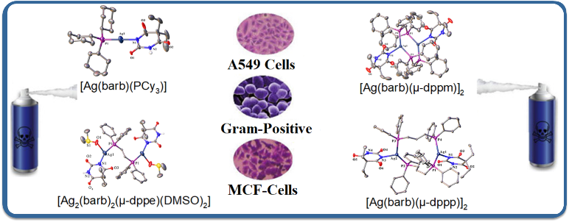
Recent Publications (minimum 5)
- J. L. Clement, P. S. Jarrett, Metal Based Drugs (1994) 1, 467–482.
- S. Medici, M. Peana, G. Crisponi, V. M. Nurchi, J. I. Lachowicz, M. Remelli, M. A. Zoroddu, Coord. Chem. Rev. (2016) 327–328, 349–359.
- V.T. Yilmaz, C. Icsel, J. Batur, S.Aydinlik, P. Sahinturk, M. Aygun. Structures and biochemical evaluation of silver(I) 5,5-diethylbarbiturate complexes with bis(diphenylphosphino)alkanes as potential antimicrobial and anticancer agents. European Journal of Medicinal Chemistry, 139, 2017, 901-916.
- V.T. Yilmaz, C. Icsel, J. Batur, S. Aydinlik, M. Cengiz and O. Buyukgungor. Synthesis, structures and biomolecular interactions of new silver(i) 5,5-diethylbarbiturate complexes of monophosphines targeting Gram-positive bacteria and breast cancer cells. Dalton Trans., 2017,46, 8110-8124.
- V.T. Yilmaz, E. Gocmen, C. Icsel, M. Cengiz, S.Y. Susluer, O. Buyukgungor. J. Biol. Inorg. Chem., 19 (2014), pp. 29-44

Photograph


Biography

Jenaidullah BATUR is currently a Ph.D. candidate at the Beijing University of Technology. He is working on promoting a novel, facile, and ecofriendly green synthesis strategy to synthesize metal oxide composite, elemental phosphorus, and metal-organic framework composite catalyst for CO₂ reduction reaction to convert CO₂ to valuable chemicals such as CO, C₂H_{4,} etc. He abstained from his master of science degree from the Uludag University of Turkey. His thesis was based on the synthesis and application of novel Ag(I)barbiturate phosphine complexes based on cancer therapy.

Email: Jbatur99@outlook.com

Notes/Comments:

