Effects of bluff-body cone angle on turbulence-chemistry interaction behaviors in large-scale semicoke and bituminous coal co-combustion
Dr Liutao Sun, School of Energy Science and Engineering, Harbin Institute of Technology, Harbin 150001, China

Abstract
Statement of the Problem: Semicoke, a solid byproduct from low-temperature pyrolysis of low-rank coal, is characterized by an ultralow volatile content (less than 10%) and a high calorific value, which always causes high NO emissions, poor flame stability and low char burnout when burned at a relatively high temperature. Hence, co-combustion with high-volatile bituminous coal is a feasible approach. However, the optimal semicoke blending ratio is limited to within 45% ~ 50%, which is usually not sufficient for the large-scale utilization of semicoke in power plants. The implementation of semicoke co-combustion by a larger proportion still faces many challenges, such as poor performances in ignition and pollution emissions. To stabilize semicoke co-combustion, bluff-body burners have been adopted to stabilize flames to promote ignition and reduce the unburned carbon content in fly ash and NOx emissions. Methodology & Theoretical Orientation: A numerical study using computational fluid dynamics (CFD) was utilized during semicoke co-combustion under various bluff body cone angles (α). Damkhöler numbers (Da) for homogeneous and heterogeneous reaction was utilized to elaborate the microscopic characteristic of co-combustion. Findings: With increasing α the main reaction zone moves upstream significantly, and a widened flame and uniform temperature profile are obtained due to enhancing the internal flue gas recirculation. The maximum homogeneous Da values are below 0.50, and the heterogeneous Da values of C-O₂, C-CO₂, and C-H₂O are within 0.670-1.207, 0.004-0.017 and 0.001-0.004, indicating that the char oxidation reaction is dominated by diffusion/kinetics, while the char gasification reactions are controlled by chemical kinetics. However, both reactions tend to be kinetically-controlled with increasing α. Conclusion & Significance: Based on comprehensive analyses of the simulations, we can gain deep insight into turbulence-chemistry interaction behaviors and NOx formation affected by the cone angle cases, further uncovering the underlying control mechanisms on low-NOx emissions in large-scale semicoke co-combustion.
Image
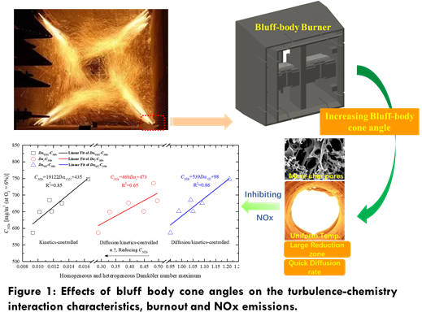
Recent Publications (minimum 5)
- Sun. L (2022) Effect of bluff body addition in fuel-rich stream on reaction behaviours of large-proportion semicoke rich/lean blended combustion. Fuel 308:122020.
- Shanbhogue. S J (2009) Lean blowoff of bluff body stabilized flames: Scaling and dynamics. Progress in Energy and Combustion Science 35: 98-120.
- Minamoto. Y (2014) Reaction zones and their structure in MILD combustion. Combust Flame 1688: 1075-96.
- Wang. Z (2019) Predicting lean blow-off of bluff body stabilized flames based on Damköhler number. Chinese Journal of Aeronautics, 32(2): 308-23.
5. Wang. C (2020) Experimental evaluation on co-combustion characteristics of semi-coke and coal under enhanced high-temperature and strong-reducing atmosphere [J]. Applied Energy, 260: 114203.

Photograph

Biography
Dr. Sun has his expertise in improving the semicoke blended combustion and air/oxy-MILD semicoke combustion. His findings can provide deep insight into the turbulence-chemistry interactions and its effect on NOx emission characteristics of semicoke co-combustion in a bluff-body tangential burner and can guide the boiler operation. This approach is responsive to all stakeholders and has a different way of focusing.
Email: 1095532412@qq.com

Notes/Comments:

